Membership Application

Business Details:

Name(s) of Owner (couple): | Click or tap here to enter text.
Name(s) of Manager (couple): | Click or tap here to enter text.
Name of Property: | Click or tap here to enter text.
Address for Hosting: | Click or tap here to enter text.
Postal Address: | Click or tap here to enter text.
 | Post Code: |  | Click or tap here to enter text.
Telephone: | Click or tap here to enter text.
Mobile: | Click or tap here to enter text.
Preferred email address: | Click or tap here to enter text.
Website: | Click or tap here to enter text.
How can we help you?  Is there something we can help you with straight away? | Click or tap here to enter text.
Host Services Proposed: (please all check boxes which apply) | ☐ Heritage | ☐ Farm |  | ☐ Home Host | ☐ Self contained unit with interactive hosting on site
Number of Rooms available: | Click or tap here to enter text.
Local Body By Laws Affecting Hosted Accommodation:

I/We are aware of various laws / regulations / bylaws that affect hosted accommodation and having referred to our Local Body Bylaw, we intend to host up to a maximum of: | Click or tap here to enter text.guests, for which no resource consent is required; or
 | Click or tap here to enter text.guests, for which we have resource consent dated Click or tap here to enter text.
How did you hear about us: | Click or tap here to enter text.
Declarations:
I / we agree:
- to abide by the Association’s Constitution, Code of Practice, and policies as amended from time to time (available for viewing on our member’s website - www.bandbassociation.co.nz). |  |  |  |  |  | ☐
- that I / we will abide by the various laws / regulations / bylaws that affect hosted accommodation. |  |  |  |  |  | ☐
- to our names and contact details being added to the Member Only section of the Association’s member website - bandbassociation.co.nz. |  |  |  |  |  | ☐
- to our property being featured on the Association’s Facebook and Instagram feeds. |  |  |  |  |  | ☐
- accept that any advertising undertaken using the Association brand (which includes the above logo) must conform with consumer laws and the Association’s Code of Practice and agree to submit our advertising material if requested. |  |  |  |  |  | ☐

Signed: | Click or tap here to enter text. | Signed: | Click or tap here to enter text.
Dated: | Click or tap here to enter text.

Note: Any electronic signatures appearing on this document are the same as handwritten signatures for the purposes of validity.

Tax Invoice

Property Name:  Click or tap here to enter text. | Invoice Date: | Click or tap here to enter text.
 | Invoice Number: | NwmemFG1
 | GST Number: | 53-674-704

Description: |  | Amount:
Annual Membership Subscription  Creating Connections 2022 Roadshow discount – 22% |  | 217.40  47.83
 | Total | $169.57
 | GST @ 15% | 25.43
 | Total Payable | $195.00

Please direct credit funds into our bank account:
02-0500-0403279-00
Bed & Breakfast Association NEW ZEALAND, BNZ Wellington Branch.
Please include your name as reference

Please keep a copy of this invoice for your records, as no receipt will be issued.

Membership subscriptions are non-refundable.

Your membership of the Association will be confirmed on receipt of your subscriptions.

Our Commitment to you:

We will endeavour to help you and your business provide a world class service to your guests by providing you with best practice guidelines, business support and education.

You can choose:
- to simply take advantage of the learning, support and advocacy provided by the Association; or
- to take your business to the next level and be assessed meeting minimum quality standards.

When you join the Association you receive access to:
- the Member Only section of the Association's website containing a large amount of helpful information, advice and templates – all free of charge to our members.
- our Facebook Group page – where members can seek feedback and ask questions from other members.
- our Quality Assurance Programme – a unique programme created to help B&B owners learn and meet best practice guidelines, operate their businesses safely and exceed guest expectations. Completing this programme leads to becoming a Quality Assessed Member.
- A listing on our promotional website, www.bedandbreakfastnz.co.nz. and mobile app (for assessed members only).
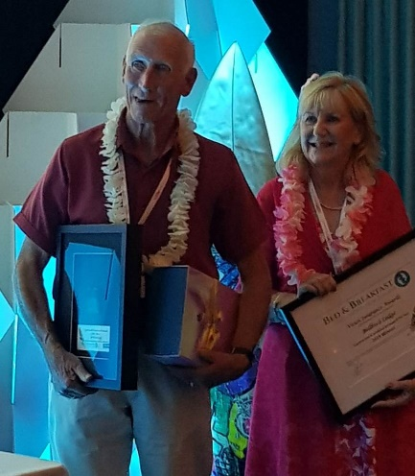
Other benefits include:
- Excellence Awards – we love to share the success stories of our members and this is the perfect showcase for members to shine and promote their businesses. There are three categories – Exceptional B&B Business of the Year (for those who have been operating longer than two years); Rising Star B&B of the Year (for those who have been operating for less than two years) and Essence of B&B (focusing on those who showcase what hosted accommodation is all about).
- Our National Conference (including our AGM) provides opportunities for you to extend your knowledge, share information and meet other B&B operators.
- ITO Trade Show – (for assessed members only) this event is usually held in conjunction with our National Conference each year and allows those members who wish to work with Travel agents (Inbound Tour Operators) to attend a separate trade show where they can make contact with a number of Inbound Tour Operators from around the country.
- Access to our Sponsors and Business Partners who provide specialist products for B&B operators.
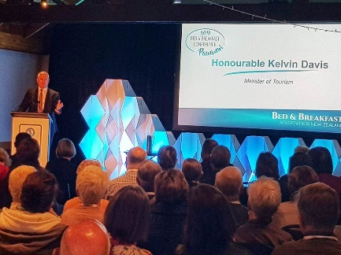
Our members also receive member only discounts through:
- our Bed & Breakfast Association Members Discount Card – which offers discounts at 20 different retailers.
- Fisher & Paykel – Member only discounts on all Fisher & Paykel products.
- Mobil Discount Card - offering up to 9c a litre off the pump price.
- Tourism Industry Association – www.tianz.org.nz. As a full member of the BBANZ, you have the opportunity to join the Tourism Industry Aotearoa New Zealand (TIA) as an Affiliate Member for just $178.25 (incl. GST) and enjoy the many privileges this offers.

And if you’d like, you also get to have a say in how our Association operates, what we provide you and how we advocate for you. We are operated by our members for our members.

We are looking forward to working with you!

