**Arts Access Aotearoa letterhead logo:
Arts Access Aotearoa Putanga Toi ki Aotearoa
T: +64 4 802 4349
E: info@artsaccess.org.nz
Toi Pōneke Arts Centre, Level 3, 61-63 Abel Smith Street
PO Box 9828, Wellington 6141
www.artsaccess.org.nz**

**Request for Expressions of Interest to be a Trustee of Arts Access Aotearoa**

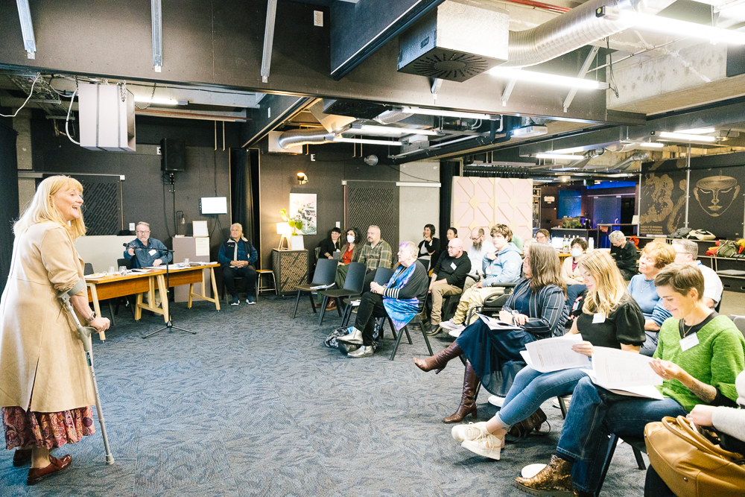

Arts Access Aotearoa’s Trustees and guests at the May 2024 AGM

Arts Access Aotearoa |<<Document Reference / Report Name>>

Arts Access Aotearoa |<<Document Reference / Report Name>>

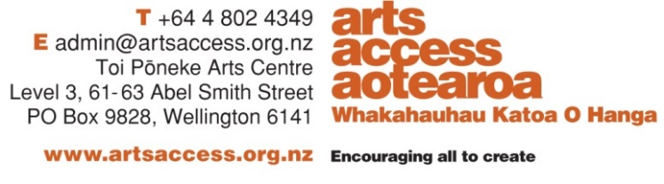**CONTENTS**

Request for Expressions of Interest 3

Arts Access Aotearoa: Our Kaupapa 3

The Board of Trustees 3

The Function of the Board of Trustees 4

Current Vacancy 5

To apply: 5

Arts Access Aotearoa Annual Report 2023 5

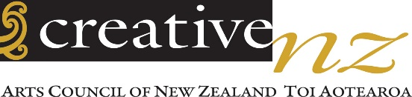

Arts Access Aotearoa receives its core funding from

# Request for Expressions of Interest

**Arts Access Aotearoa | Putanga Toi ki Aotearoa invites expressions of interest from individuals with experience in Accounting, Financial Management or Strategic Finance to join our Board of Trustees.**

**Organisation name:** Arts Access Aotearoa | Putanga Toi ki Aotearoa

**Organisation website:** www.artsaccess.org.nz

Organisation type: Charitable Trust

Industry Sector: Community/Social assistance. Not for profit

Position type: Trustee

# Our Kaupapa

Established as a charitable trust in 1995, Arts Access Aotearoa’s vision is that people in Aotearoa can access and participate in the arts. We believe in the right of every individual to creative expression and fulfilment. Our purpose is to work in partnership to increase access to the arts for people facing barriers to participation.

We are committed to the principles of Te Tiriti o Waitangi and actively work to uphold its values of partnership, participation, and protection in everything we do.

# Our work includes:

* Supporting and championing organisations and projects that enable people to access the arts, regardless of their circumstances.
* Advising arts organisations on enhancing accessibility for Deaf and disabled people, both as artists and as audiences.
* Creating employment opportunities in the arts sector for artists who face barriers to practicing their craft.
* Additionally, Arts Access Aotearoa:
* Facilitates and strengthens networks, relationships, and collaboration among arts organisations across the country.
* Works with a nationwide network of creative spaces to build their long-term capability and expertise.
* Partners with arts and cultural organisations, artists, producers, festivals, and venues to help them improve accessibility for Deaf and disabled people, and for those with lived experience of mental distress.

# Our core funder is Creative New Zealand, and we receive significant support from Foundation North, Auckland Council, and Wellington City Council. We also hold contracts with the Department of Corrections and the Ministry for Culture and Heritage.

# The Board of Trustees

Our Board is made up of 5–8 trustees, each serving a three-year term, with the possibility of renewal for another three years. Trustees volunteer their time, and travel and related expenses are reimbursed.

We meet five times a year on Saturdays, either in Wellington or virtually. Our Annual General Meeting is held in May.

## The Function of the Board of Trustees

We govern the activities and responsibilities of Arts Access Aotearoa. We work directly with the Executive Director to ensure that we are a cohesive unit.

As a Board, we provide effective leadership and governance by:

* Championing the organisation’s values, vision, mission, and purpose
* Defining and confirming strategic direction and priorities.
* Upholding the principles of Te Tiriti o Waitangi and the New Zealand Disability Strategy 2016–2026, and ensuring their influence on our operations.
* Fostering partnerships and maintaining open, transparent communication with external stakeholders.
* Supporting the Executive Director, ensuring they are positioned for success through clear performance indicators.
* Approving annual business plans and monitoring their implementation, alongside the organisation’s financial performance.
* Ensuring all legal and compliance obligations are met.
* Implementing efficient systems and procedures that support the organisation’s smooth and compliant operation.
* Overseeing risk management, including the evaluation and mitigation of potential risks.
* Adopting best practice governance methods, ensuring agility in responding to change.
* Assisting with fundraising activities where appropriate.

As individuals, we are all expected to:

* Demonstrate a strong commitment to the goals of Arts Access Aotearoa.
* Uphold the principles of Te Tiriti o Waitangi and the New Zealand Disability Strategy.
* Always act in the best interests of the organisation and share accountability for Board decisions.
* Be informed on key issues, exercising sound judgment in decision-making.
* Respect different viewpoints and actively engage in open and constructive discussions.
* Commit the necessary time to attend and participate fully in meetings.

We are dedicated to ensuring that our Board reflects the voices of the communities we serve, including young people (rangatahi) of Aotearoa.

We cultivate an inclusive, respectful, and collaborative environment within our Board. We approach meetings well-prepared, having reviewed all materials, and engage in constructive, open kōrero. We value diverse perspectives and actively listen to one another’s viewpoints. While we strive for consensus in our decision-making, we recognize that unanimity isn't always possible. In such cases, we remain unified in supporting the collective decisions of the Board.

## Current Vacancy

We are seeking a new Board member with experience in Accounting and Financial Management or Strategic Finance. Governance experience is helpful but not required. Applicants must live in New Zealand and can be based anywhere in the country.

**Time Commitment:** 5 meetings annually (approx. 3–4 hours on Saturday mornings). Trustees may also join sub-committees and attend Arts Access Aotearoa events when possible.

**Remuneration**: This is a voluntary role. Travel and accommodation costs for meetings are covered, and any other related expenses will be reimbursed.

## To apply:

To express interest, please send a cover letter and your CV to [info@artsaccess.org.nz](mailto:info@artsaccess.org.nz) (Attention: Chair of Arts Access Aotearoa) by 5pm, Monday 24 February 2025. In your cover letter, please highlight how your skills and values align with our mission and kaupapa.

Victoria Crockford

Board Chair

Arts Access Aotearoa|Putanga Toi ki Aotearoa

Wellington / September 2024

## Arts Access Aotearoa Annual Report 2023

For more information about our work, view our latest, here:

<https://artsaccess.org.nz/Arts-Access-Aotearoa-in-2023>