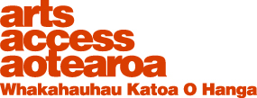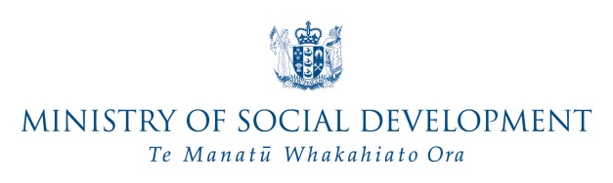

You are invited to a weekend workshop to explore the theme
“Working with digital media and video to
advocate for increased access to arts and culture”

What: Arts Access Advocates Workshop
When: Saturday 28 and Sunday 29^{h} November
Where: CQ Hotels Wellington, 223 Cuba St
Free to join. Enjoy guest speakers and discussions and be with others from around New Zealand to increase access and inclusion in the arts for people with lived experience of disability. Travel, accommodation for up to two nights, meals and taxi transfers will be paid for people living outside of Wellington.

- Explore and increase your advocacy skills and digital media tools available to you

- Meet up with like-minded people

- Build your social media skills

- Learn video editing for smart phone

- Discuss how disabled people can improve their on line and social media presence
The goal of the workshop is to create a national network of partners: friends and contacts who will help build a more accessible arts environment in New Zealand led and inspired by people with disability – like you.
By attending you will build personal connections with counterparts with lived experience of disability who are interested in accessible arts and culture. They will be interested to learn about and use digital technology, web sites, social media, blog sites, photo sharing and video as tools for advocacy.

The workshop will be a relaxed informal experience in which participants will share what they know with each other and learn more about
- how to use social media and other free digital tools ( improve your skills and knowledge )

- a new web site that will be available for a growing a community of people interested in arts accessibility and inclusion to promote their blogs, photos, videos, projects and ideas

- connecting with others to increase access to arts and culture for people with a disability

- the role of video making in telling our own stories and advocacy for accessible arts and how to be involved

- examples of where the arts are increasingly more accessible and inclusive of disabled people and how to be involved locally and connected nationally

If you are interested in participating - you will have lived experience of disability and care about or be interested in making the arts more accessible for disabled people. You will be interested in or want to increase skills using social media, video and internet. You will need to use and bring your own smart phone or equivalent communication technology with you.
You will get to have discussions with like-minded people, enjoy presentations from social media and video experts perhaps even uncover or increase your ability as a blogger, writer, and photographer or Face Book broadcaster.
If you are interested in attending, fill out the attached form or text or telephone the workshop coordinator Prudence Walker. Prudence will answer questions and discuss your access needs. You may also have an idea for presenting your experience or knowledge at the workshop – your ideas and questions are welcome.
Please contact Prudence by noon Friday 20 November.
contact@prudencewalker.com
021 546 006
+64 21 546 006
www.prudencewalker.com
Skype: prugie15

