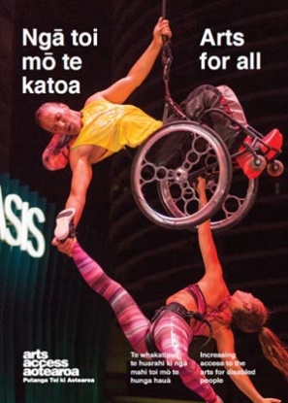
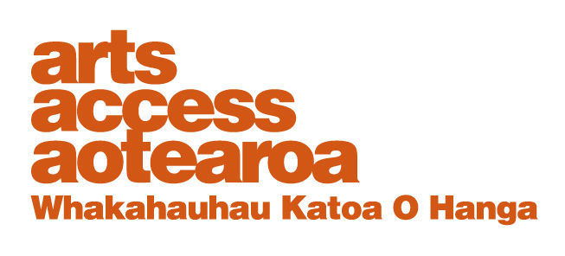
Q & A INSIGHT: ARTS FOR ALL
Exhibiting accessibility and inclusion

The exhibition Tirohia Mai, Look at Us Now marked 120 years of women’s suffrage in New Zealand and opened in the National Library of New Zealand in Wellington in June 2013.

Robyn Hunt joined a group of women advisors to bring the perspective of disabled women to the exhibition, and to help ensure its accessibility. Robyn, who is partially sighted and a leading communications accessibility consultant, writes about the process and challenges in ensuring an accessible exhibition.

1. Background: National Library of New Zealand

The National Library is the repository and guardian of this country’s information and knowledge. It collects and protects our documented taonga in words, sounds and pictures.

An extensive refurbishment was completed in late 2012 so it could be more accessible and available to New Zealanders, both physically and through its digital collection and communication.

The National Library has become more externally focused and more welcoming to visitors. Staff are keen to engage with the public through exhibitions and other programmes. It is physically accessible, and staff are on duty to welcome visitors and provide help. There’s free Wi-Fi, meeting and seating areas, catalogue access and a café.

2. The exhibition: achieving accessibility and inclusion

The exhibition was based in Wellington, with an outreach education-based programme in Auckland. Accessibility activities were all focused on Wellington.

It included:
- a static, largely text-based exhibition with still photographs and posters arranged as a timeline from the signing of the Treaty of Waitangi by 14 Maori women to the second wave of feminism in the 1970s and 1980s.
- a film loop supplied by the New Zealand Film Archive, which included silent footage and film with sound
- an interactive element, available via an iPad at the exhibition or online, using sound and photographs to tell women's personal stories
- seating at various locations, including a seating area with a low table and books, magazines and reports identified by women as meaningful on their life journey as women
- a blank wall with post-it notes for visitors to post their comments
- several plinths with photographs of women and their activities, plus a "Gentle Annie" washing machine representing women’s domestic role
- a multi-sensory art installation called Passage, with strings of mostly clear beads through which visitors could move
- a short film, Night Shift, and a photographic exhibition in other parts of the building.
Four objectives

The accessibility activity concentrated on the main exhibition space. We had four objectives. We wanted:
- the exhibition itself to be accessible, both the space and the content
- to include the stories of disabled women in the timeline and the interactive display to make our history and world view visible
- to include the perspectives of disabled women in the programme of panel discussions to run alongside the exhibition
- to encourage disabled women to attend the exhibition.

When we talked about the exhibition we noted that there had been little inclusion of disabled women's stories in the general histories about women, particularly at the hundredth anniversary of women's suffrage. At that time, our presence and contribution was invisible in mainstream women’s activities. We wanted to see our own stories alongside those of other women in a welcoming and inclusive environment.

For the same reasons, it was also important that our voices were heard in the panel discussions.

3. What we did to achieve accessibility and inclusion

Even though the building itself and the exhibition space is physically accessible, we made a couple of tweaks to improve access. The double glass doors to the exhibition space were hard to see so they were decorated with white camellia and kawakawa leaves to make them more visible but in a way that contributed to the exhibition.

However, the doors still presented a barrier for wheelchair users and people with mobility impairments. We also made sure the text displays were large, clear, had strong contrast and were well-lit. The level of ambient lighting was also raised.

The text on the digital display was reasonably large and clear, with good contrast, and did not change quickly. The same information was available on the website. Women could add their stories on an iPad on the wall by the display or online via the website, or email it to a staff member who would post it for them. National Library staff were often available at the exhibition as well.

Entering the exhibition, visitors could read the introduction in te reo Maori, New Zealand Sign Language and English.

We researched disabled women's history and added elements in the timeline, including some census data. I was able to contribute printed material, including reports and an article from my own records. There were also a few photographs.

Disabled women visited individually and we encouraged them to do so. We also organised an audio described tour of Tirohia Mai for a group of vision impaired women.

4. Challenges and how we overcome them

Most of the challenges related to time and budget. Lack of time for everyone meant there was a limit to what we could achieve. But with leadership from the curator and staff willingness to go the extra mile, we managed a significant amount, especially as an accessible exhibition was a first for the library.

Lack of time meant that I missed discovering there would be one item in a display case, and that the case was the wrong height to be accessible for a visitor in a wheelchair.

In future, I would ask more questions about exhibition content and display.

Finding material was also challenging because of the invisibility of the documented lives of disabled women. However, the content we did have was noticed and commented on by many people who attended, not just disabled people.

It was also a challenge to encourage disabled women to contribute to the interactive section of the exhibition but in the end, our contribution was fairly similar to other distinct groups of women. As with attendance, it’s a matter of developing an audience that has often felt excluded in the past and isn’t used to attending and participating.

There was a steep learning curve for National Library staff, who were mostly inexperienced in accessibility and audio description. But they were very willing to learn and make creative suggestions.

No one at the National Library had led an audio tour but several of us took the touch and audio described tour with Bruce Roberts at Te Papa, which gave us lots of good ideas.

The National Library didn’t have a database of people likely to be interested in attending all the panel discussions. So everyone involved in the project contributed names. We also used social media. All the panels had an excellent attendance and high levels of participation from enthusiastic audiences, including disabled people and their supporters.

5. What worked well?

The exhibition raised the level of debate within the disability community, in particular, but also within the National Library, about collecting and preserving disability history. It was also successful from the perspective of library staff who were able to see possibilities and were generally responsive to access issues.

The audio described tour was great because the people leading the tour had some understanding of vision impairment and blindness, and had worked hard to acquire more knowledge. Visitors were also able to take home some of the disability material that interested them and scan it.

The introduction to the exhibition in our three national languages was a great success. National Library staff were delighted with how well this worked and from now on, all exhibitions in the National Library will be introduced this way.

The beautiful bead Passage installation by Cathryn Monro provided a delightfully accessible, multi-sensory experience all visitors could enjoy.

6. What we do differently?

I would use some of the international standard guidance for things like the height of display cabinets. I’d also allow more time to research and prepare if at all possible. I would also try to have some more variety in the type of exhibits to encourage more interaction from disabled people.
- A positive attitude, an open mind to new ideas and a willingness to learn is a great starting point.
- Explore opportunities for individually tailored tours: e.g. audio described and Sign Language tours.
- Ensure your tours are well-prepared, and based on knowledge and understanding.
- Networking with partners in the disability community is critical.
- Work with a disabled person or people with relevant expertise.

For more information
Arts For All is an Arts Access Aotearoa/Creative New Zealand partnership programme. It aims to encourage arts organisations, venues and producers to improve access to Deaf and disabled audiences. Download the guide at artsaccess.org.nz or call 04 802 4349 for more information.

