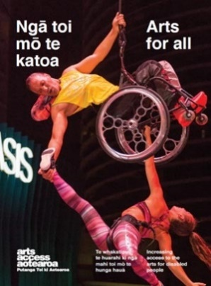
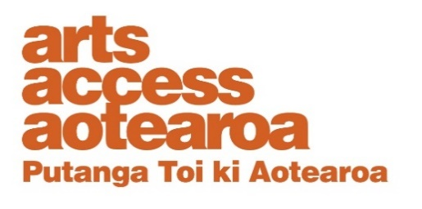
Q & A INSIGHT: ARTS FOR ALL
Gallery opens doors to its art for students
Hastings City Art Gallery offers free education programmes for students of all levels and learning abilities. Its Gallery Educator, Kelsey Hankins, talks to Arts Access Aotearoa about the processes and challenges of developing a programme for students at Kōwhai Specialist School in Hastings.
1. Background: about the education programmes at Hastings City Art Gallery
Hastings City Art Gallery offers free education programmes to suit students of all levels and learning abilities. Its programmes and art-making workshops encourage students to explore their personal responses to contemporary art and deepen their understanding of it.
In my role as Gallery Educator, I develop and lead all the education programmes, adapting them to complement every exhibition. The programmes are flexible, and can be tailored to suit individual classes and students of all learning abilities.
All of the programmes are developed in line with the New Zealand National Curriculum, and are supported by the Ministry of Education’s LEOTC (Learning Experiences Outside The Classroom) programme.
I have a Master of Museum and Heritage Practice. I started working at Hastings City Art Gallery in 2019 and in 2021, ran a pilot work experience project with a group of students from Kōwhai Specialist School.
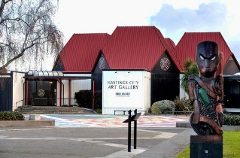
I represent Hastings City Art Gallery as a member of the Arts For All Hawke’s Bay Network, one of six regional networks facilitated by Arts Access Aotearoa aimed at improving access and inclusion.

2. Tell us about the Kōwhai Specialist School programme.
In 2021, we ran a pilot work experience programme with a group of four awesome tertiary education course students (aged 18 to 21) from Kōwhai Specialist School. The students’ main focus was choosing their favourite artwork in our te MOKO on our face / in your face exhibition, and thinking about three things they liked about the artwork. They then had to present their favourite pieces to classes from Kōwhai School, and also friends from other local schools.
Over the ten weeks, students visited the gallery once or twice a week. They worked on developing personal responses to artworks, and were involved in decision-making, public speaking, te reo Māori pronunciation/engagement, and becoming comfortable in the gallery space.
The students were nervous to speak about their works but they all did a phenomenal job. Each of them brought a different perspective and at the end of each session, they left the gallery feeling proud of themselves.
3. Outline the key steps you took to develop and implement the programme.
When I was doing an internship at the gallery a few years ago, I started developing “social stories” (using straightforward text and images to provide information). I consulted Kōwhai Specialist School, which is just around the corner from the gallery, and that’s when our relationship started. When I was employed at the gallery a few years later, I picked this relationship back up and that’s when the idea for the programme started.
- First up, I consulted with gallery staff. They were very supportive of what I wanted to do but I was careful to take people with me, including the gallery technicians and front of house team.
- The most important part of developing and implementing this programme was creating a strong relationship with the school from the outset. I attended all-staff meetings, visited the school, and met classes and teachers early in the picture to better understand how the gallery could support the school and the students’ learning.
- Finding a contact person (or people) at the school is vital. Deputy Principals Angie Dent and Amy Shoebridge became my primary contact teachers. We had regular meetings discussing possible programmes, and it was through these meetings that we realised the need to run a work experience programme.
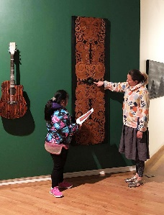
- Collaboration is also important and I worked alongside Angie and Amy throughout the entire programme. I got regular feedback on lesson plans and visit structures to ensure the programme was meeting learning goals and was suitable for the students. There isn’t much research available about gallery work experience programmes for students with different/additional learning needs so having open discussions with teachers and talking to disability organisations was extremely helpful.
- I gave as much information as possible in advance of the sessions for both staff and students. So, for example, I put together laminated information sheets about each session and talked to the students in advance so they knew what to expect. Teachers were then able to reinforce what I had told the students back in the classroom. This meant they became more comfortable coming into the gallery space and knew what to expect each session.
- In between the response sessions (where students responded to an artwork) and the delivery/student presentation sessions, I prepared an information sheet for each student with and image of their selected artwork, its name and the name of the artist, and the things they had said they liked about it. This provided a reference point for them to practise their presentations.
- We had four practice sessions of their presentations so they could feel comfortable doing it in front of their peers, teachers and any family.
- I made an invitation to the gallery presentations, which the school principal sent out and managed the bookings.
- When it was all over, I made certificates for each of the students and presented them at the school.
4. What were the key challenges and how did you overcome them?
The main challenge for me was not knowing the students going into the project. Each student was completely different and I found it tricky to gauge how they were finding the programme – whether they were nervous about anything, whether they were enjoying it, and so on.
I overcame this challenge by checking in with teachers regularly and also having an open, thorough debrief at the end of the programme.
Another challenge was getting useful feedback directly from the students. It’s something I’m working on for next year’s programme.

5. How did you evaluate the impact of the programme?
I debriefed with my contact teachers, Angie Dent and Amy Shoebridge, at the end of the programme. I brought a series of questions to the meeting: for example, how did you find the work experience overall? How do you think the students responded to the programme?
The conversation flowed naturally, and I received some great feedback and insight from the teachers, particularly about student progress. This included feedback that showed students had gained increased confidence in communication and social interaction skills; increased ability to transfer skills and knowledge into a new environment and context; and improvement of and engagement with te reo Māori.
They had also overcome anxiousness of public speaking; and displayed improvement in audibility, clarity of speech, confidence etc. Feedback also revealed the programme overall had enhanced the students’ mana and self-esteem.
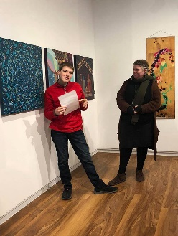
Had we not debriefed so thoroughly, I would never have gathered so many rich insights.
We also discussed running the programme again, which the teachers were very positive about.

6. Is there anything you would do differently if you offer the programme again?
Next time, we’ll run the programme very similarly to this year but focus on a totally different type of exhibition – an interactive show. Instead of students choosing their favourite artwork, they will be responsible for talking about different aspects of the show, including interactive stations, accompanying artwork, decorative floor vinyl, and so on.
We’re also hoping to get a student who participated in the programme this year to come on board next year and act as a student mentor.
Once we have run the programme a second time, I will have a stronger idea of how it works in practice, and will look at offering the programme to more local schools and organisations in the region.
7. Kelsey’s five tips for anyone developing programmes for students with a learning disability.
- Research: Begin by undertaking some general research about working with students with additional needs, especially if you haven’t worked with these groups before. Special schools have students with an extremely varied range of conditions and impairments – from physical disabilities to sensory-processing conditions. It’s a helpful starting point and can provide insight on possible barriers to accessibility as well as mannerisms, habits and potential stressors.
- Relationship building: Developing strong relationships with your target school or organisation is key. Begin by finding a contact person (or people) and set up times to meet with them regularly. Regular meetings ensure the programme you are creating meets the needs of the students and also provides opportunity for feedback and discussion. I also suggest having a tour around the school, meeting teachers and students, attending staff meetings etc.
- Open dialogue: Having open dialogue with teachers from the outset and throughout is paramount. Getting feedback on your lesson plans, programme structure and ideas ensures your programme will work in practice and helps you understand how to best (and most effectively) engage with students.
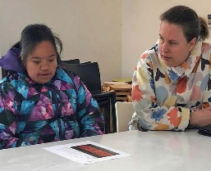
- Planning: Plan your programme carefully and make sure it is stretched out over a longer period of time. This allows time for the students to become more comfortable with your space. Every group will be different but I suggest starting the programme by meeting students in a familiar environment (in class, for example) and going from there.
- Preparation time for students: Give the students as much of an opportunity to prepare as possible, particularly if your programme has a performance/delivery aspect. The more practice the students have, the more confident and comfortable they’ll be with the task and final presentation.
For more information
Kelsey Hankins
Schools LEOTC Educator
Hastings City Art Gallery
T: 06 871 5095 / 027 332 5496
E: kelseyh@hdc.govt.nz
W: hastingscityartgallery.co.nz
Arts For All is an Arts Access Aotearoa/Creative New Zealand partnership programme. It aims to encourage arts organisations, venues and producers to improve access to Deaf and disabled audiences. Download the guide at artsaccess.org.nz or call 04 802 4349 for more information.

