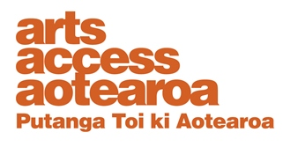  ARTS FOR ALL: CHECKLIST  Marketing to the disabled community  This checklist provides suggestions on ways to provide and promote your material to people in the disabled community. Use this in conjunction with the Print and publications guidelines.  Have you included general access information in/on: Yes No Comments  Media releases, newsletters and e-newsletters?  Season brochures and programmes?  Advertising and social media?  Websites?  Calendar of events?  Any other publicity material (e.g. posters, flyers, text messages)?  Have you included information details about: Yes No Comments  Wheelchair access, accessible parking and public transport?  Hearing augmentation systems?  Times and availability of service (e.g. box office hours; if patrons need to collect audio receivers 20 minutes before the show)?  Costs and booking requirements of services (e.g. deposit for an audio receiver or use of wheelchair)?  Contact detail options (phone, office address, email, mobile phone number) for people who require more information?  whether relevant staff know how to use the relay service?  Presentation of information Yes No Comments  Are international access symbols included?  Is there a specific access guide for disabled people, in addition to general publicity material?  Have clear print guidelines in your presentation of material been met?  Have web accessibility standards been met?  Is appropriate language in the description of your services and in reference to disabled people used?  Are positive images of disabled people as part of usual representation of audiences included (e.g. in newsletters or brochures)?  Is clear information provided about any barriers to access that may exist? |  | 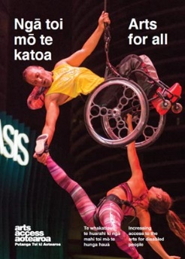  Arts For All is an Arts Access Aotearoa-Creative New Zealand partnership programme. The aim of this programme is to encourage arts organisations, venues and producers to improve their access to Deaf and disabled audiences. Download the guide at artsaccess.org.nz or call 04 802 4349 for more information.

Alternative formats
Have you provided information in the following alternative formats? | Yes | No | Comments
Large print

CD or podcast download
Braille
Plain English, accessible Word document that can be emailed as an attachment
An accessible website
Print version of any audio material
Captioning of audio-visual material

Communications with the disability community
Media | Yes | No | Comments
Have you included disability media in media and marketing plan?
Have you included access information in all material sent to general media?
Disability organisations | Yes | No | Comments
Do you have a contact list of disability organisations in your community?
Have you identified and established relationships with disability organisations in your community, especially Disabled People’s Organisations, which represent their views?
Have you communicated with disability organisations representing any specifically targeted group (e.g. local Deaf clubs to promote an NZSL tour at your gallery)?
Have you identified programmes or services that would benefit from collaboration with the disabled community?
Have you ensured that disabled people are invited to and included in: | Yes | No | Comments
All public meetings and events?
Advisory groups?
Market research?
Formal and informal consultations?
Any audience/community consultative processes?
Research | Yes | No | Comments
Have you undertaken research to help you identify the access requirements of disabled people?
Have you provided opportunities for disabled people to give feedback?
Contact Arts Access Aotearoa
T: 04 802 4349
E: info@artsaccess.org.nz
W: www.artsaccess.org.nz

Disclaimer:
The material in this checklist is intended as a general guide only and should not be relied on as a substitute for technical, legal or other professional advice. While care has been taken in the preparation of this material, the writers and publisher do not accept responsibility for any errors or omissions, or for the result of any actions taken on the basis of this information.

