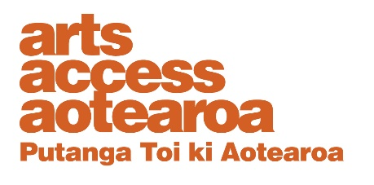

Te Putanga Toi Arts Access Awards 2021:

Arts Access Holdsworth Creative Space Award 2021

1. Things to know before you start
About the Creative New Zealand Arts For All Award
This award celebrates the outstanding contribution and impact of a creative space that provides opportunities for people with limited access to make art across any or all artforms.
Arts Access Aotearoa refers to creative spaces as organisations or places where people who experience barriers to participation can make art or participate in artistic activities. They provide space, resources and assistance in ways that lead to creative self-expression, empowerment and self-development.

The recipient of this award receives $3000.

Arts Access Aotearoa will provide travel and one night’s accommodation for one representative to attend the awards ceremony.

2. Eligibility criteria
To be eligible, the nominee must:
- be a not-for-profit organisation

- support/provide opportunities for people with limited access to make art across any or all artforms

- not be a previous recipient of the Arts Access Creative Space Award in the previous three years*

*Previous recipients are eligible for nomination after three years have lapsed: e.g. the 2017 recipient is eligible for nomination in 2021 if it has introduced a series of new initiatives or programmes not recognised in its previous award.

If you need any clarification or wish to discuss your nomination, please contact Kate Hiatt, Creative Spaces Advisor (T: 04 802 4349 E: kate.hiatt@artsaccess.org.nz) or Gary Silipa, Auckland Community Arts Engagement Advisor (T: 021 799 352 E: gary.silipa@artsaccess.org.nz).

3. Nomination details
Nominations close: 5pm Friday 26 March 2021
Self-nomination is accepted. Organisations may submit only one nomination in this category. Arts Access Aotearoa staff will shortlist the nominations. An industry judging panel will make the final decisions.

Late or incomplete nominations will not be accepted. We will confirm we have received your nomination and that it meets the award criteria within one week of receiving it.

Complete the nomination form below and email it to stace.robertson@artsaccess.org.nz or post it to Arts Access Aotearoa, PO Box 9828, Wellington, 6141, New Zealand.
If your nominee is shortlisted
If your nominees is shortlisted you will be asked to provide the following supporting information for the judging panel:
- two support letters
- two items of support material (e.g. video, publicity material, images)
- evidence of the creative space’s impact (e.g. artists’ feedback, statistics).

Nomination form

Arts Access Holdsworth Creative Space Award 2021

Please enter the name of the nominated creative space below

Contact details:

Please ensure your nominee knows they are being nominated.

Nominee (the creative space being nominated)

Creative space:

Contact person from the creative space:

Physical address:

Postal address:

Phone/mobile: Email:
Website:
Your details (the person making the nomination)

Name:

Job title/organisation:

Phone/mobile: Email:

What the judges want to know

Please answer the following question. Use the word length as a guide and use bullet points where suitable. Below are some bullet points to guide your answer.

1. Why do you think your nominee should receive this award?
(Between 300–400 words)

Write your answer below.

Think about:

- what makes their work outstanding
- what they have achieved
- the impact of their work on the artists who attend
- their relevance and value to the community

Nomination checklist

Before submitting your nomination, please type an X in the boxes below to ensure all information is supplied correctly.

The nominee meets the eligibility criteria, listed in this

document.
The nominee knows they are being nominated.

Every section of this nomination form is completed.

You agree to supply the required support material if your nominee is shortlisted.

