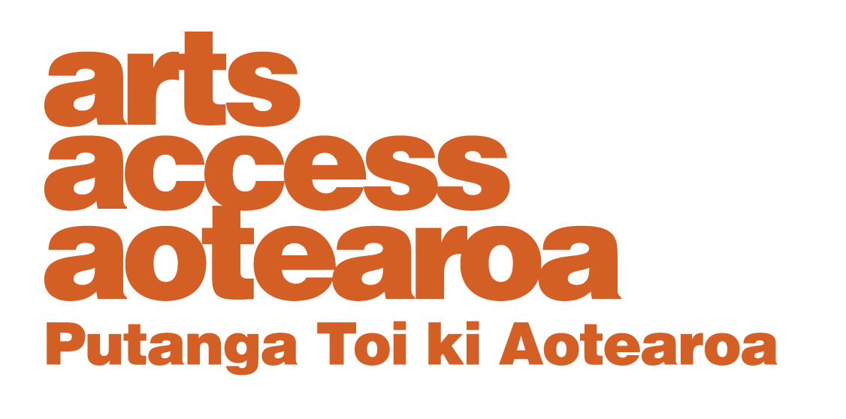

Te Putanga Toi Arts Access Awards 2021:

Arts Access Creative New Zealand Arts For All Award 2021

1. Things to know before you start
About the Arts Access Creative New Zealand Arts For All Award
This award recognises an individual or organisation that is an arts accessibility champion. This includes professional performing arts companies, festivals, literary events, venues, artists, producers, individuals and galleries that best demonstrate an ongoing commitment to increasing their accessibility and including artistic opportunities for Deaf and disabled people.

Please note: Museums will not be considered. However, we recommend making a nomination to the Arts Access Museums Award, presented annually at Museum Aotearoa’s New Zealand Museum Awards.

The recipient of this award receives $4000, to be used to continue developing its accessibility.

Arts Access Aotearoa will provide travel and one night’s accommodation for one representative to attend the awards ceremony.

2. Eligibility criteria
To be eligible, the nominee must:
- be an indiviual living in New Zealand or a New Zealand professional performing arts company, festival, literary event, venue, artist, producer or gallery

- be able to demonstrate commitment to increasing accessibility initiatives, including opportunities for Deaf and disabled people, between January 2020 and up to the nomination closing date of 26 March 2021

- not be a previous recipient of the Arts Access Creative New Zealand Arts For All Award in the previous three years*

*Recipients prior to (but not including) 2018 are eligible again if they have new accessibility initiatives not recognised in their previous award.

If you have any questions or would like to discuss your nomination, please contact Stace Robertson, Access, Inclusion and Participation Advisor (T: 04 802 4349 E: stace.robertson@artsaccess.org.nz).

3. Nomination details
Nominations close: 5pm Friday 26 March 2021
Self-nomination is accepted. Organisations may submit only one nomination in this category. Arts Access Aotearoa staff will shortlist the nominations. An industry judging panel will make the final decisions.

Late or incomplete nominations will not be accepted. We will confirm we have received your nomination and that it meets the award criteria within one week of receiving it.

Complete the nomination form below and email it to stace.robertson@artsaccess.org.nz or post it to Arts Access Aotearoa, PO Box 9828, Wellington, 6141, New Zealand.
If your nominee is shortlisted
If your nominee is shortlisted you will be asked to provide the following supporting information for the judging panel:
- two support letters, including one from the impacted community or communities
- two items of support material (e.g. video, publicity material, images)
- evaluation data, demonstrating increased accessibility.

Nomination form

Arts Access Creative New Zealand Arts For All Award 2021

Please enter the name of the nominated individual or organisation below

Contact details:

Please ensure your nominee knows they are being nominated.

Nominee (the individual/organisation being nominated)

Name/Organisation:

Contact person:
Physical address:
Postal address:

Phone/mobile: Email:

Website:
Your details (the person making the nomination)

Name:

Job title/organisation:

Phone/mobile: Email:

What the judges want to know

Please answer the following question. Use the word length as a guide and use bullet points where suitable. Below are some bullet points to guide your answer.

1. Why do you think your nominee should receive this award?
(Between 300–400 words)

Write your answer below.

Think about:

- what makes their accessibility work outstanding
- initiatives that have increased accessibility
- their consultation and engagement with Deaf and disabled communities
- examples of innovation and problem solving
- evidence of increased audiences and audience satisfaction (e.g. statistics, feedback)
- evidence of an accessibility policy and/or accessibility action plan (please attach with this nomination).

Nomination checklist

Before submitting your nomination, please type an X in the boxes below to ensure all information is supplied correctly.

The nominee meets the eligibility criteria, listed in this

document.
The nominee knows they are being nominated.

Every section of this nomination form is completed.

You agree to supply the required support material if your nominee is shortlisted.

