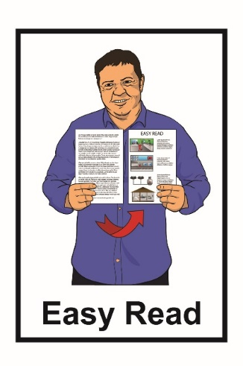
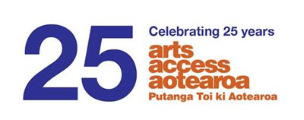

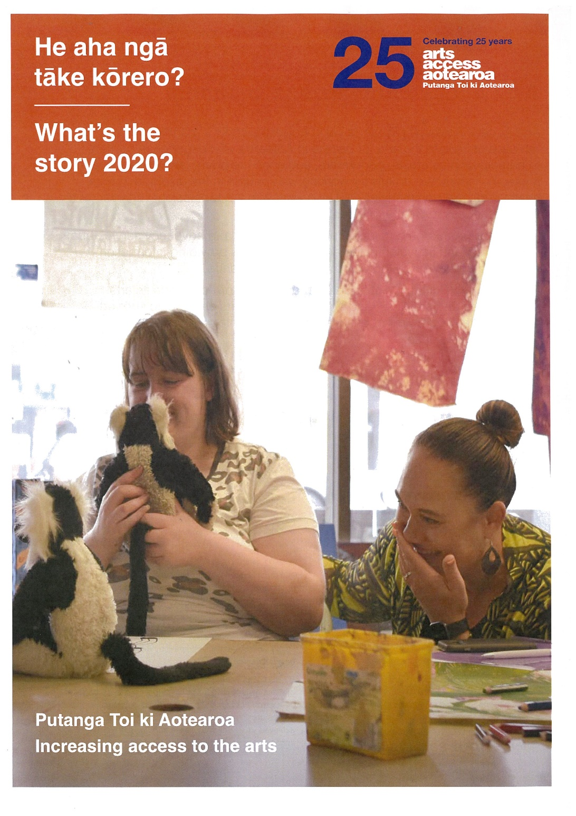

Annual Report 2020
About Arts Access Aotearoa

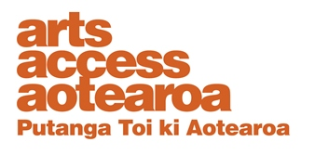
Arts Access Aotearoa works so everyone can enjoy the arts.
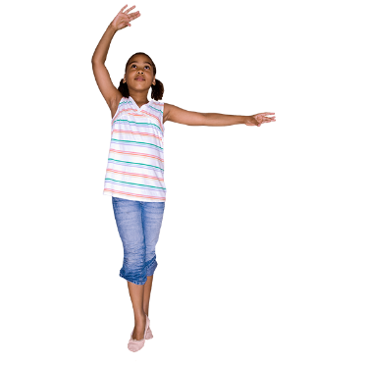

The arts means things like:
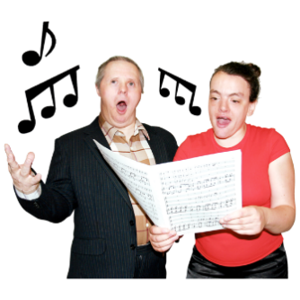
- dancing
- music / singing
- acting

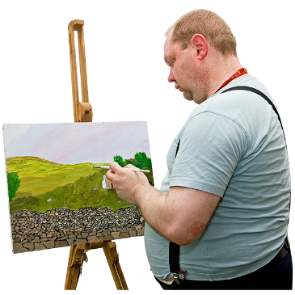
- things in museums / galleries

- paintings
- writing
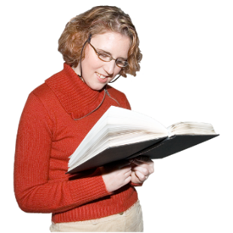
  - poems
  - stories

  - novels.
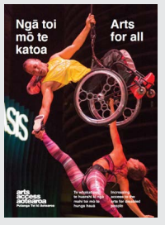
We work to increase access to the arts for people who face barriers to being a part of the arts.

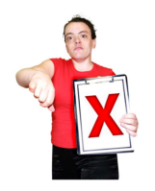
Barriers are things that stop or make it hard for people to take part or enjoy the arts.

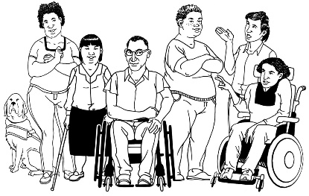
We do this by working with the:

- disabled community

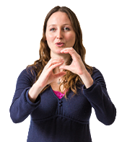
- autistic community

- mental health community

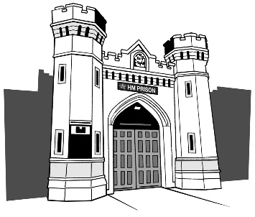
- Deaf community

- people in prison.

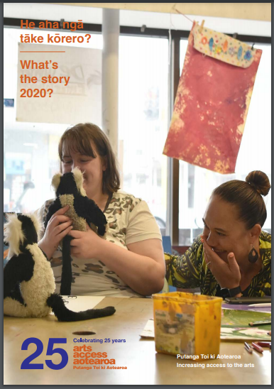
This is an Easy Read translation of some of the important things in our 2020 Annual Report.

An Annual Report is about:

- our goals

- our values

- the things that we have done in a year.

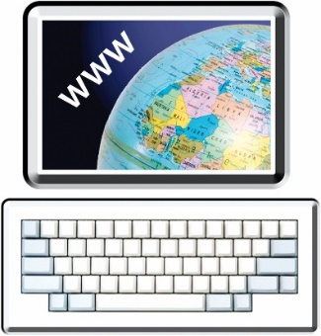
You can find the full Annual Report on our website at:

https://artsaccess.org.nz/
Our goals
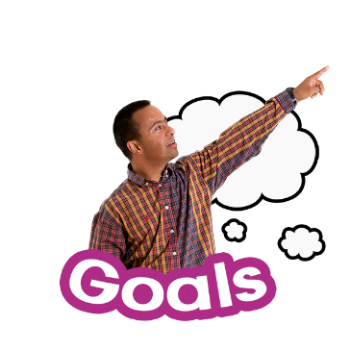

Goals are the things we want to make happen.

Arts Access Aotearoa has 3 goals of things that we want to make happen:

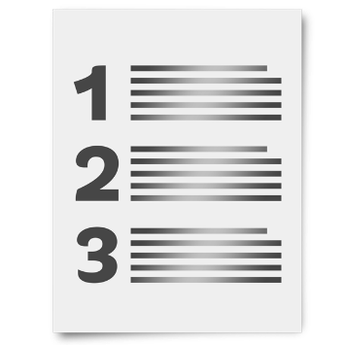
Goal 1: Access

Goal 2: Leadership

Goal 3: Influence.

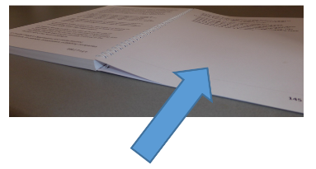
We talk more about each of these goals on the next page 5 to 7.

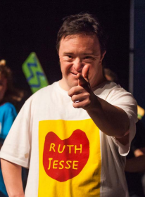
Goal 1: Access

Access is about working with others to make it easier for more people to enjoy the arts.

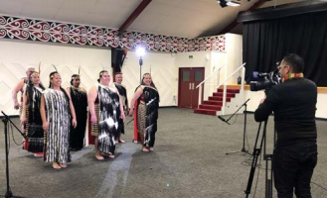
This includes:

- Māori
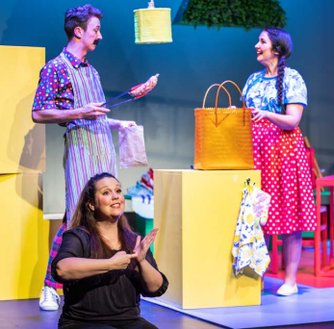
- Pasifika peoples
- disabled people

- young people

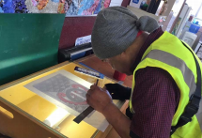
- Deaf people

- people in prison.

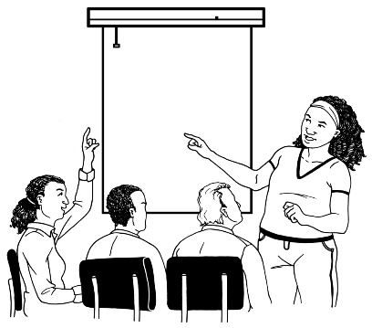
Goal 2: Leadership

We support people so they can become leaders in the arts.

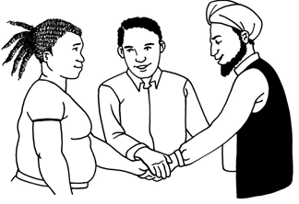
Leaders are people who bring people together to work on making
things happen.

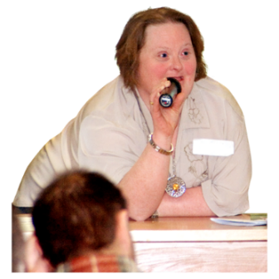
We want to support the people we work with to speak up.

Goal 3: Influence

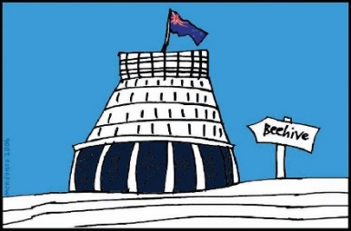
We work on getting more government support for everyone to enjoy the arts.
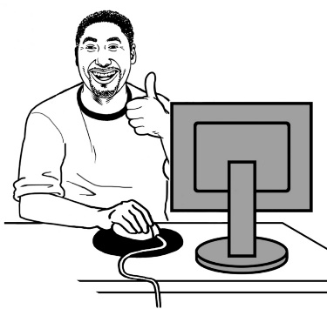

We provide lots of information that people can use to improve access to the arts.

Our values

Values are the things we believe in.

Our values are:
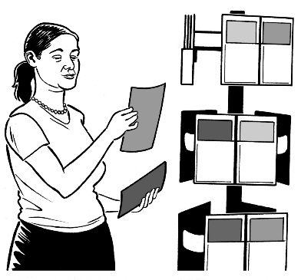
- Mōhiotanga which means looking for understanding
- Rangatiratanga which is respecting the mana of others
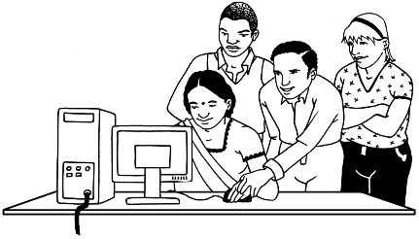
- Whanaungatanga which means we believe it is important to work together
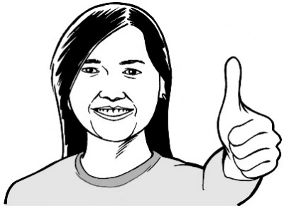
- Kotahitanga which is working well together to make the things we all believe in happen
- Kaitiakitanga which is doing things well for other people.

How COVID-19 changed things

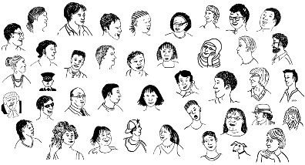
COVID-19 changed things for a lot of people in 2020.

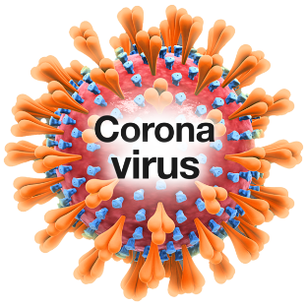
COVID-19 is a virus that can make people very sick.

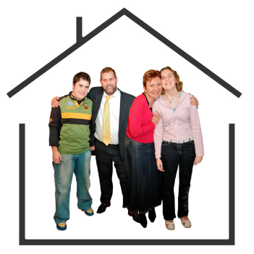
We did things like staying at home to make sure not many people in
New Zealand got COVID-19.

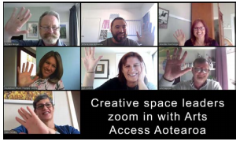
COVID-19 meant we held a lot of our meetings online.

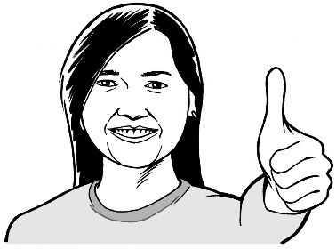
We are proud that people in the arts found ways to still make things happen.

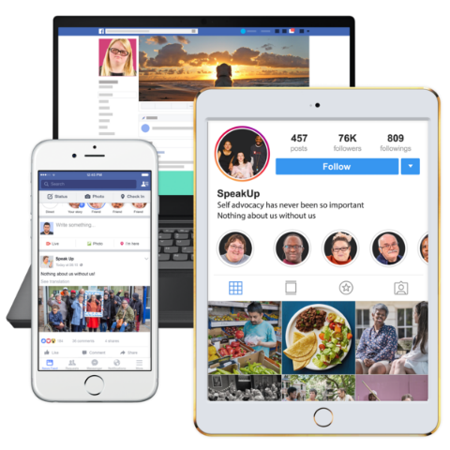
For example:
- people stayed in touch with their communities using the internet
- some performances were online.

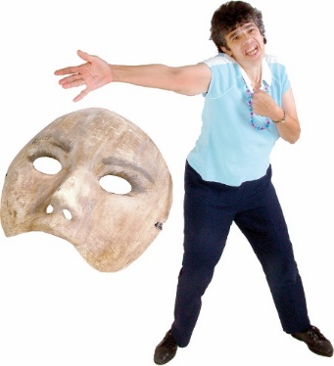
A performance is something people can watch like:
- a play
- singing

- dancing
- reading poems.

Te Putanga Toi Arts Access Awards

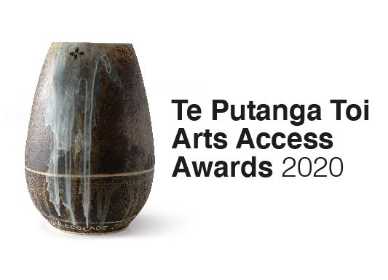
The Te Putanga Toi Arts Access Awards are given to people who have made it easier for everyone to be part of the arts.

In 2020 we gave out the awards online for the first time.

More than 1 thousand people watched the awards on the night.

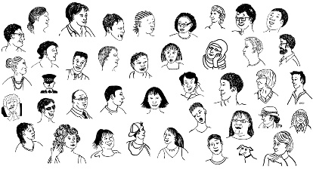
This is a lot more people who watched it in other years when we gave out the awards at parliament.

.

Performances everyone can enjoy

Performances can be hard for:
- people with learning disability
- autistic people.

Relaxed performances can be better because
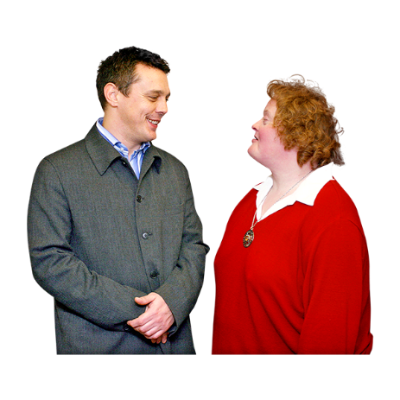
- the lights are not too bright
- it is okay to:
  - talk
  - move around.
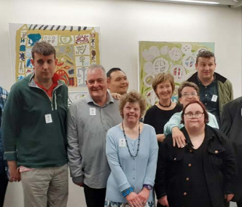

In 2020 there were 13 relaxed performances or events in New Zealand.
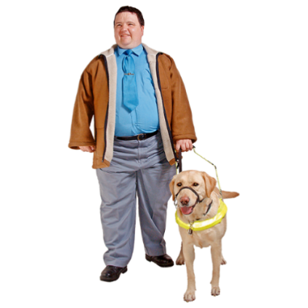
Audio description is a way for people who are blind or have low vision to enjoy performances.

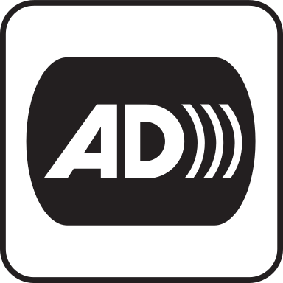
Audio description is when someone tells you what other people can see like:

- costumes

- dancing.

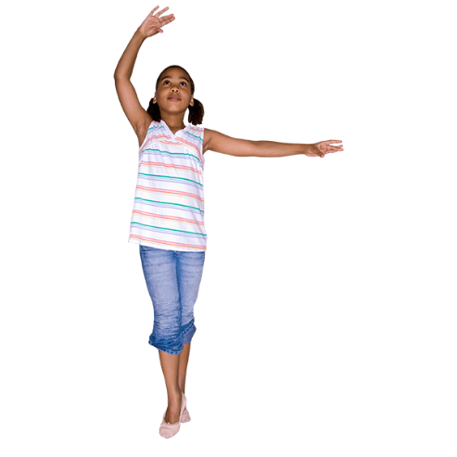
In April 2020 the Royal New Zealand Ballet said they would play videos of their ballet performances on the internet.

Ballet is a kind of dance.
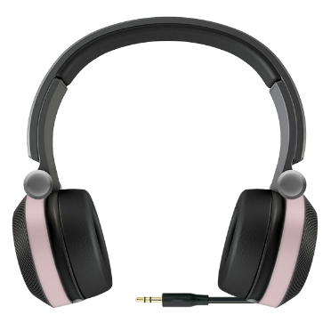

Audio Described Aotearoa worked with them to add audio description of the performances.
Our 25th birthday

2020 was our 25th birthday.

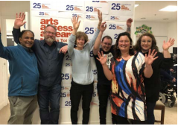
Lots of people wrote to us to say thank you for the work we do.

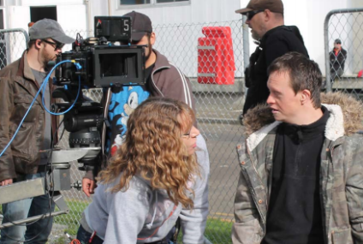
An artist called Duncan Armstrong said:

Arts Access Aotearoa is great because it supports the arts by people with disabilities.
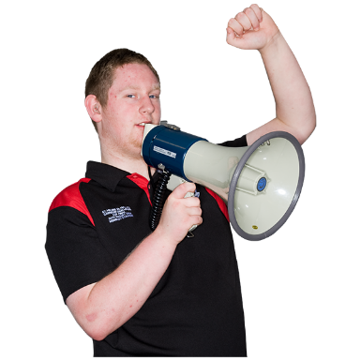

It helps give us a place to stand and be heard.

Creative spaces

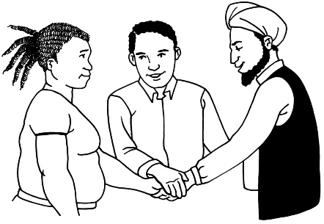
We worked with other organisations to make sure the government understood how important creative spaces are.

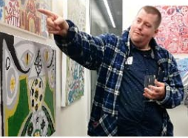
Creative spaces are places where people can go to do things like:
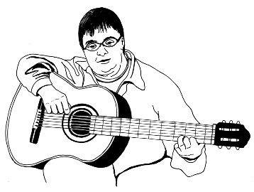
- paint
- dance
- make music.

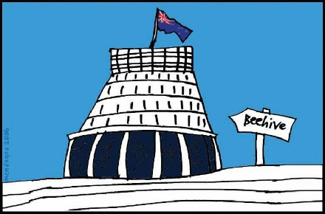
At the end of 2020 the government said it would set up an 18 million dollar fund to help creative spaces.

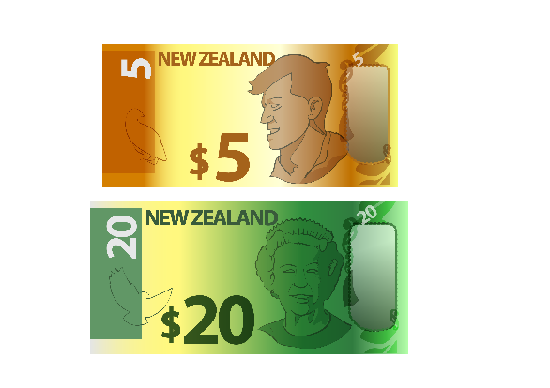
A fund is money that can be given to people or organisations to do specific things.

More information

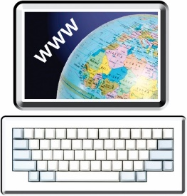
You can find out more about Arts Access Aotearoa on our website at:

www.artsaccess.org.nz.

You can also contact us:

- by email to:
info@artsaccess.org.nz

- by phone to:
04 802 4349

- by post to:
PO Box 9828
Wellington 6141.
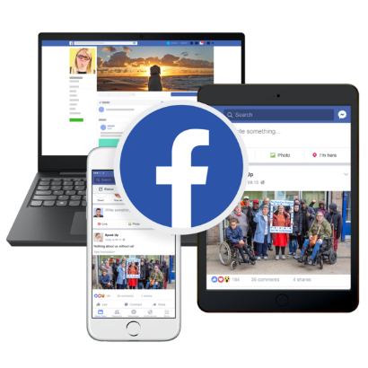
You can find out more about what we do on social media:

- Facebook
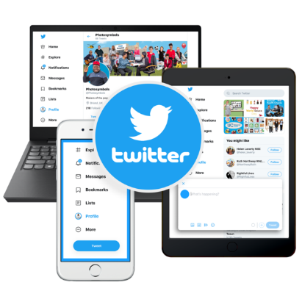
facebook.com/ArtsAccessAotearoa

- Twitter
twitter.com/ArtsAccessNZ
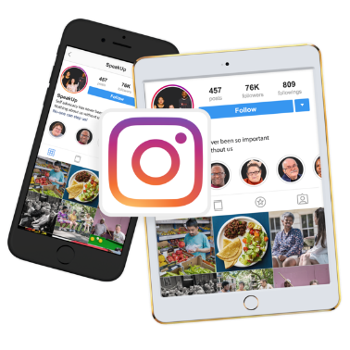
- Instagram
instagram.com/arts_access_aotearoa

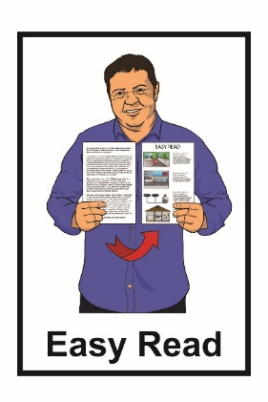
This information has been translated into Easy Read by the Make It Easy service of People First New Zealand Inc. Ngā Tāngata Tuatahi.
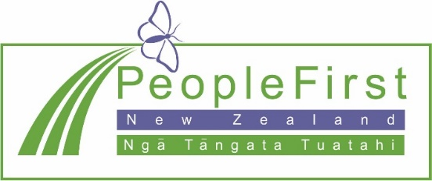
The ideas in this document are not the ideas of People First New Zealand Ngā Tāngata Tuatahi.
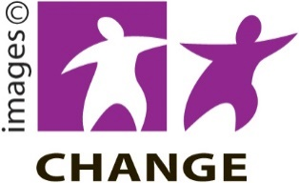
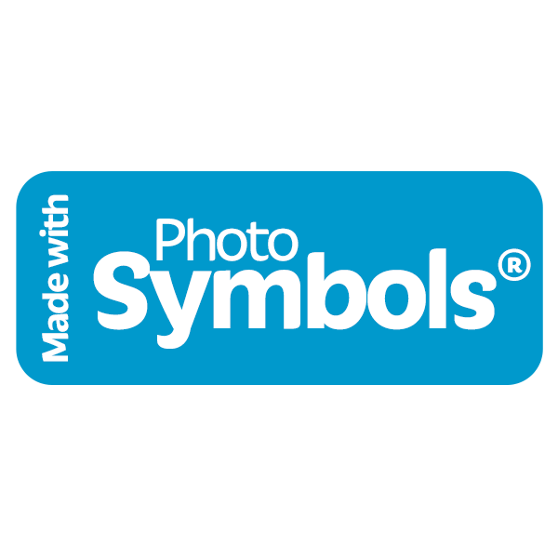
Make It Easy uses images from:

- Changepeople.org

- Photosymbols.com

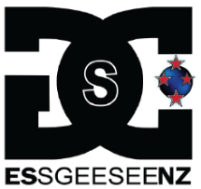
- Sam Corliss

Some images have also been supplied by Arts Access Aotearoa.

All images used in this Easy Read document are subject to copyright rules and cannot be used without permission.

