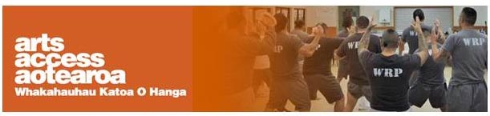
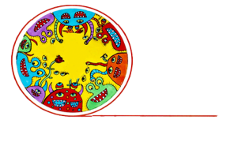
Q & A: Arts in Corrections
Taking music into prisons
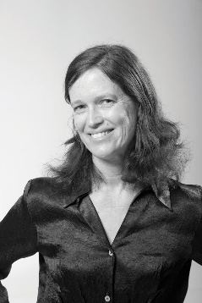
Christchurch Symphony Orchestra created a one-week programme that connected with young offenders in Christchurch Men’s Prison. Cathy Irons, violinist and Project Leader of its Community Engagement Programme, shares insights into why the programme was successful and what it achieved.
1. Background: about the Christchurch Symphony Orchestra
The Christchurch Symphony Orchestra (CSO) is the South Island’s leading professional orchestra. Each year, we perform more than 20 events on stage through our own self-presented concert season with performances that range from Mozart to Moana. We also play in performances with other arts organisations such as Royal New Zealand Ballet and New Zealand Opera.
Beyond the stage, our musicians take live music to people wherever they might be. Through our Community Engagement Programme, we take live music into places such as schools, retirement villages, hospitals, libraries and community halls.
2. Why did you want to do a programme in prison? And why the Youth Unit?
It’s really important to the CSO that everyone has access to live music, wherever they are.
We saw the positive outcomes of our Karawhiua! Let’s Play! residency programme on students in primary schools in terms of changing their behaviour and building rapport. In a similar way, we wanted to offer people in a Corrections facility the opportunity to engage and be immersed in musical projects that would challenge them to learn something new.
There’s a great sense of accomplishment in working together to put on a performance. We wanted to share that with prisoners to help them develop their skills and confidence, which we hope will help in their reintegration into society.
We chose the Youth Unit because we have worked extensively with teenagers in our other Community Engagement Programme activities such as our Ambassador Programme for high school students, our composition workshops, and ensemble performances, as well as through our own private teaching.
We felt that this would be a good starting point for a pilot programme and we jumped at the opportunity when the Youth Unit at the Christchurch Men’s Prison expressed an interest in running this, alongside their existing arts and music programmes.
3. How did you go about developing the programme?
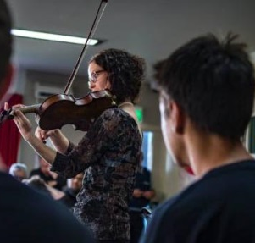
We worked closely with Carey Ewing, manager of Pathway Reintegration, which helps offenders reintegrate into society. Carey is very familiar with the prison environment and was able to give us a lot of guidance.
Carey introduced us to Youth Interventions Coordinator Luan Smith and Principal Corrections Officer Gary Smallridge, who were passionate about bringing arts programmes to the young men. We were briefed on their needs, backgrounds and what would be relevant to them.
What we learned was that many of these young men had experienced dysfunctional childhoods. They didn’t have many positive role models, had received limited formal education, had short attention spans and displayed a distrust of adults.
We had to understand their needs in order to connect with them and create a programme that would be manageable, challenging and meaningful.
4. How did the programme work inside the prison?
The programme ran for a week with two-hour sessions each day with three CSO musicians. Carey was present to provide guidance and he ran the introduction every day and also the reflection time that finished each session.
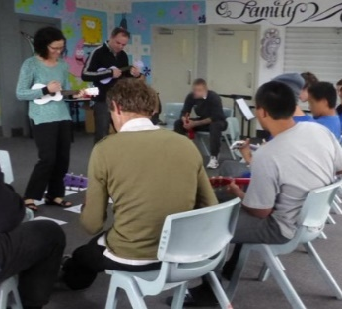
One of the challenges was establishing trust between the CSO tutors and the young men. The first thing we did was learn their names to show respect for them as individuals, and to help build a relationship of respect and trust between everyone involved.
The young men had varying music abilities. Some of them had never played music before while others were very capable guitarists. After the first session, we noticed that some of them would only give an activity one attempt and then give up if they didn’t achieve success the first time, believing that they couldn’t learn.
We broke the projects into manageable chunks and had break-out groups, with some of the more able participants stepping into team leader roles to help others. We also gave them as much one-on-one tutoring time as possible.
5. What did the programme achieve?
We noticed how the confidence of these young men grew. Their communication improved and their self-motivation developed. They co-operated as a team, took pride in their new skills and embraced the performance with courage – all skills that are transferable to life.
Music has a wider impact than just being something on a stage to listen to. Music can profoundly change the way we connect. It challenges us to do our best and we can experience accomplishment through performing together – whether we’re a professional musician or someone who has never played before.
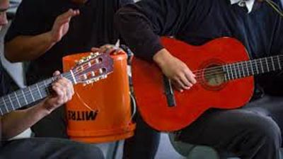
All of the CSO tutors involved in the programme found their lives enriched by engaging with these young men.
One of the pleasures of being a musician is experiencing moments of being touched by music. It is as if the present holds still. It was like that for me. We were rehearsing a guitar piece in a hall, surrounded by walls, barbed wire, surveillance cameras, guards and security alarms. It was in the middle of a song that I suddenly took a step back and saw a bigger picture. We had forgotten everything. The past. The future. We hung in the present. Singing and playing our hearts out. Connecting. Sharing. Music is an incredible artform. It has no barriers. We could have been anywhere on the planet.
6. Three tips to an organisation wanting to provide a project or programme in a prison.
- Research. I did a lot of research, looking at what arts projects people are currently running in Corrections. I also spoke to many people and sought their advice so I could learn from their experience.
- Ask yourself lots of questions. Do you want to copy or build on what others are doing in Corrections? What are your strengths? What will current projects you run "outside" look like in a prison environment? Look at your concept from many different angles – most importantly, the people receiving the programme. Is it relevant to them? Helpful? Engaging? We had a successful programme running in schools which we adapted for this age level, so in effect we had done some preparation training.
- Be flexible. Things might not work quite as you had planned. Be prepared to adapt your project to suit the participants, their skill level and interest. The young men don't like to feel exposed or shown up as incompetent. We found it helpful to break down the project into smaller methodical chunks, split into groups, give as much one-on-one assistance as possible, and use leaders from the group to assist those with fewer skills.
7. Any plans to continue the work with Corrections?
Yes, definitely. We are currently talking to Corrections and Pathway about future projects, not only at the Youth Unit but in different Corrections facilities and with different ages.
We have learned so much through this pilot project and because of its promising outcomes, we would like to continue and grow this programme into an ongoing Arts Programme. This would allow us to continue to mentor this part of our community through musical activities and relationship, offering support as they gain new life skills.

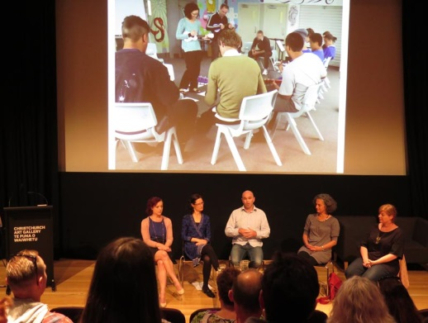

Cath Irons took part in a guest panel discussing the Christchurch Symphony Orchestra partnership with the Department of Corrections at a combined Arts in Corrections South Island Network and Arts For All Canterbury Network ..meeting at the Christchurch Art Gallery

For more information
Cathy Irons
Project Leader, Community Engagement Programme
Christchurch Symphony Orchestra
T: 03 943 7797 E: communityengagement@cso.co.nz

