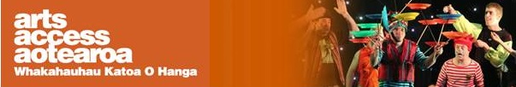

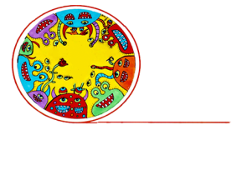
Q & A: Creative spaces
Circability Central: measuring your impact
Why is it important to measure the impact of what you do? And what are some useful tools to help you do this? Frances Kelliher, co-director of Circability Trust in central Auckland, talks to Arts Access Aotearoa about some practical and meaningful ways to measure the impact you are having.
1. Background: about Circability Trust
Circability Central provides social circus programmes for all ages and abilities, with the aim of celebrating difference. We’re situated in the former Campbell Free Kindergarten in Victoria Park and received the Arts Access Creative Space Award 2016.
The Circability Trust was formed in July 2012 after the successful workshop series and performance of Circolina’s Leap in the Pumphouse Theatre. This inclusive project, which involved more than 50 people of all ages, abilities and artforms, received the Arts Access CQ Hotels Wellington Community Partnership Award in 2013.
Together, my co-director (and partner) Thomas Hinz and I have more than 30 years’ experience delivering social circus in both Germany and New Zealand. We’ve been delivering programmes throughout Auckland since 2010, including workshops, performances and events for people of all ages and abilities.
Community circus research
In 2009, we commissioned Rachael Trotman to carry out the research Developing Community Circus in Aotearoa New Zealand, which was funded by the Lottery Community Sector Research Fund.

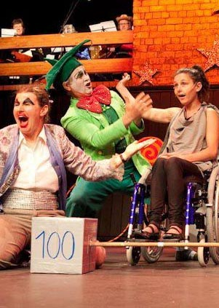
The findings of this two-year research helped us communicate the key benefits and effectiveness of community circus. They confirmed what we already knew – that community circus:
- is inclusive, fun and bonding, supporting personal growth and development
promotes social learning
- helps people build trust and co-operation, leadership and responsibility
- encourages a willingness to try new things, and builds empathy, teamwork, respect and performance skills
- builds community, a sense of pride and belonging
- can change attitudes and be a vehicle for social messages such as anti-bullying and violence prevention.
The research gave us useful guidance on ways to measure ongoing programmes and introduced us to a global network of researchers and providers.
2. Why is it important to measure the impact of what your creative space does?
There are several reasons why it’s important to be able to measure and demonstrate the impact of what you do:

- It keeps you focused on your goals and what you’re trying to achieve
- It keeps your engaged with your stakeholders and responding to their feedback means you can provide better and more meaningful service
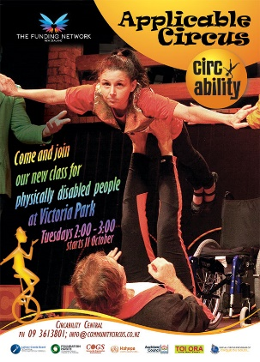
- Measuring your impact is vital when it comes to reporting back to your investment/funding partners.
3. What are the main measurement tools you use?
Finland’s circus evaluation toolkit, called A Guide to the Study of the Wellbeing Effects of Circus (http://bit.ly/2fxKwF7) has interviews and survey questionnaires to measure physical, social and psychological outcomes for participants and caregivers of different target groups. It includes my favourite “Mood-O-Meter” for youth at risk.
However, we use a range of techniques for different programmes. Before we start, we try to ask participants and partners what they want to achieve and then measure that.
We then try and keep it simple because we need to be able to evaluate and present the data. For our mixed ability programmes, we’ve adapted the Finnish measurements so it’s just a few straightforward questions using smiley faces instead of the international 1-5 Likert scale (i.e. from strong disagree to strongly agree).
Here are some other measurement tools we use:
- Feedback circles at the end of each class
- Freeform expression: e.g. asking participants to draw or comment openly on programmes
- Numbers attending shows, workshops, waiting lists etc
- Photos and video footage.

At Circability Central, we like to use a variety of evaluation tools and not overload participants with too much paperwork. We also like to present the results in a way that’s readable and interesting, using things like nice-looking graphs, photos and pullout quotes.
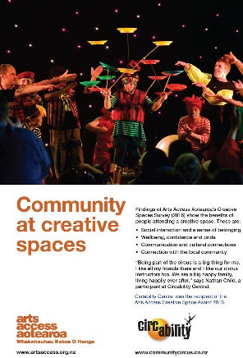
Although we have to gather data for our Statements of Service performance, it’s refreshing to see more and more funders also interested in creative storytelling methodologies.

By this, I mean case studies, freeform expression, stories, video and photos, unexpected outcomes that exceeded your objectives, and any media coverage and profile. It’s true that a picture can paint a thousand words. A photo of a kid’s face showing engagement and interaction says it all really.

Rachel Trotman’s research told us that circus was well-suited to these storytelling methodologies. We did gather statistics because we thought that’s what funders wanted. For example, 79% of audiences attending Circolina’s Leap said it had changed their attitudes towards disabled people.

Statistics provide clear-cut evidence and are useful but funders want more. They also appreciate story-based evaluation methods that actively involve participants.

One of the great things about doing a circus show is the immediate feedback you get from an audience. We get similar feedback from participants in our programmes but that can be fleeting so if possible, we like to use film and photo.

4. How do you decide what to evaluate?
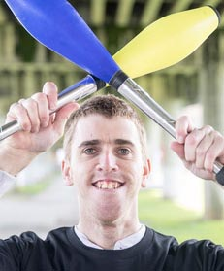
Often the resources you have available means that you don’t have a lot of time or money to design or capture information, or run focus groups. It’s important to be strategic in what you evaluate – and how often. We get funded for our work in inclusion so it’s important to measure outcomes in our core work. For example, one of the trust’s objectives is to break down barriers and so we measure the impact of a show by asking participants and audience members if it has changed their attitudes to disability – and the reasons why.
We’ve saved all of our evaluation forms in Google Forms, which means we can email people the link and ask them to fill in the forms online. This means the data is gathered for us and saves us wasting a lot of paper.
However, we have to give people the option. Some people prefer using paper and others are happy to enter the information online.
Ideally, it would be great to have tables available at the event so people could enter their feedback straight away,
5. What are some easy ways to measure what you do?
- Record great quotes at the time on post-its and then record them later into a spreadsheet
- GIve participants a camera and get them to tell the story
- Take meaningful photos
- Use simple feedback forms: e.g. two tick-box questions and two open-ended questions
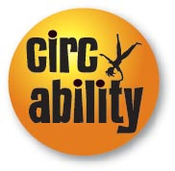
- Leave free-form expression sheets lying around on chairs and tables for people to draw or write on.
6. Five tips for creative spaces on measuring your impact
- Find volunteers to help capture and input the data
- Try a range of techniques and keep it fresh
- Make it look pretty (PowerPoint or Google slides does the trick)
- Keep it simple
- Be sensitive and ask permission to share.

For more information
Frances Kelliher
Co-director, Circability Trust
Victoria Park, Freemans Bay, Auckland
T: 09 361 3801 E: frances@communitycircus.co.nz
W: www.communitycircus.co.nz

