Guide to smartphone photography for beginners
By Sophie Macdonald
Photography is a powerful way to tell stories, capture moments and showcase creativity. You don't need fancy gear to take great photos.
Here are some key tips to help you make the most of your phone’s built-in camera:
- Plan your photo session: Before you start shooting, think about the story or emotion you want to convey. This will help you create interesting shots that stand out. Consider adjusting shooting locations or using relevant props to highlight the story behind your photo. For product photos (e.g. artwork, ceramics, jewellery), simplicity and good lighting are key.
- Know your equipment: Familiarise yourself with your phone's camera settings. Understand how to adjust exposure, focus and other settings for better image quality. Experiment with different camera modes, like portrait mode, to isolate subjects or control exposure creatively.
It’s easy to adjust your exposure settings on a smartphone. Follow these steps:
Step 1: Open your camera app. Always use your camera’s original app. Don’t shoot photos within apps like Instagram as these will decrease your photo quality.
Step 2: Tap on your screen to focus on your subject. You’ll notice a little sun-shaped symbol pop up on the screen next to your selected subject.
Step: 3 Tap and hold on the sun icon and simply slide your finger up or downward on the screen to adjust the exposure. Phone cameras tend to overexpose, so you may find that a slight drag downwards gives your picture just the right exposure.
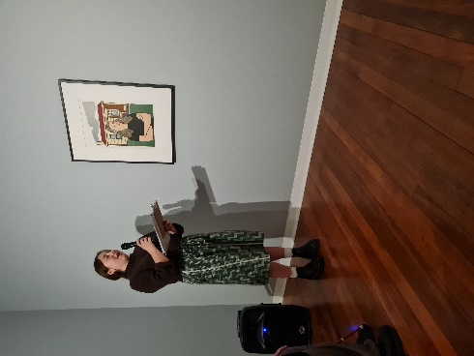
- Pay attention to lighting conditions: Shoot outdoors or near windows to take advantage of natural light, which is often the most flattering. Avoid challenging lighting situations like harsh office lights or poorly lit areas.
In this candid photo on the next page, you can see that the speaker, Maya, and artwork are well-lit and appear natural. The lighting is flattering although a harsh shadow is cast onto the wall behind the speaker. This photograph is a great example of a clean, simple and attractively lit event shot in challenging lighting conditions.
You may notice that in poorly lit spaces, your photos tend to look grainy or the quality is reduced. This is because in most cases, your phone’s camera can only let in a small amount of light and so it will try to adjust automatically. As a result, the quality of your photo may be sacrificed to let more light into the camera.
Low lighting settings are difficult to get right so to get around things, you could look to use flash or adjust your location.
- Avoid the built-in zoom if you can: Built-in digital zooms on phone cameras reduce image quality as they are extremely limiting. Instead of relying on your phone’s zoom function, try moving closer to your subject to maintain sharpness and clarity. If you need better zoom capabilities, consider using external lenses for your phone's camera. These can be purchased online.
As you can see in the photo to the right, presenter Gareth Tiopira-Waaka and NZSL interpreter Byron Bibbons appear very pixelated, and the lighting creates unflattering contrast. This photo was taken in the theatre at Te Papa using a phone's built-in zoom, which significantly reduced the quality.
If possible, a better option would have been for the photographer to move physically closer to the subjects.
- Compose your shots: Frame your photos carefully. Keep it simple when showcasing artwork by centring your subject. Experiment with different angles and perspectives to add depth and interest to photos of other people. Most of all, always include your subject's full head. It’s very important that you don’t cut them off. Sometimes, this can be a compositional decision that you can make when you’re editing, but you need to include as much detail as possible when taking your shots. In Māori culture, the head is tapu (sacred) and should not be cropped in photos. Arts Access Aotearoa respects this belief.
- Choose the right orientation: Understand the differences between portrait and landscape orientations. Landscape is great for capturing wide natural settings, while portrait is ideal for emphasising details and expressions.
Consider the purpose of your photo and where it will appear to choose the right orientation.
- Capture genuine emotions: Understand the differences between portrait and landscape orientations. Landscape is great for capturing wide natural settings, while portrait is ideal for emphasising details and expressions. Consider the purpose of your photo and where it will appear to choose the right orientation.
Take a look at the shot below, capturing a powerful moment of connection at the opening of the Wāhine exhibition at Auckland Arts Festival 2023.
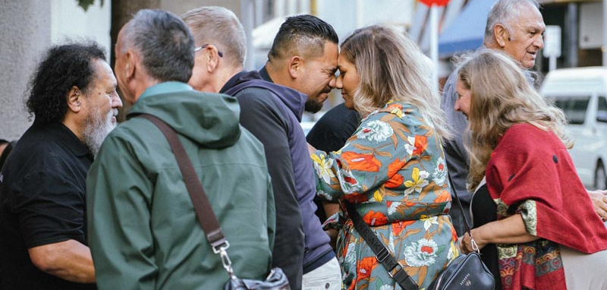
Although the shot is crowded with several people, they do a beautiful job of framing the hongi taking place at the centre of the frame, helping the viewer to feel connected and like they are part of the events taking place. This is one of my favourite shots in the Arts Access Aotearoa catalogue.
- Edit and enhance: Although the shot is crowded with several people, they do a beautiful job of framing the hongi taking place at the centre of the frame, helping the viewer to feel connected and like they are part of the events taking place. This is one of my favourite shots in the Arts Access Aotearoa catalogue.
- Be consistent: Establish a consistent visual style for your photos. Natural and well-lit images are generally more appealing.
Remember, photography is an art of storytelling. Experiment, practise, and have fun capturing amazing moments with your phone camera.
Sophie Macdonald is the Communications Assistant Kaitautoko Whakarite at Arts Access Aotearoa, and professional photographer at shotbysophie.com.

