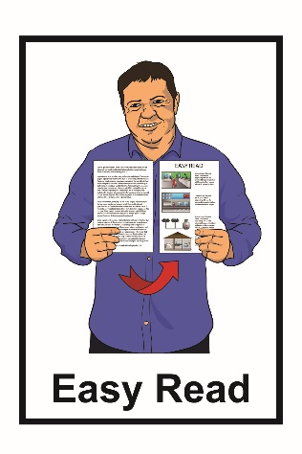
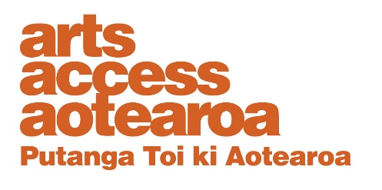

How to apply to be a board trustee
at Arts Access Aotearoa
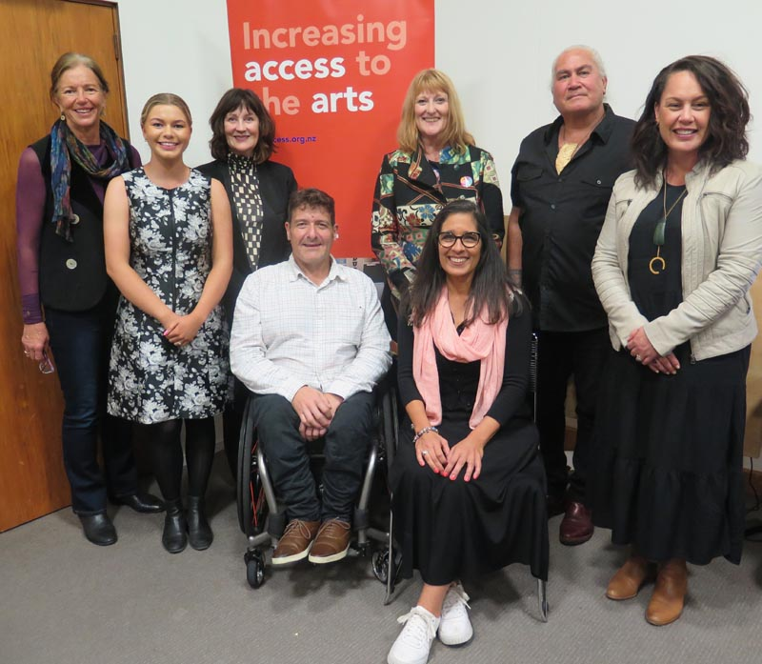

August 2022

Who is Arts Access Aotearoa?

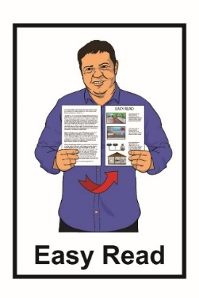

This Easy Read document is from Arts Access Aotearoa.

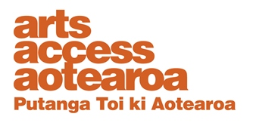
Arts Access Aotearoa works so that everyone can enjoy the arts.

The arts are things like:
- dancing
- music / singing
- acting

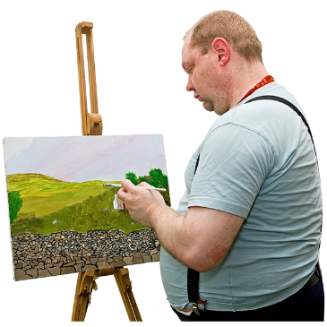
- things in museums / galleries

- painting
- writing.

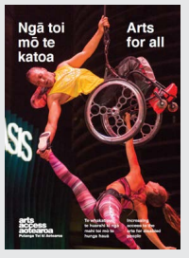
Arts Access Aotearoa works to make it easier for people who experience barriers to be a part of the arts.

Barriers are things that make it harder for people to:

- take part in the arts

- enjoy the arts.

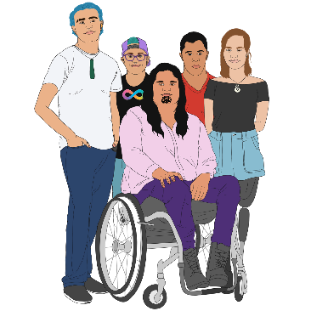
We do this by working with many different groups of people like:
- the disabled community
- the autistic community

- the mental health community

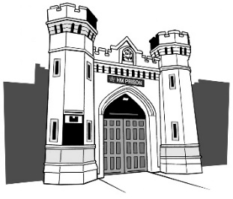
- the Deaf community

- people who are in prison.
What is this document about?

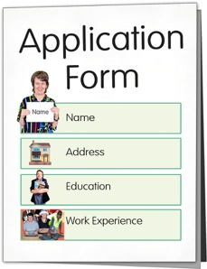
This document is about how you can apply to be a trustee of the board of Arts Access Aotearoa.

A trustee is 1 person who is part of the board.

The board of Arts Access Aotearoa:

- is a group of 5 to 8 people

- makes important decisions about:

- Arts Access Aotearoa

- any plans it has for the future.

Arts Access Aotearoa is looking for
2 new trustees.

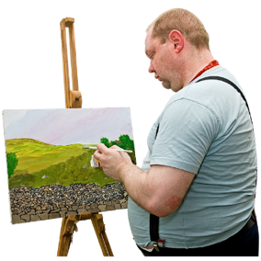
We want our trustees to know about / have experience in many different things like:

- the arts

- being disabled / Deaf

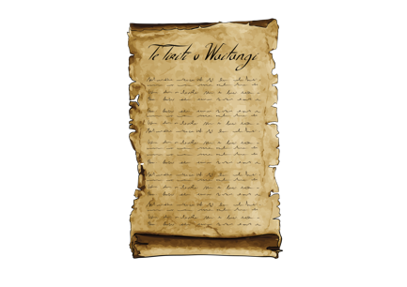
- Te Tiriti O Waitangi / the Treaty of Waitangi

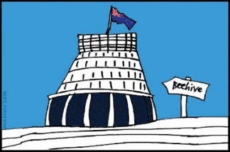
- politics / the government

- people and different cultures

- the law
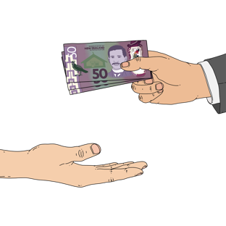
- raising money.
What does the board do?

The board watches over the work that Arts Access Aotearoa does.

The board leads and supports Arts Access Aotearoa by making sure it has:
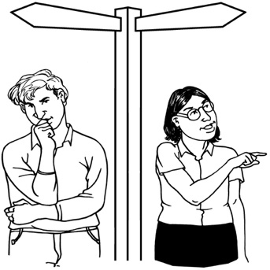
- good values / plans for the future

- a clear direction and purpose
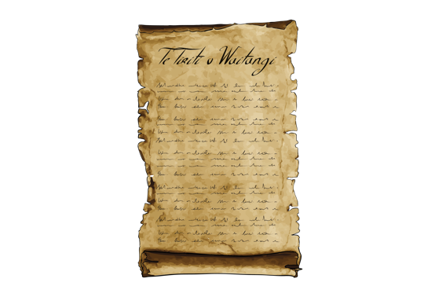
- a good understanding of:
- the principles of Te Tiriti o Waitangi
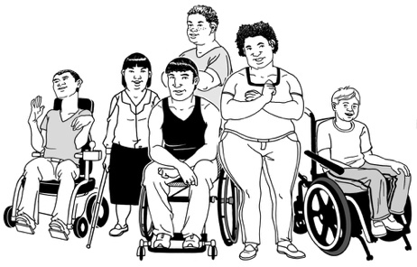
- the New Zealand Disability Strategy 2016 to 2026.

The board also works with the Executive Director to make sure everyone is working well together.

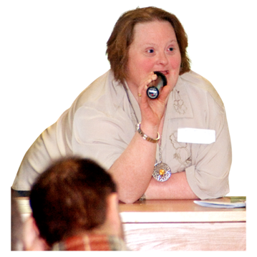
An important thing the board does is to make sure that the ideas / voices of everyone supported by Arts Access Aotearoa are heard.

Other things you need to know

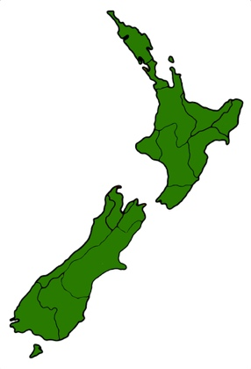

Anyone who wants to apply to be a trustee must live in New Zealand.

The board has 5 meetings a year on a Saturday morning.

The meetings are:

- held in Wellington
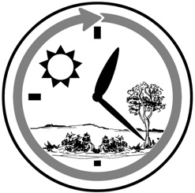
- last around 3 to 4 hours.

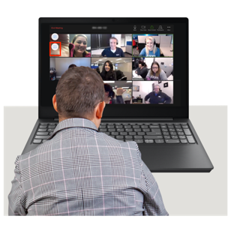
Trustees can also join the meetings online.

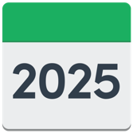
The job of trustee is for 3 years.

You will not get any money for doing this job

but

Arts Access Aotearoa will pay for you:
- to travel to the meetings
- to find a place to stay when you join the meetings

- to buy other things you need to join the meetings.

How to apply to be a trustee

You should send your application to be a trustee to Arts Access Aotearoa:
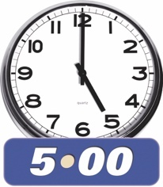
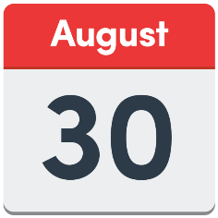
- by 5 pm in the evening

- on Tuesday 30 August 2022.

Your application should include a letter that says:
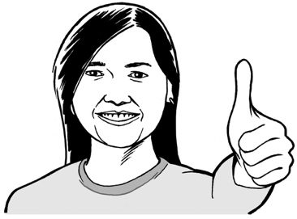
- why you want to be a trustee
- the things you can do that will make you a good trustee.
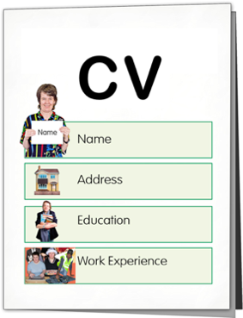
Your application should also include your CV.

A CV is a document that shows:

- what kind of education you have
- what kinds of work you have done

- your skills / experience.
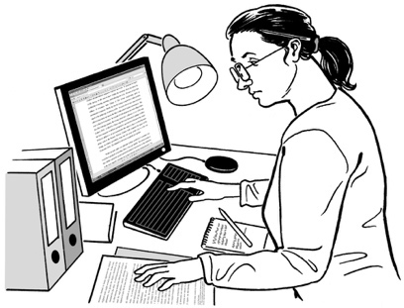

Skills are things you have learned to do / are good at.

You should send your application by email to Lynley Hutton at:
info@artsaccess.org.nz
You can call us if you have any questions on:
04 802 4349
Where to find more information

You can find out more about Arts Access Aotearoa at this website:
https://artsaccess.org.nz/

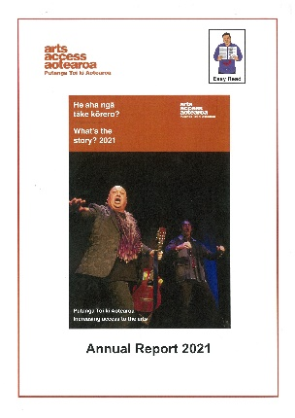
You can read an Easy Read document of the 2021 Arts Access Aotearoa annual report at:

https://artsaccess.org.nz/Arts-Access-Aotearoa-in-2021

You can find also out more about what Arts Access Aotearoa does on:

- Facebook at:
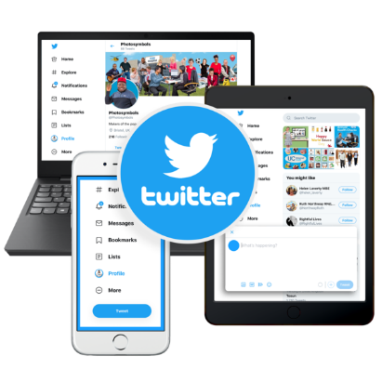
facebook.com/ArtsAccessAotearoa
- Twitter at:
twitter.com/ArtsAccessNZ
- Instagram at:
instagram.com/arts_access_aotearoa
This information has been written by Arts Access Aotearoa.
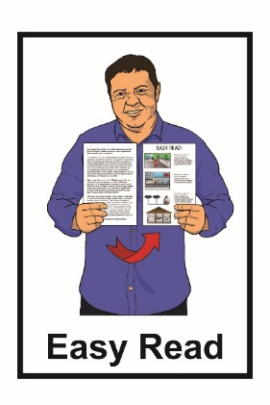
It has been translated into Easy Read with advice from the Make It Easy service of People First New Zealand Inc. Ngā Tāngata Tuatahi.

The ideas in this document are not the ideas of People First New Zealand Inc. Ngā Tāngata Tuatahi.

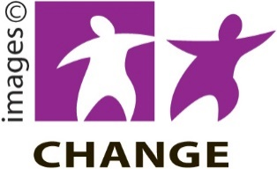
Make It Easy uses images from:

Changepeople.org

Photosymbols.com
SGC Image Works
Huriana Kopeke-Te Aho.

All images used in this Easy Read document are subject to copyright rules and cannot be used without permission.

