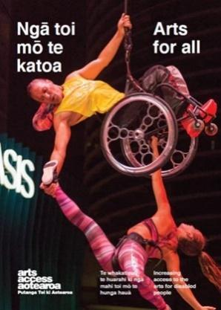
Q & A INSIGHT: ARTS FOR ALL

Making publications more accessible

How do you make written documents and publications accessible to blind and low vision arts patrons and gallery visitors? Hamish Petersen, former Writing and Publications Co-ordinator at The Physics Room in Christchurch, talks about what was involved in producing an audio book of its new publication, Correspondence.

1. Background: About The Physics Room
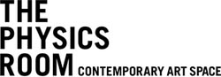
The Physics Room supports contemporary art and artists through regular commissions and curatorial support, public events, residencies and publications.

It evolved from the itinerant South Island Art Projects into a single space in 1996. Over the years, the gallery has been situated in various spaces in Ōtautahi Christchurch and is now based in The Arts Centre Te Matariki Toi Ora.

The Physics Room’s former Business Manager, Keren Oertly Ryan, led our work with Blind Low Vision NZ, and audio describers Judith Jones and Rachel Tully, who ran an ongoing series of workshops for audio describing visual and multimedia contemporary art.

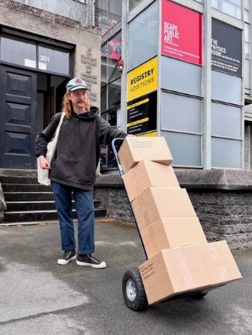
Alongside large-print information pamphlets for every exhibition and regular audio-recorded and transcribed public events, our current Access and Participation Co-ordinator Audrey Baldwin is leading efforts to develop an organisation-wide accessibility policy with support from Arts Access Aotearoa.

From 2017 to 2022, I was the inaugural Writing and Publications Co-ordinator for The Physics Room, producing HAMSTER Magazine issues 1–7 and the new serial, Correspondence. As such, I commissioned, edited, recorded, organised and distributed these free, serial publications as a way for more stories to be told alongside the artwork and artists in our gallery space.

2. Tell us about Correspondence and what prompted you to explore accessibility options.
While I was working on HAMSTER, a conversation with a close friend prompted me to think about who we as artists, publishers, and curators actually speak to when we publish these texts, images and objects that wrap around contemporary art.

It made me think that I may have been “preaching to the choir,” as they say. In other words, we might be providing additional routes into contemporary art practices (by publishing these texts) for the people who already had access to the art through the traditionally white, middle class and non-disabled/neurotypical crowds of art schools and intellectualised contemporary art audiences.

What I wanted to do with our publications was to provide routes into contemporary art for people who are restricted by the language and published formats that contemporary art often relies on.
While The Physics Room’s learning about accessible publications began with HAMSTER, I envisaged Correspondence as a way to focus more on how people tell and receive stories through a structure of “call and response” among the writers, artists and friends who contribute. This means that one contributor would publish in issue one, and invite a friend to respond with a contribution to issue two.

In the first two issues, the contributors shared stories about their relationships and the issues that connected them, from family histories to activism and language-learning. This way, instead of the publication merely being a container for the stories, it also celebrated the relationships that make the stories possible and safe to tell.

Correspondence also allowed me as an editor to spend a full year developing and publishing the two issues. During this time, I got to know the pairs of contributors better than I could in a usual magazine publishing cycle of two to six months.

I think this allowed for more considerate editing and support, resulting in a more trustworthy environment for creative exploration by contributors, such as voicing their own audiobook contributions.

3. Why did you decide to produce an audio book rather than other screen reader-accessible options?

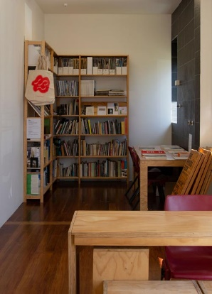
I felt that the audio option held more creative potential for our contributors to make their work more widely accessible from the start. It asks them to put their own bodies into the work in a way that writing and publishing perhaps avoids too often.

By this, I mean that writing can often feel very abstract when it only involves Microsoft Word and emails. By asking contributors to voice their own work, and consider how their work can be accessed solely through audio, they are asked to consider how they listen, and how their lived experience of their own body has shaped those habits.

This choice to make our bodies apparent is a choice that disabled and neuro-divergent folks do not always have. Print publications also ask readers to think about their bodies holding, flicking through, and reading in very different ways to digital devices, which is why we continued a dual, print+audio approach instead of going entirely online.
With the help of web designer Emma Kevern and our web developers Sons & Co, we have also reached the stage of being able to upload all the text, alt-text-enabled images, and audiobook tracks for each issue on to The Physics Room website. This provides an HTML text version alongside the audio so we can offer all the accessibility benefits that come with HTML because readers/listeners can customise the ways the text appears on their devices, or how screen readers access and interpret it.

Starting with the audiobook, however, we prioritised a “born-accessible” approach where contributors are directly involved in interpreting their work for an audience that is perhaps disabled by the print format.

4. What were the key steps you took to develop the audio book?

- Asking friends and whānau with print and/or vision disabilities what they would find helpful to enable their access to our publications
- Reviewing examples of audio books and audio content from other galleries, publishers, and libraries
- Reviewing our time, resources and available skills to determine the scale of production and distribution that would be possible and sustainable
- Producing HAMSTER Issue 5 as a dual print/audiobook as an initial trial
- Sharing HAMSTER Issue 5 with Petronella Spicer and Erin Eyles from Blind Low Vision NZ and low vision art collector Mark Flowerday, alongside audio describer Rachel Tully after publishing. We then met up to discuss their feedback.
- Developing accessible audiobook recording guidelines with Rachel Tully for contributors to use when recording
- Producing further issues of the magazine in multiple formats, asking informally for feedback from members of our audience.

5. What were the key challenges you faced and how did you overcome them?
- Feedback: Asking for feedback can be difficult and even knowing who to ask can be hard. However, Blind Low Vision NZ was a huge help. At Arts For All Network meetings, they’ve offered to be involved in supporting new initiatives that could benefit their members. Organisations like Blind Low Vision NZ are invaluable advocates for their community. Building attentive, reciprocal relationships with staff provided us with both support and motivation.
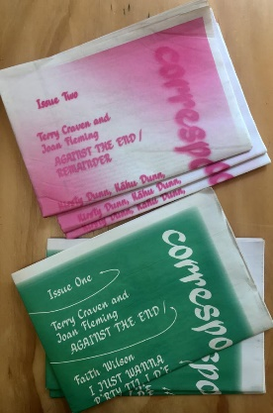
- Distribution: This goes hand in hand with feedback. If you can’t get your accessible project out to your target audience, you can’t receive feedback on its value or where you could improve it. This is something we struggled with. We’re a small organisation with only 17 hours per week allotted to the publications role. Prioritising the promotion and distribution of our audiobooks using advocacy networks such as Arts Access Aotearoa or community groups nationwide over other projects may have helped. Regardless, we decided to upgrade our website so the audio could be embedded, allowing all of our audiences to have easy access to the audiobooks rather than through a rabbit warren of links and downloads. This may allow word-of-mouth to help spread these projects more widely while we build more relationships with organisations, libraries, and communities of audiobook users. I’m not sure we’ve overcome either of these challenges yet but it’s useful to reflect on them and the pathways for improving these areas.

7. Hamish’s five tips for anyone wanting to make their publications accessible to people who are blind or have low vision.
- Start small and move slowly. Keeping expectations and likely feedback sustainable for your organisation will help to make the task feel achievable and worth developing further.
- Do it for real people you can talk to about your accessible publication and for whom it would actually make a difference – not an imagined, generalised disabled community.
- Ensure you personally understand how making it more accessible for some folks will make the whole project more valuable, accessible and engaging for everyone, including the writers and artists.
- Have honest conversations with your colleagues, community, employer, board members and funders about your aspirations for making accessible publications. This will get you “buy-in” to the process so that these accessible projects become part of the organisation’s core activity. These conversations may be awkward and difficult when it comes to discussing how inaccessible publishing can be. These are also the times where you and the people you’re talking with can express an honest desire and motivation to change that.
- Keep on checking in and having conversations about what your listening audience wants and what is/is not working about your current project/process. It’s not a journey that ends or reaches a perfect outcome or model process. Every publication will be made and received slightly differently and reach different people, so there is always more to be learned from those who access these projects.

For more information
Name: Orissa Keane
Title: Writing and Publications Co-ordinator
The Physics Room
T: +64 3 379 5583 E: orissa@physicsroom.org.nz
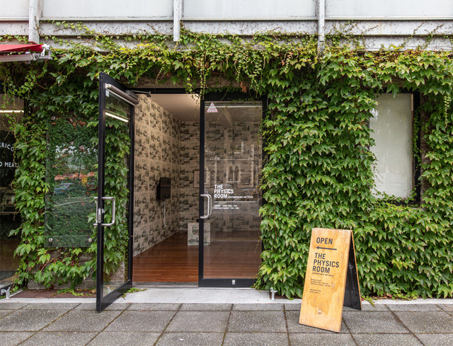
Access to The Physics Room gallery is described on its website

