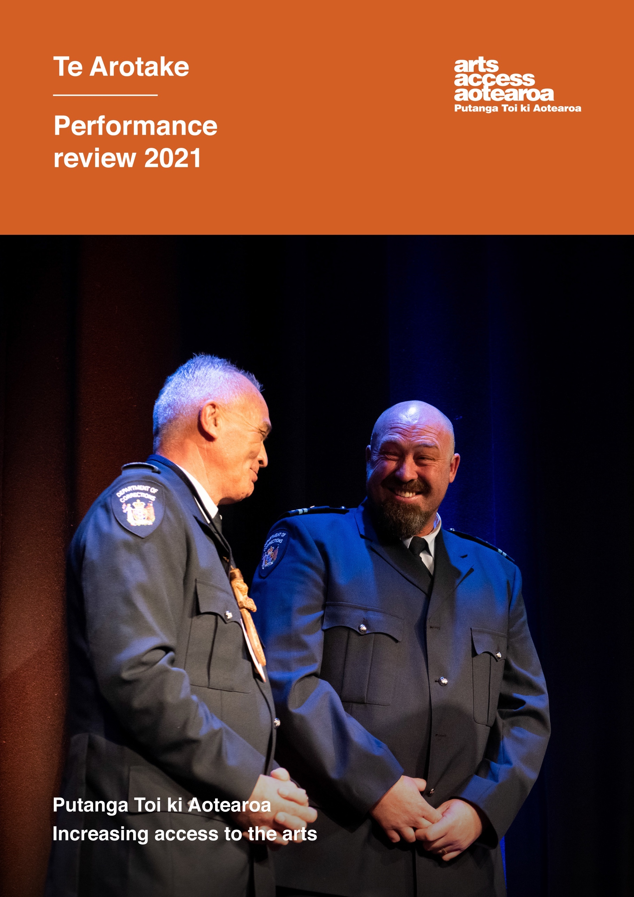

Contents

For the year ended 31 December 2021

Entity information Page 3
Statement of service performance Page 5

Financial information:

Statement of financial performance Page 8

Statement of financial position Page 10

Statement of cash flows Page 11

Statement of accounting policies Page 12

Notes to the Performance Report Pages 13

Audit Report Pages 20-21
Funders and sponsors Page 22

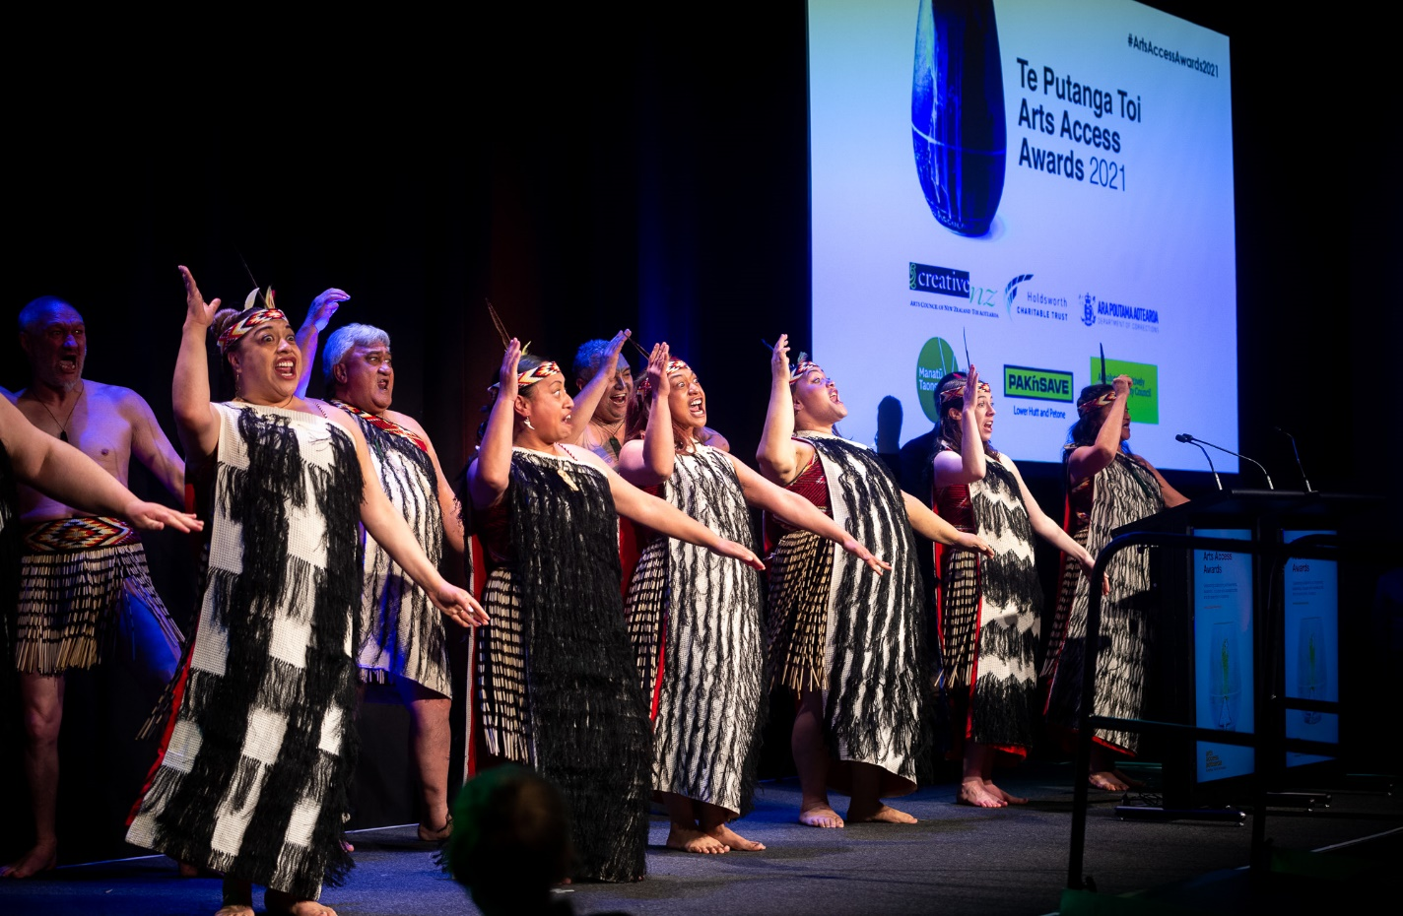
NgātI Pōneke Young Māori Club perform at Te Putanga Toi Arts Access Awards 2021
Photo: Elias Rodriguez, marktantrum.com
Cover image: Kyle Ellison and Pirika Taepa, Hawkes Bay Regional Prison, receive the Arts Access Corrections Whai Tikanga Award at Te Putanga Toi Arts Access Awards 2021 Photo: Elias Rodriguez, marktantrum.com

Entity information
For the year ended 31 December 2021
Legal name of entity: Arts Access Aotearoa Whakahauhau Katoa o Hanga
Other name of entity (if any): Arts Access Aotearoa
Type of entity and legal basis (if any): Charitable trust
Registration number: CC 33533
Registration date: 30 June 2008
Entity's purpose or mission
All people in New Zealand are able to participate in the arts
Entity structure
Trust governed by board of trustees
Main sources of the entity's cash and resources
Grants, fundraising and donations
Main methods used by the entity to raise funds
Application for grants from Government, local bodies, charities and gaming organisations
Entity's reliance on volunteers and donated goods or services
Significant level of volunteers
Additional Information
Contact details
Level 3, Toi Pōneke, 61–63 Abel Smith St, Wellington
Postal address: PO Box 9828, Wellington 6141 E: info@artsaccess.org.nz
W: www.artsaccess.org.nz
Facebook /ArtsAccessAotearoa
Twitter @ArtsAccessNZ
Instagram @arts_access_ aotearoa

Design: Graphic Solutions Ltd
Print: Coherent

Arts Access Aotearoa
Arts Access Aotearoa | Putanga Toi ki Aotearoa works in partnership to increase access to the arts for people in Aotearoa who experience barriers to participation as artists, performers, audience members, and gallery and museum visitors. We do this by working with people in the disabled, mental health and Deaf communities. We also work with the professional arts sector to improve access to Deaf and disabled audiences.
Arts Access Aotearoa provides a national advisory and advocacy service about accessibility and inclusion in the arts. This includes providing information, resources and research through the Information Centre.
We advise Ara Poutama Aotearoa Department of Corrections on its arts programmes and activities, and advocate for the arts as a tool to support the rehabilitative process of prisoners and their reintegration back into the community on release.

Vision
All people in Aotearoa can access and participate in the arts.

Purpose
Arts Access Aotearoa works in partnership to increase access to the arts for people in Aotearoa who experience barriers to participation.
Te Arotake Performance Review 2021
Te Arotake Performance Review 2021 compares outputs against the previous year, and includes actuals, measures and targets. It complements He aha ngā tāke Kōrero What’s the story? 2021, a narrative of Arts Access Aotearoa in 2021. Download both documents from the Arts Access Aotearoa website

Statement of service performance
For the year ended 31 December 2021
Description of the entity's outcomes
Arts Access Aotearoa works to achieve the following outcomes:
Te Puna Toi |Access, Inclusion and Participation: Arts organisations, companies, artists, producers and venues are accessible and inclusive.
Manaaki Hapori | Community Engagement: Community-based creative spaces have the capacity and sustainability to deliver quality arts programmes for people with limited access. There is increased awareness among funders and policy makers about the value of the arts in building strong communities and enhancing people's health and wellbeing.
Te Ao Marama | Sector Advocacy and Profile: There is increased public awareness of and advocacy for access to the arts for everyone in New Zealand.
Te Pito Whakamarama | Information Centre: Arts Access Aotearoa provides a national information service on access to and participation in the arts, including advice on best practice, research, resources and opportunities.
Toi Ara Poutama | Arts in Corrections: Arts activities and programmes support the rehabilitation of prisoners and their reintegration into the community on release.
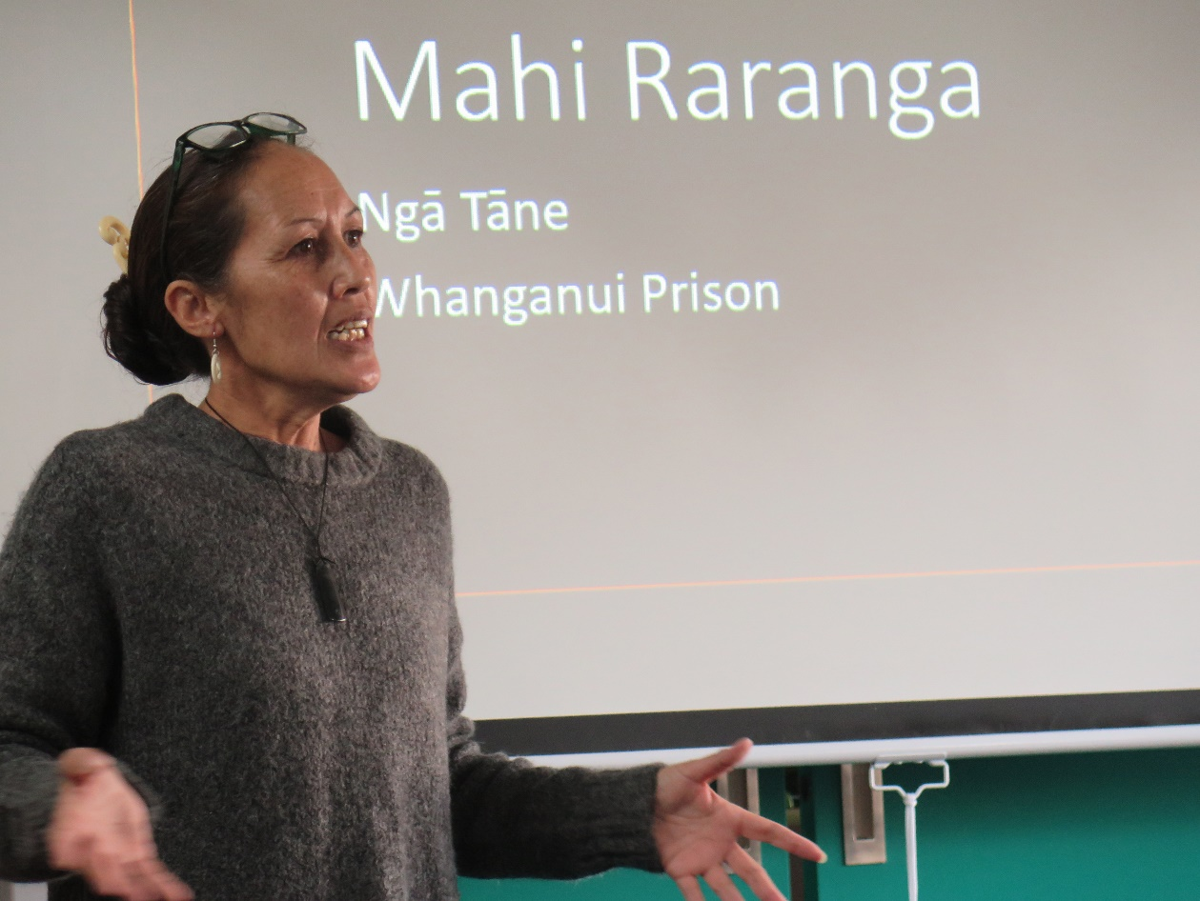
Juanita Davis talks at an Arts in Corrections Network meeting in Palmerston
North about her raranga workshops with men in Whanganui Prison
 |  | 2021 |  | 2020
Output | Measure | Actual | Target | Actual
Te Puna Toi |Access, Inclusion and Participation
Facilitate Arts For All Network meetings to encourage increased access to the arts by venues, performing arts companies, museums, galleries and festivals | The number of Arts For All Network meetings held in Auckland, New Plymouth, Wellington, Dunedin, Christchurch and Hawke’s Bay in 2021 | Facilitated six regional in-person meetings in Auckland, Hawke’s Bay, New Plymouth, Wellington, Dunedin and Christchurch, along with four virtual network meetings | Facilitate ten network meetings in 2021 | Facilitated ten meetings in Auckland, New Plymouth, Wellington, Dunedin and Christchurch in 2020
Support Arts For All Network members to provide accessible services, performances and other events | The number of accessible services, performances and other events provided by Arts For All Network members | 182 accessible services, performances and other events provided by Arts For All Network members | Arts For All Network members provide 110 accessible services, performances, and other events | 110 accessible services, performances and other events provided by Arts For All Network members
Consult with Arts For All Network members on developing their accessibility policies/plans | The number of Arts For All Network members consulted on developing their accessibility policies/plans | Consulted with 19 Arts For All Network member organisations on developing their accessibility policies/plans | Consult with 38 Arts For All Network member organisations on developing their accessibility policies/plans | Consulted with 38 Arts For All Network member organisations on developing their accessibility policies/plans
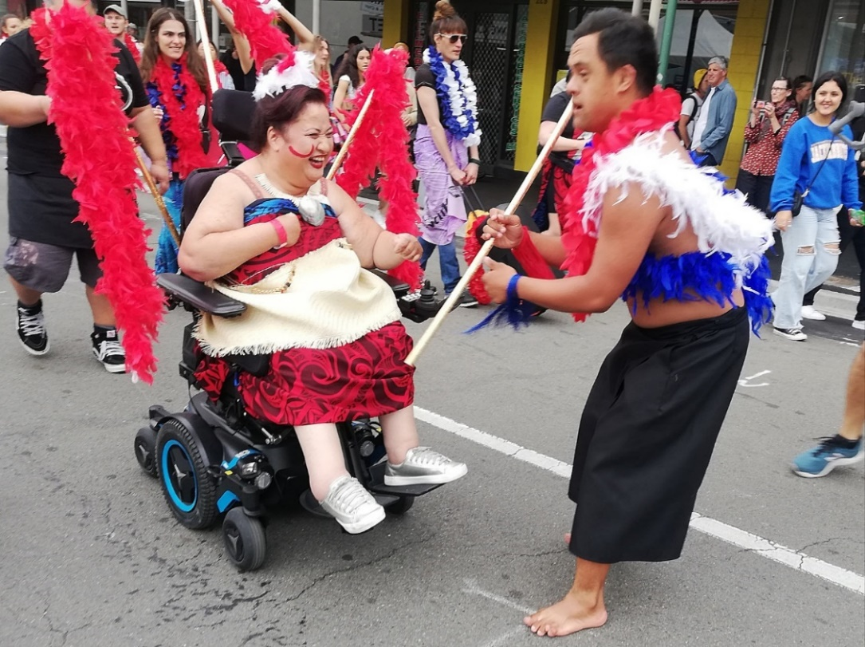
Lusi Faiva and Jacob Dombroski in Wellington’s CubaDupa 2021,
perform a work called Taupou, made in collaboration with
Everybody Cool Lives Here

Output | Measure | 2021 |  | 2020
 |  | Actual | Target | Actual
Manaaki Hapori | Community Engagement
Community engagement: Increased strength of sector and the network has a shared common purpose | Deliver a  quarterly pānui to the national Creative Spaces Network | Four pānui distributed (in February, August, November, December) | Distribute four pānui to the creative spaces national network | Three pānui distributed (in March, July, October, December)
Community engagement:  advocacy to agencies and funders for sustainable sector funding | Increase support for government agencies and funders with assistance and information about the value of Creative Spaces | Delivered to contract with the Ministry for Culture and Heritage (MCH) to facilitate investment in creative spaces, as part of the Government’s Creative Arts Recovery Employment (CARE) Fund | Deliver to contract with MCH to facilitate investment in creative spaces, as part of the Government’s Creative Arts Recovery Employment (CARE) Fund | Developed a proposal to support and advise MCH in its delivery of workforce funding for creative spaces over three years
Auckland Sector Needs:  Deliver the Empowering the Auckland Creative Spaces Sector project | Deliver: Empowering the Auckland  Creative Spaces Sector project. Implement strategic plan developed in 2020 | MCH CARE Fund delivered to Strategic Priority 2: Sustainable funding  Successful  recruitment for a new Auckland-based contractor to take over the role of Creative Spaces Advisor – Auckland | Deliver to the Empowering Auckland Strategic Plan 2021–2023 | Undertook a comprehensive survey of the Auckland creative spaces sector which informed the development of the Empowering Auckland Strategic Plan 2021–2023

Output | Measure | 2021 |  | 2020
 |  | Actual | Target | Actual
Te Ao Marama | Sector Advocacy and Profile
Present Te Putanga Toi Arts Access Awards 2021 | Six awards and the Arts Access Accolade are presented at Te Putanga Toi Arts Access Awards 2021 | Seven awards and the Arts Access Accolade were presented at Te Putanga Toi Arts Access Awards 2021 | Presented six awards and the Arts Access Accolade at Te Putanga Toi Arts Access Awards 2021 | Present six awards and the Arts Access Accolade at Te Putanga Toi Arts Access Awards 2020

Output | Measure | 2021 |  | 2020
 |  | Actual | Target | Actual
Te Pito Whakamarama | Information Centre
Maintain and continue to develop a high-quality information centre that provides capability-building information and resources for the sector | Number of website sessions | 58,215 website sessions (41% increase) | 41,423 website sessions | 41,423 website sessions
 | Number of unique visits to the website | 48,808 unique visits to the website | 32,260 unique visits to the website | 32,260 unique visits to the website
 | Advocacy and promotion on social media channels increase | Facebook "likes" increased by 4.2%, Twitter followers increased by 2.7% and  Instagram followers increased by 14.9% in 2021 | An increase in Facebook "likes" and Twitter / Instagram followers compared to the previous year | Facebook "likes" increased by 6% in 2020, Twitter followers increased by 3.4% and  Instagram followers increased by 43.5%

 |  | 2021 |  | 2020
Output | Measure | Actual | Target | Actual
Toi Ara Poutama | Arts in Corrections
Arts Advice and Support: the Arts in Corrections Advisory Service is provided by a specialist Arts in Corrections Advisor | Summary of advisory support  and advice provided, summary of consultations with arts organisations and artists | 122 consultations with arts organisations and artists, / advisory support  and advice provided | 62 consultations with arts organisations and artists, / advisory support  and advice provided | 62 consultations with arts organisations and artists, / advisory support  and advice provided
National Arts in Corrections networks: across three reg0ions (Northern, Central and Southern). Network members include Corrections staff, arts organisations, artists and arts workers | The number of Arts in Corrections Network meetings delivered | Four Arts in Corrections Network meetings delivered (three in-person, one online) | Facilitate four Arts in Corrections Network meetings | Two in-person Arts in Corrections Network meetings in 2020: Wellington (October), Otago (November)  Two online Arts In Corrections meetings (5 and 12 June)

Statement of financial performance

For the year ended 31 December 2021

 | Note | Actual | Budget | Actual
 |  | This year  $ | This year  $ | Last year  $
Revenue
Funding from central or local government | 1 | 1,140,266 | 1,157,553 | 629,710
Revenue from non-govt sources for providing goods and services | 1 | 10,000 | 10,000 | 10,000
Donations, fundraising and other similar revenue | 1 | 110,110 | 111,239 | 129,028
Interest, dividends and other similar revenue | 1 | 4,830 | 4,800 | 6,228
Other revenue | 1 | 5,041 | 5,000 | 417
Total revenue |  | 1,270,247 | 1,288,592 | 775,383
Expenses
Expenses related to public fundraising | 2 | 20,346 | 22,354 | 20,312
Volunteer and employee-related costs | 2 | 729,618 | 718,252 | 520,529
Costs related to providing goods or services | 2 | 333,039 | 385,767 | 194,875
Other expenses | 2 | 27,150 | 27,899 | 20,717
Total expenses |  | 1,110,153 | 1,154,272 | 756,433
Surplus for the year |  | 160,094 | 134,320 | 18,950
Non-operating and extraordinary
(not an every-year activity)
Creative spaces – capacity building and support expenditure |  | (3,231) | (3,600) | (5,244)
Total non-operating and extraordinary items |  | (3,231) | (3,600) | (5,244)
Surplus for the year after non-operating |  | 156,863 | 130,720 | 13,706

*The notes, policies, and Auditor’s report are integral to these financial statements.

Statement of financial position
As at 31 December 2021

 | Note | Actual | Actual
 |  | This year  $ | Last year  $
Assets
Current assets
Bank accounts and cash | 3 | 588,994 | 436,539
Debtors and prepayments | 3 | 3,921 | 14,909
Total current assets |  | 592,915 | 451,448
Non-current assets
Property, plant and equipment | 4 | 5,533 | 4,117
Total non-current assets |  | 5,533 | 4,117
Total assets |  | 598,448 | 455,565
Liabilities
Current liabilities
Creditors and accrued expenses | 3 | 20,076 | 9,866
Employee costs payable | 3 | 58,861 | 36,622
Unused donations and grants with conditions | 3 | 149,121 | 195,550
Total current liabilities |  | 228,058 | 242,038
Total liabilities |  | 228,058 | 242,038
Total assets less total liabilities (net assets) |  | 370,390 | 213,527
Accumulated funds
Trustee/member accumulated equity | 5 | 257,576 | 100,713
Investment reserve | 5 | 12,814 | 12,814
Restricted/discretionary reserve funds | 5 | 100,000 | 100,000
Total accumulated funds |  | 370,390 | 213,527
Adopted as a true and correct by the governance board on 30 April 2022.
Lynley Hutton, Chair, 30 April 2022 Richard Benge, Executive Director 30 April 2022

*The notes, policies, and Auditor’s report are integral to these financial statements.

Statement of cash flows
For the year ended 31 December 2021

 | Actual | Actual
 | This year  $ | Last year  $
Cash flows from operating activities
Cash was received from:
Donations, fundraising and other similar receipts | 3,079 | 5,458
Funding from central or local government* | 1,178,647 | 760,005
Receipts from non-govt sources for providing goods or services* | 99,575 | 129,775
Interest, dividends and other investment receipts | 3,093 | 7,900
Fundraising revenue | 16,200 | 16,043
Other revenue | 7,214 | 616
Net GST | 101,677 | 82,833
Cash was applied to:
Payments to suppliers and employees | 1,253,545 | 843,694
Net cash flows from operating activities | 155,940 | 158,936
Cash was applied to:
Payments to acquire property, plant and equipment | 4,916 | 1,740
Net cash flows from investing and financing activities | (4,916) | (1,740)
Net increase/(Decrease) in cash | 151,024 | 157,196
Opening cash | 432,348 | 275,152
Closing cash | 583,372 | 432,348
This is represented by:
Bank accounts and Mastercard account | 583,372 | 432,348

*The notes, policies, and Auditor’s report are integral to these financial statements.

Statement of accounting policies
For the year ended 31 December 2021

Basis of preparation

Arts Access Aotearoa has elected to apply PBE SFR-A (NFP) Public Benefit Entity Simple Format Reporting - Accrual (Not-For-Profit) on the basis that it does not have public accountability and has total annual expenses of equal to or less than $2,000,000. All transactions in the Performance Report are reported using the accrual basis of accounting. The Performance Report is prepared under the assumption that the entity will continue to operate in the foreseeable future.

Goods and Services Tax (GST)

All amounts are recorded exclusive of GST, except for Debtors and Creditors, which are stated inclusive of GST.

Income tax

Arts Access Aotearoa is wholly exempt from New Zealand income tax having fully complied with all statutory conditions for these exemptions.

Bank accounts and cash

Bank accounts and cash in the Statement of Cash Flows comprise cash balances and bank balances (including short term deposits) with original maturities of 90 days or less.

Changes in accounting policies

There have been no changes in accounting policies during the financial year (last year - nil)

Fixed assets
Fixed assets, other than land, are recorded at cost less accumulated depreciation.

Depreciation

Depreciation has been calculated on a straight line basis over the estimated useful life of the assets.

Debtors

Debtors have been recorded at their net realisable value.

Revenue recognition

Income is recognised when invoiced or receipted except where income is received in advance. Income in Advance is stated as a current liability where the funds have not yet been expended, according to the authorised purpose, and those funds would be required to be repaid to the funder.

Income tax exemption

Sections CW41 & 42 of the Income Tax Act 2007 exempt income tax on an organisation registered with the Charities Commission and applying income to its charitable purposes. The Trust has income tax exemption and charitable status through its registration with the Charities Commission on the 30 June 2008 (CC 33533).

*The notes, policies, and Auditor’s reports are integral to these financial statements.

Notes to the performance report
For the year ended 31 December 2021

Note 1: Analysis of revenue

 |  | Actual  This year  $ | Budget This year  $ | Actual Last year  $
Revenue Item | Analysis
Funding from central or local government | Creative New Zealand – core | 460,000 | 460,000 | 450,000
 | Department of Corrections | 182,500 | 159,500 | 145,000
 | Wellington City Council | 25,279 | 24,408 | 24,710
 | Creative New Zealand – Arts Access Awards | 10,000 | - | 10,000
 | Oranga Tamariki | 135,743 | 163,332 | -
 | Ministry of Culture and Heritage | 230,208 | 230,204 | -
 | Creative New Zealand – Oranga Tamariki project | 96,536 | 120,109
 | Total | 1,140,266 | 1,157,553 | 629,710
 |  | Actual  This year  $ | Budget This year  $ | Actual Last year  $
Revenue Item | Analysis
Sources for providing goods and services | Wellington Community Trust | 10,000 | 10,000 | 10,000
 | Total | 10,000 | 10,000 | 10,000
 |  | Actual  This year  $ | Budget This year  $ | Actual Last year  $
Donations, fundraising and other similar revenue | Foundation North Trust | 70,492 | 75,000 | 87,036
 | Thomas George Macarthy Trust | 5,000 | 5,000 | 5,000
 | National Foundation of Deaf | - | - | 1,739
 | Other donations | 4,279 | 900 | 6,428
 | Rehabilitation Welfare Trust | - | - | 1,000
 | Lion Foundation | - | - | 8,000
 | Sponsorships of Arts Access Awards | 15,000 | 15,000 | 10,000
 | In-kind donations of Goods and Services | 15,339 | 15,339 | 9,825
 | Total | 110,110 | 111,239 | 129,028
 |  | Actual  This year  $ | Budget This year  $ | Actual Last year  $
Revenue item | Analysis
Interest, dividends and other Investment revenue |  | 4,830 | 4,800 | 6,228
 | Total | 4,830 | 4,800 | 6,228
 |  | Actual  This year  $ | Budget This year  $ | Actual Last year  $
Revenue Item | Analysis
Other revenue | Other | 5,041 | 5,000 | 417
 | Total | 5,041 | 5,000 | 417

*The notes, policies, and Auditor’s reports are integral to these financial statements.

Note 2: Analysis of expenses

 |  | Actual  This year  $ | Budget  This year  $ | Actual  Last year  $
Expense Item | Analysis
Expenses related to public fundraising | Travel | 177 | 5,000 | 783
 | Marketing & Promotions | 12,682 | 11,954 | 11,705
 | Arts Advocates | - | - | 471
 | Fundraising & Sponsorship | 7,487 | 5,400 | 7,353
 | Total | 20,346 | 22,354 | 20,312
 |  | Actual  This year  $ | Budget  This year  $ | Actual  Last year  $
Expense item | Analysis
Volunteer and employee-related costs | Salaries and wages | 701,785 | 689,998 | 501,303
 | Professional development | 6,022 | 8,000 | 1,319
 | Kiwisaver Contributions | 18,334 | 18,334 | 14,216
 | ACC levies | 1,382 | 1,100 | 1,013
 | Health and safety | 695 | 120 | 740
 | Payroll fees | 898 | 700 | 696
 | Recruitment | 502 | - | 1,242
 | Total | 729,618 | 718,252 | 520,529
 |  | Actual  This year  $ | Budget  This year  $ | Actual  Last year  $
Expense item | Analysis
Costs related to providing Goods and Services | Administration and overhead costs | 22,204 | 25,980 | 29,378
 | Projects | 266,186 | 321,631 | 134,780
 | Trustees’ expenses | 17,108 | 10,000 | 9,217
 | Premises | 27,541 | 28,156 | 21,500
 | Total | 333,039 | 385,767 | 194,875
 |  | Actual  This year  $ | Budget  This year  $ | Actual  Last year  $
Expense item | Analysis
Other expenses | General expenses | 8,537 | 8,560 | 10,017
 | Depreciation | 3,500 | 3,800 | 2,740
 | Volunteer programme | 11,906 | 11,039 | 4,915
 | Audit | 3,207 | 4,500 | 3,045
 | Total | 27,150 | 27,899 | 20,717

*The notes, policies, and Auditor’s reports are integral to these financial statements.

Note 3: Analysis of assets and liabilities

 |  | Actual  This Year  $ | Actual  Last year  $
Asset item | Analysis
Bank accounts and cash | Current account | 230,737 | 60,219
 | Saver account | 3,355 | 3,353
 | Petty cash | 398 | 200
 | Term investments | 354,504 | 372,767
 | Total | 588,994 | 436,539
 |  | Actual  This year  $ | Actual  Last year  $
Asset item | Analysis
Debtors and prepayments | Debtors | - | 11,500
 | Prepayments | 3,921 | 3,409
 | Total | 3,921 | 14,909
 |  | Actual  This year  $ | Actual  Last year  $
Liability item | Analysis
Creditors and accrued expenses | Accounts payable | 3,516 | 1,693
 | Westpac MasterCard | 720 | 1,224
 | Audit fees accrual | 3,500 | 3,500
 | GST due | 12,340 | 989
 | Other accrued expenses | - | 2,460
 | Total | 20,076 | 9,866
 |  | Actual  This year  $ | Actual  Last year  $
Liability item | Analysis
Employee costs payable | MD salary allowance accrued | 10,000 | 10,000
 | Leave balance accrued | 36,782 | 18,677
 | Salary accrued | 12,079 | 7,945
 | Total | 58,861 | 36,622
 |  | Actual  This year  $ | Actual  Last year  $
Liability item | Analysis
Unused donations and grants with conditions | Wellington City Council | 12,773 | 12,507
 | Foundation North | 26,667 | 17,159
 | Oranga Tamariki | 53,593 | 139,992
 | Grace Memorial Trust | 20,425 | 25,000
 | Auckland Council | 25,000 | -
 | Creative New Zealand | 3,114 | -
 | Sub total | 141,572 | 194,658
Funds held in trust | Crip the Lit funds | 301 | 392
 | Project WHA | 300 | 300
 | Winton & Margaret Bear | 6,548 | -
 | Audio description bond | 400 | 200
 | Sub total | 7,549 | 892
 | Total | 149,121 | 195,550

*The notes, policies, and Auditor’s reports are integral to these financial statements.

Note 4: Fixed assets

This year
Asset class | Opening carrying amount | Purchases | Sales/ Disposals | Current year depreciation & impairment | Closing carrying amount
Furniture and fixtures | 2,533 | 2,885 | 1,000 | 924 | 3,494
Office equipment | 828 |  |  |  | 828
Computers (including software) | 756 | 2,031 | - | 1,576 | 1,211
Total | 4,117 | 4,916 | 1,000 | 2,500 | 5,533
Last year
Asset class | Opening carrying amount | Purchases | Sales/ Disposals | Current year depreciation & impairment | Closing carrying amount
Furniture and fixtures | 1,857 | 969 |  | 293 | 2,533
Office equipment | 3,114 |  |  | 2,286 | 828
Computers (including software) | 146 | 771 |  | 161 | 756
Total | 5,117 | 1,740 | - | 2,740 | 4,117

*The notes, policies, and Auditor’s reports are integral to these financial statements

Note 5: Accumulated funds

This year
Description | Accumulated surpluses or deficits | Investment reserve | Equity funds  reserves - restricted/ discretionary | Total
Opening balance | 100,713 | 12,814 | 100,000 | 213,527
Surplus/(Deficit) for the year from operations | 160,094 |  |  | 160,094
Total non-operating and extraordinary items | (3,231) |  |  | (3,231)
Closing balance | 257,576 | 12,814 | 100,000 | 370,390
Last year
Description | Accumulated surpluses or deficits | Investment reserve | Equity funds  reserves - restricted/ discretionary | Total
Opening balance | 87,007 | 12,814 | 100,000 | 199,821
Surplus/(Deficit) for the year from operations | 18,950 |  |  | 18,950
Total non-operating and extraordinary items | (5,244) |  |  | (5,244)
Closing balance | 100,713 | 12,814 | 100,000 | 213,527

Note 6: Commitments and contingencies

 |  |  |  | At balance date  This year  $ | At balance date  Last year  $
Commitment |  |  | Explanation and timing
Commitments to lease or rent assets |  |  | Arts Access Aotearoa has a monthly lease on the premises at 63 Abel Smith Street from which it operates. Rent is paid monthly, two weeks in advance and two weeks in arrears. At least three months’ notice is required for termination of the lease. | 22,607 | 22,607
 | Guarantees provided | No guarantees have been provided to any person or organisation.

Note 7: Other

Unused donations and grants with conditions
Description | Original amount | Not fulfilled amount | Purpose and nature of the condition(s)
Wellington City Council | 25,546 | 12,773 | Support creative spaces in Wellington City and advocating for greater access to the arts in Wellington. In partnership with City Arts, provide workshops, training and support to the Arts for All network.
Oranga Tamariki | 216,928 | 53,593 | AAA to work with Oranga Tamariki's children to engage with artistic activities. AAA to provide dedicated Arts Advisor for duration of contract.
Grace Memorial Trust Fund | 25,000 | 20,425 | AAA to apply funds to two projects - To engage community-based artists to provide arts skills/therapy in youth justice facilities and for prisoners with visual arts for rehabilitation.
Foundation North | 80,000 | 26,667 | Funds received for Empowering Auckland creative spaces project yet to be used.
Auckland Council | 25,000 | 25,000 | Funds received from Auckland Council for Auckland creative services project.
Creative NZ/ Oranga Tamariki artists | 99,650 | 3,114 | Funds received from Creative NZ for funding of artists in the Oranga Tamariki project.
Funds held in trust
Description* | Original Amount* | Fund Amount | Derivation of the Fund
Wilton & Margaret Bear | 9,788 | 6,548 | Funding for Winton & Margaret scholarships granted
Goods or services provided to the entity in-kind
Description |  |  |  | Amount
Time donated by volunteers |  |  |  | 11,039
Goods and services donated by individuals and organisations |  |  |  | 4,300
Assets used as security for liabilities
Nature and amount of borrowing
None noted

Note 8: Assets held on behalf of others
None noted

Note 9: Related party disclosures
There were no transactions involving related parties during the financial year. (Last year – Nil)

Note 10: Events after the balance date
There were no events that have occurred after the balance date that would have a material impact on the Performance Report. (Last year – Nil)

Note 11: Ability to continue operating
The governance has considered the going concern principle and believes to the best of its knowledge that the organisation has resources to continue operating for the foreseeable future.

Note 12: Correction of errors
The governance is not aware of any material errors requiring correction in the financial statements.

Note 13: Comparatives
Last Year's comparative amounts have been prepared on the same basis as this year's amounts.

Note 14: COVID-19
In March 2020, the World Health Organisation declared the outbreak of COVID-19 a pandemic. Since March 2020, the New Zealand Government has imposed a number of measures to reduce the spread of COVID-19, including most recently implementing the COVID-19 Protection Framework on 2 December 2021. While the country is under the COVID-19 Protection Framework there are restrictions on large gatherings of people and how public places can operate.

The Trust has as a consequence been unable to operate exactly as it would under normal conditions. While disruptions are expected to be temporary, there is a level of uncertainty around the duration of these restrictions. At the date of issuing the financial statements, the Trust has been able to absorb the majority of the impact of current public health measures.

At this time the full financial impact of the COVID-19 pandemic is not able to be determined, but it is not expected to have a significant adverse effect on the future of the Trust.

*The notes, policies, and Auditor’s report are integral to these financial statements.

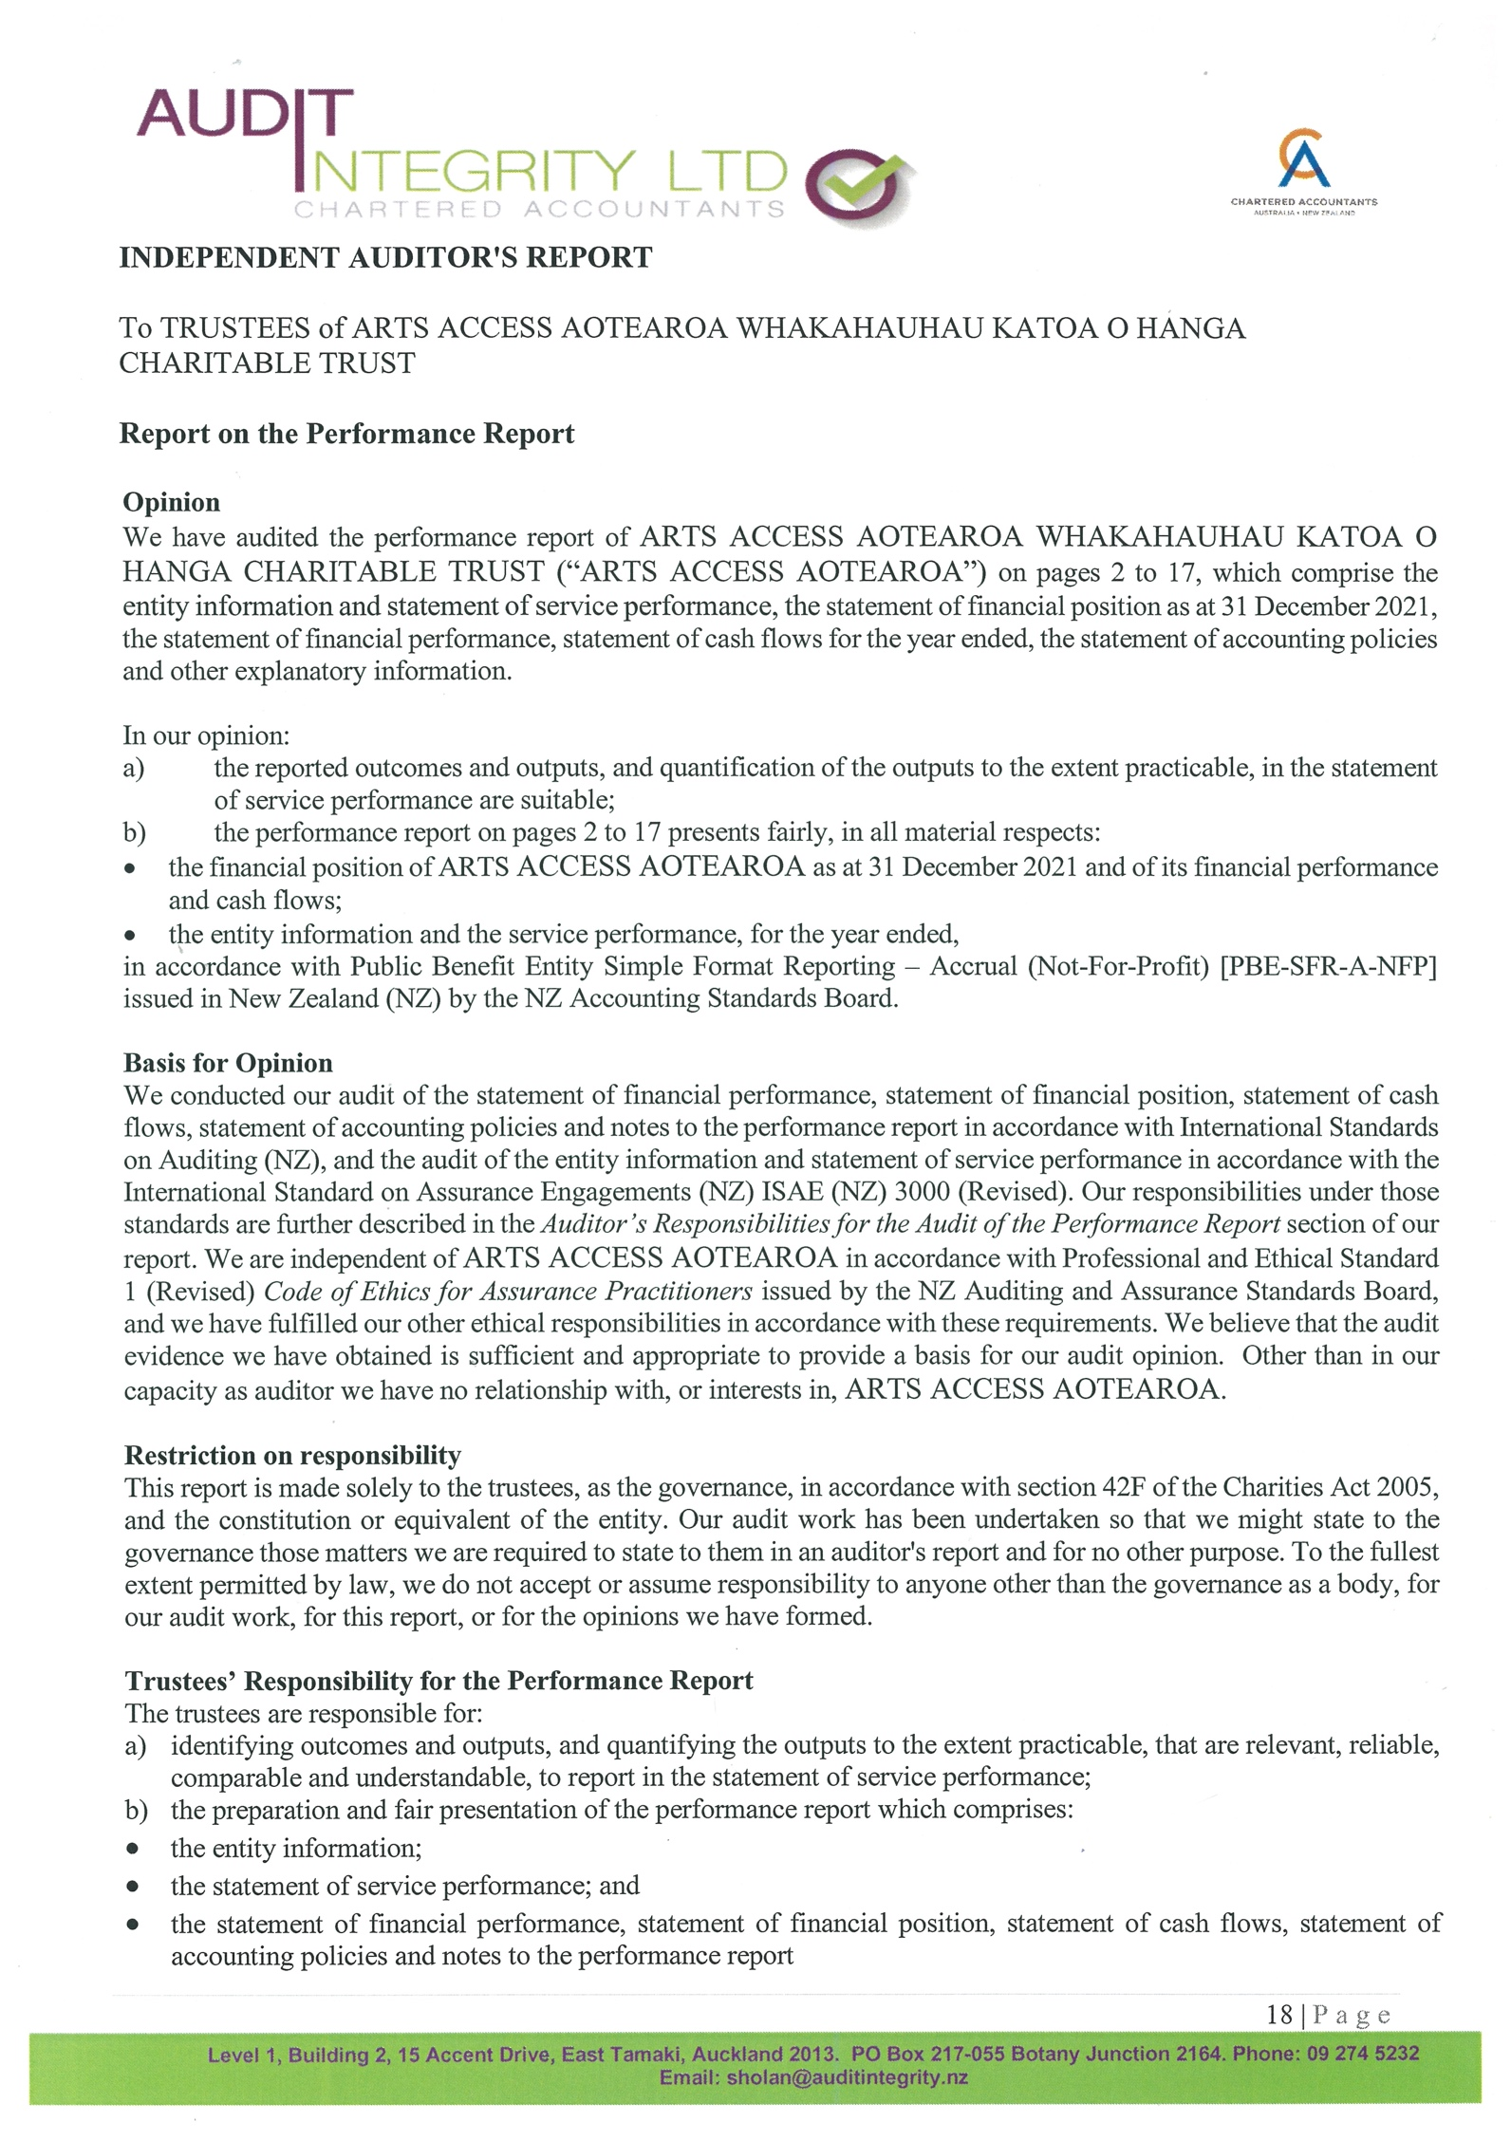
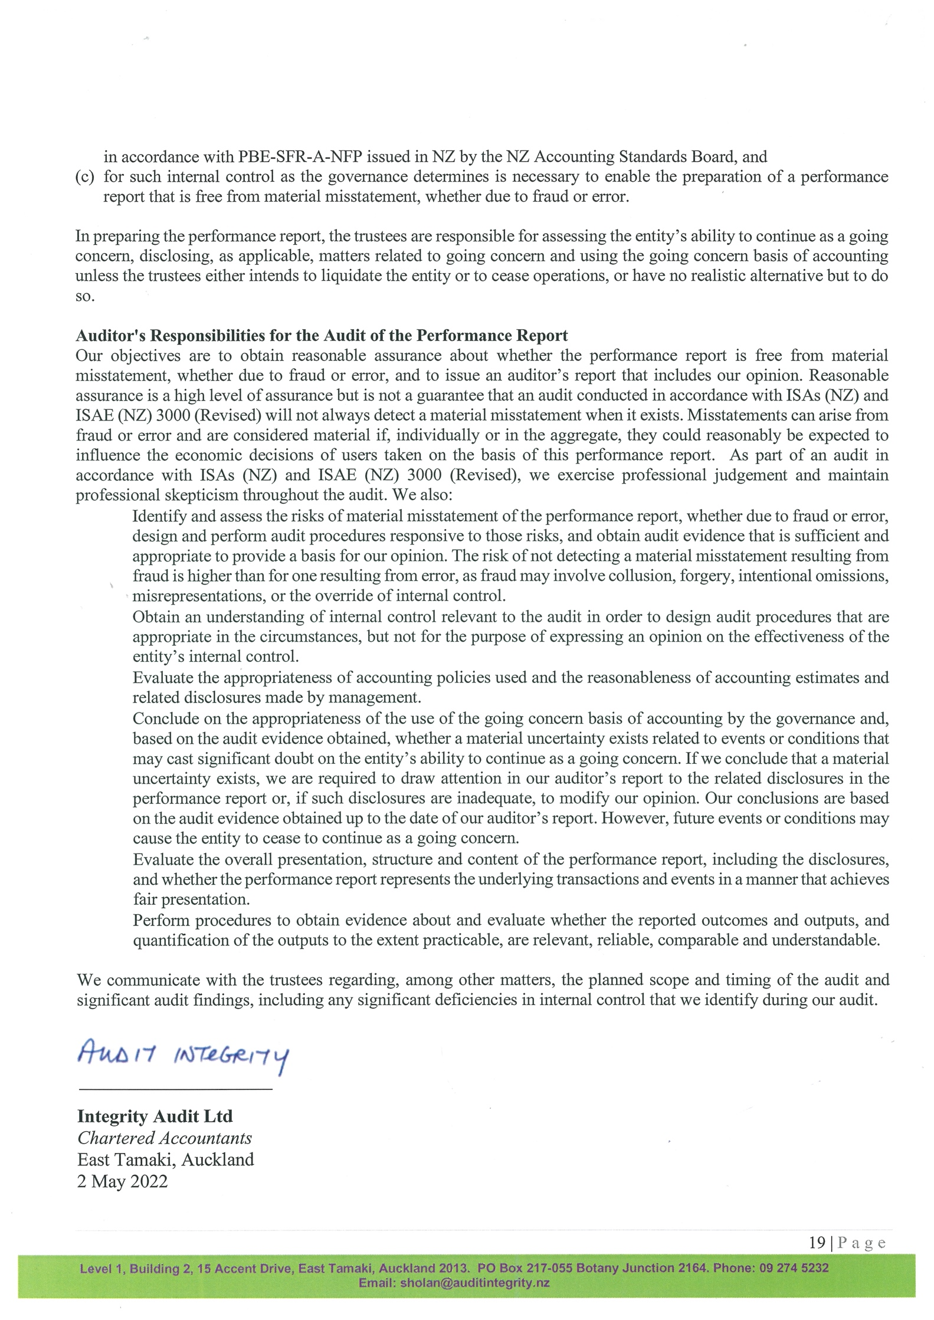

Funders and sponsors
Arts Access Aotearoa thanks the following organisations that have supported our work in increasing access to the arts in 2019. We look forward to your ongoing support.

Core funder
Creative New Zealand

Major contract
Ara Poutama Aotearoa Department of Corrections
Oranga Tamariki

Local government grants
Wellington City Council
Auckland Council

Legal services
Chapman Tripp

Grants
Foundation North
Wellington Community Trust
Thomas George Macarthy Trust
Winton and Margaret Bear Charitable Trust

Te Putanga Toi Arts Access Awards 2021 sponsors
Creative New Zealand
Ara Poutama Aotearoa Department of Corrections
Holdsworth Charitable Trust
PAK’nSAVE
Wellington City Council

Supporters

Thank you to the generous Friends of Arts Access Aotearoa whose regular donations supported the activities in this report. Thanks also to Rajeev Mishra, Otago Museum, Te Papa and the University of Canterbury Arts Centre for their in-kind support. Thanks also to our business supporters Fraser Carson and Flightdec; Craig Christensen and Graphic Solutions; Marty Brooky and Coherent; Ben Courtney and Base IT; Gordon Harris, Wellington; and Volunteer Wellington. Finally, thanks to Nope Sisters for supporting our mahi.

