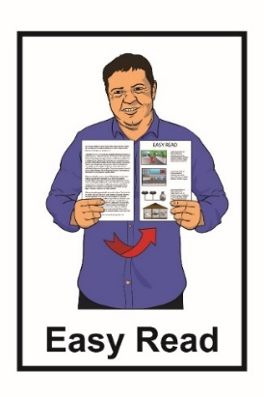
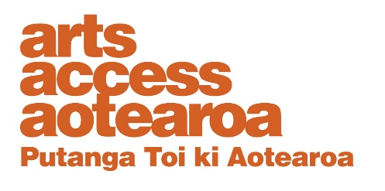
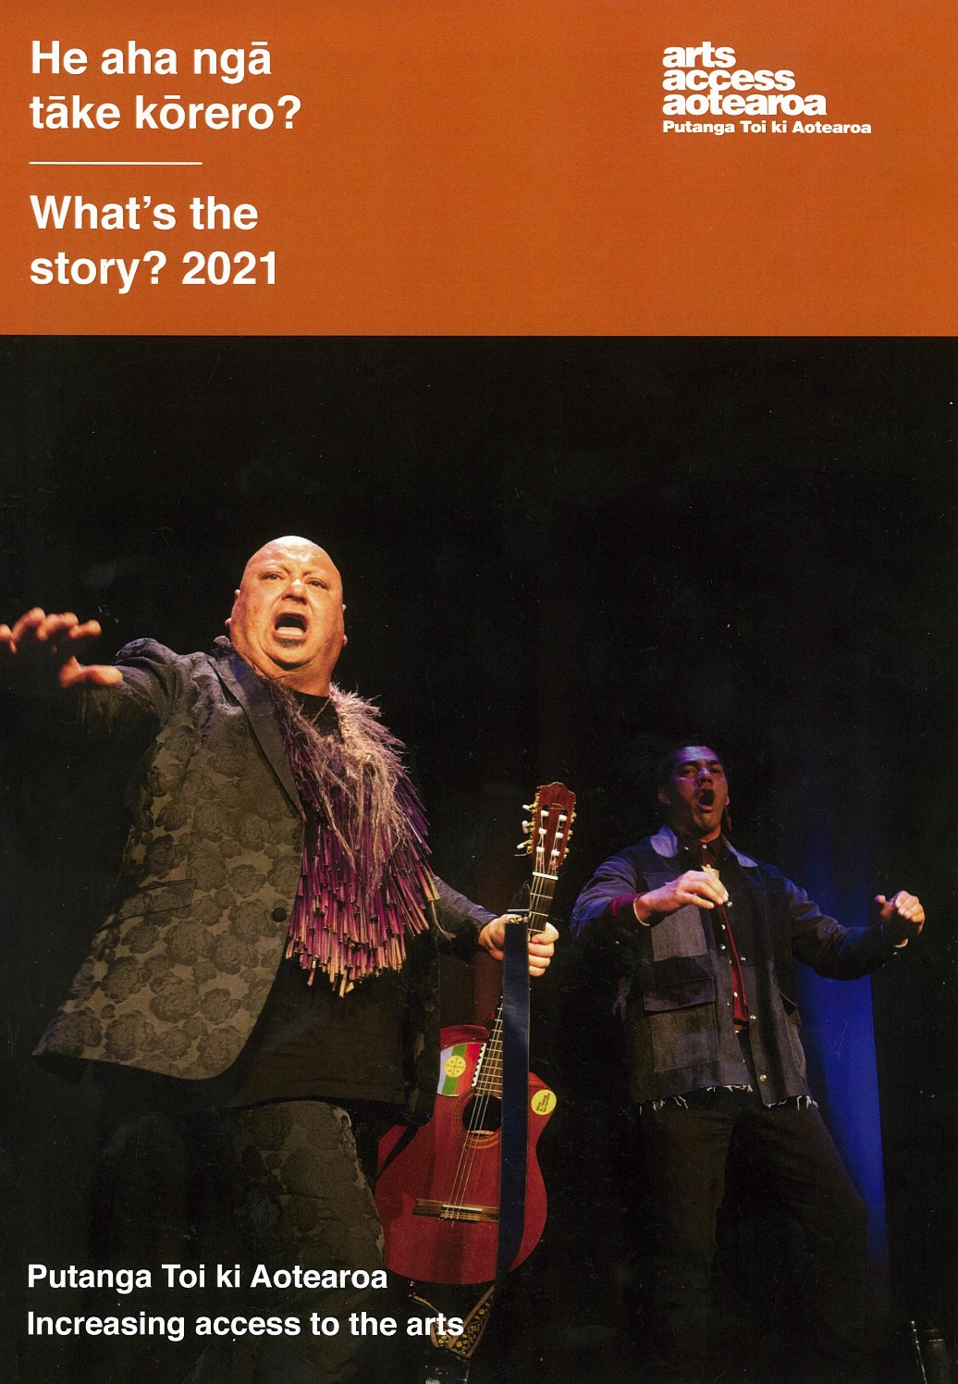

Annual Report 2021
About Arts Access Aotearoa

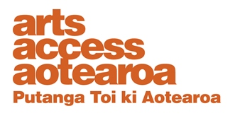
Arts Access Aotearoa works so everyone can enjoy the arts.
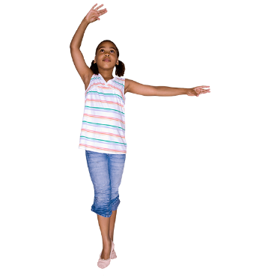

The arts means things like:
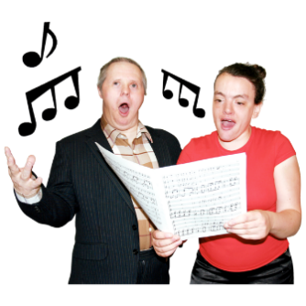
- dancing
- music / singing
- acting

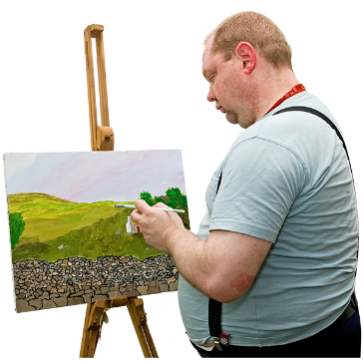
- things in museums / galleries

- paintings
- writing
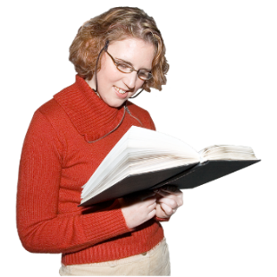
  - poems
  - stories

  - novels / books.
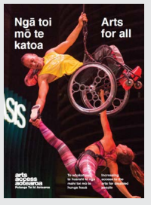
We work to make it easier for people who face barriers to be a part of the arts.

Barriers are things that stop or make it hard for people to:

- take part in the arts

- enjoy the arts.
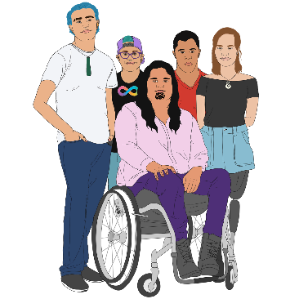

We do this by working with the:

- disabled community

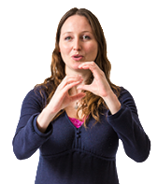
- autistic community

- mental health community

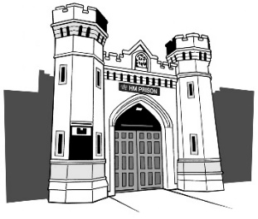
- Deaf community
- people in prison.

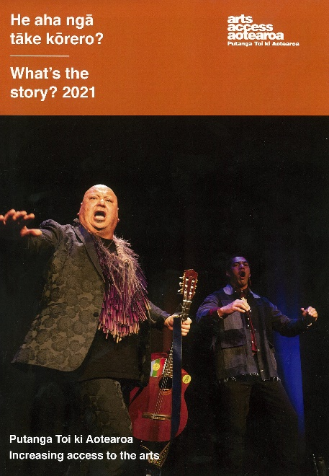
This is an Easy Read translation of some of the important things in our 2021 Annual Report.

An Annual Report is about:

- our goals

- our values

- the things that we have done in a year.

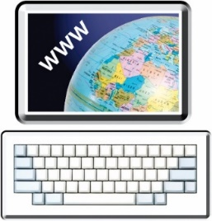
You can find the full Annual Report on our website at:

https://artsaccess.org.nz/
Our goals
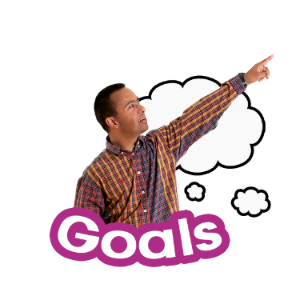

Goals are the things we want to make happen.

Arts Access Aotearoa has 3 goals of things that we want to make happen:

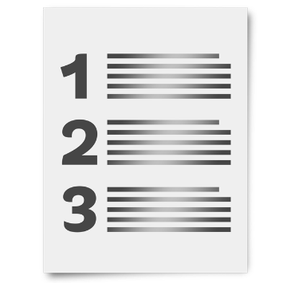
Goal 1: Access

Goal 2: Leadership

Goal 3: Influence.

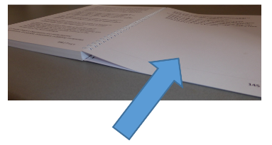
We talk more about each of these goals on pages 5 to 7.

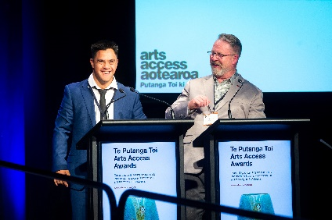
Goal 1: Access

Access is about working with others to make it easier for more people to enjoy the arts.

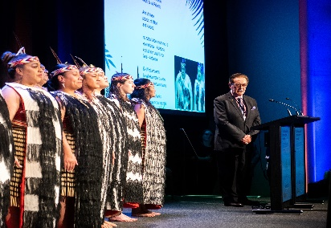
This includes:

- Māori
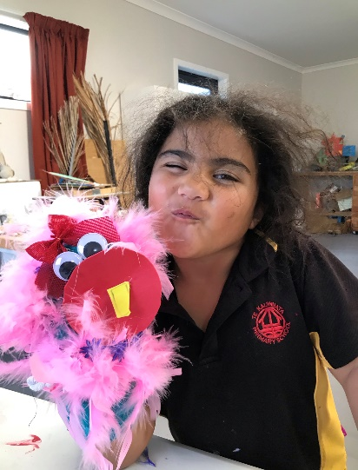
- Pasifika peoples
- disabled people

- young people

- Deaf people
- people in prison.

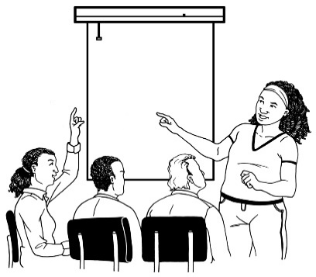
Goal 2: Leadership

Arts Access Aotearoa supports people so they can become leaders in the arts.

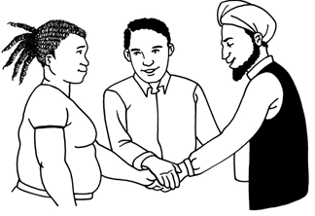
Leaders are people who bring people together to work on making things happen.

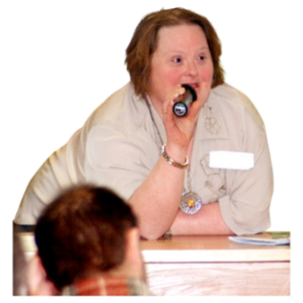
We want to support the people we work with to speak up.

Goal 3: Influence

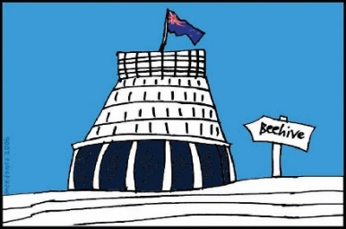
Arts Access Aotearoa works on getting more government support for everyone to enjoy the arts.
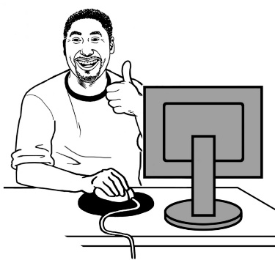

We provide lots of information that people can use to improve access to the arts.

Our values

Values are the things we believe in.

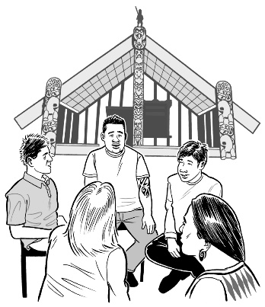
The values of Arts Access Aotearoa are:

- Mōhiotanga which means looking for understanding
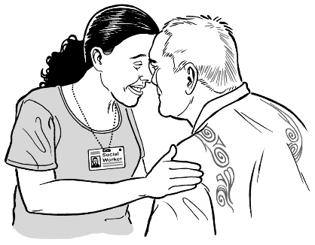
- Rangatiratanga which is respecting the mana of others
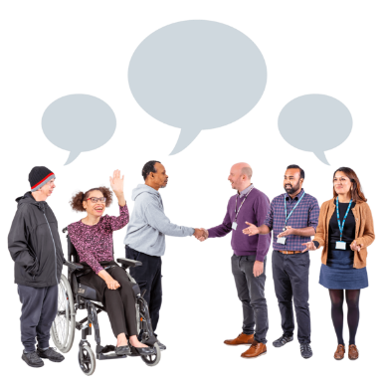
- Whanaungatanga which means we believe it is important to work together
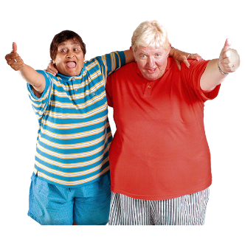
- Kotahitanga which is working well together to make the things we all believe in happen
- Kaitiakitanga which is doing things well for other people.
How COVID-19 changed things

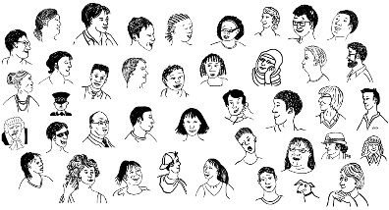
COVID-19 changed things for a lot of people in 2020 and 2021.

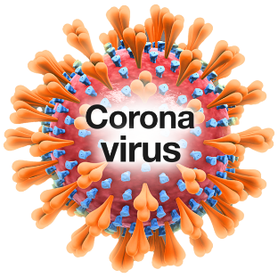
COVID-19 is a virus that can make people very sick.

To help slow down the spread of COVID-19 many of us did things like:

- staying at home if we were sick
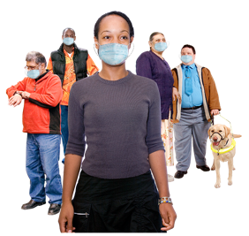
- getting our COVID-19 vaccines

- wearing a face mask when we went out.
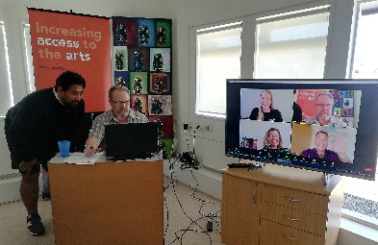

COVID-19 meant we held a lot of our meetings online.
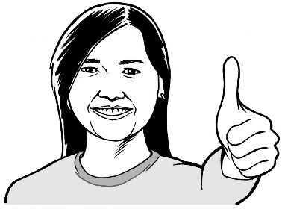
Arts Access Aotearoa is proud that people in the arts found ways to still make things happen.

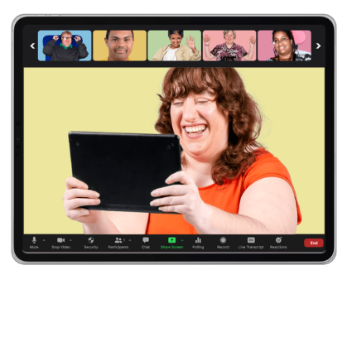
Some of the ways that the arts still happened were:
- people stayed in touch with their communities using the internet
- some art classes were online

- some performances were online.

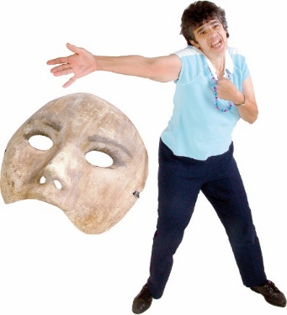
A performance is something people can watch like:
- a play
- singing

- dancing
- reading poems.
Te Putanga Toi Arts Access Awards

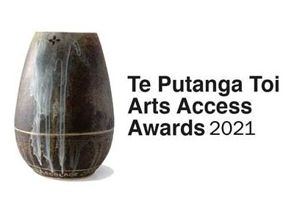
The Te Putanga Toi Arts Access Awards are given to people who have made it easier for everyone to be part of the arts.

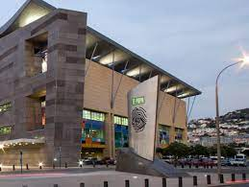
In 2021 Arts Access Aotearoa gave out the awards at Te Papa.

Te Papa is the New Zealand national museum in Wellington.

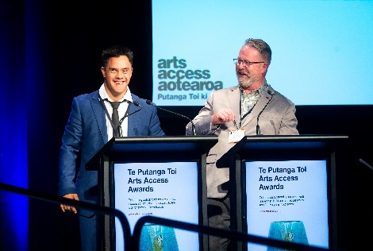
Jacob Dombroski is an actor.

He was 1 of the people on the stage telling people what was going to happen at the awards event.

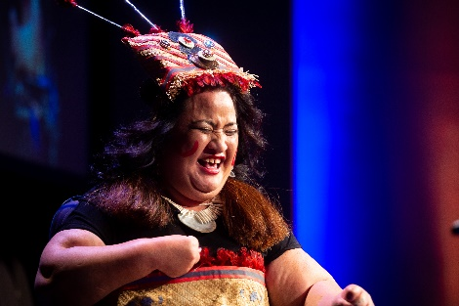
Lusi Faiva is a dancer.

She won an award.

She also did a dance at the awards event.

Performances everyone can enjoy

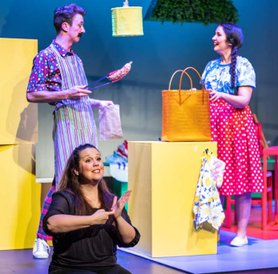
Performances can be hard for:
- people with learning disability
- autistic people.

Relaxed performances can be better because
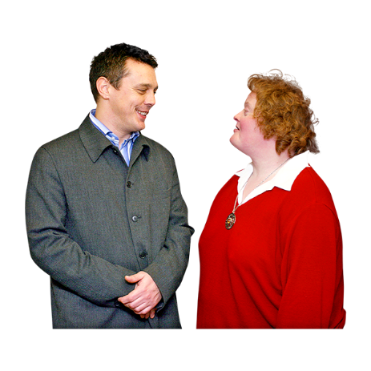
- the lights are not too bright
- it is okay to:
  - talk
  - move around.
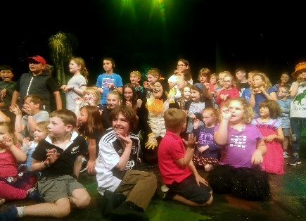
In 2021 there were 37 relaxed performances or events in New Zealand.
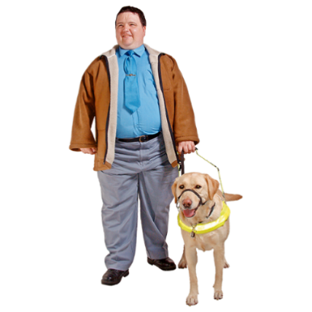
Audio description is a way for people who are blind or have low vision to enjoy performances.

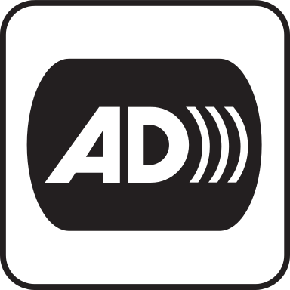
Audio description is when someone tells you what other people can see like:

- costumes

- dancing.

In 2021 there were 44 audio described:
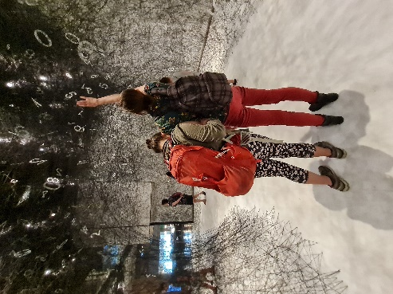
- performances

- museum tours

- arts events.

New Zealand Sign Language is used in theatres so Deaf people can enjoy performances.

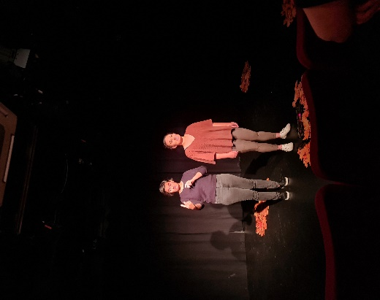
New Zealand Sign Language interpreters:

- stand on the stage

- tell Deaf people using sign language what the actors are saying.

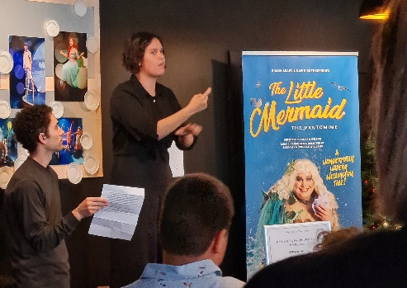
In 2021 there were 44 New Zealand Sign Language interpreted:

          - performances

          - museum tours

          - arts events.

Creative spaces
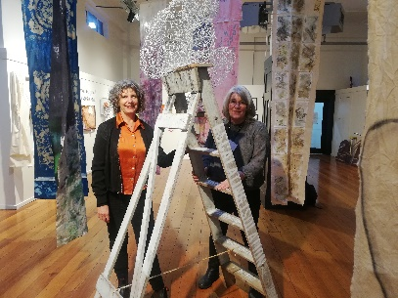
In 2021 Arts Access Aotearoa worked with creative spaces to support them with the hard things that happened because of COVID-19.

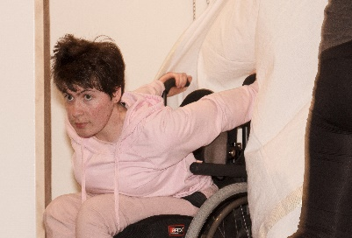
Creative spaces are places where people can go to do things like:
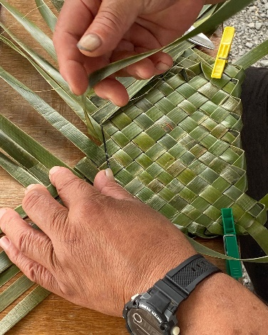
- dance
- paint
- weave
- make music.

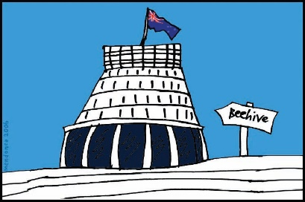
In 2021 many creative spaces got money from the Government’s 18 million dollar fund to help creative spaces.

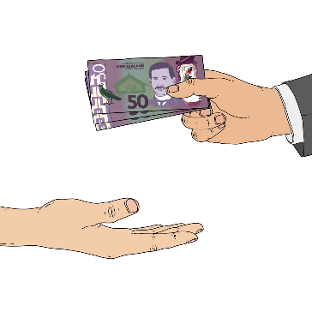
A fund is money that can be given to people or organisations to do specific things.

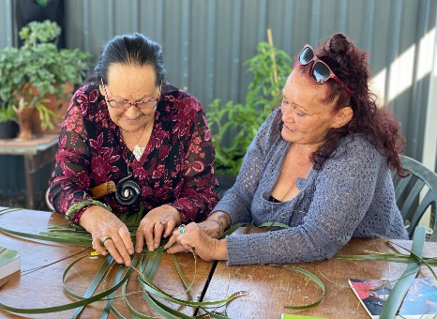
Some of this funding was given to creative spaces:

- for more people to have jobs

- for more people to make art.

Arts in prisons

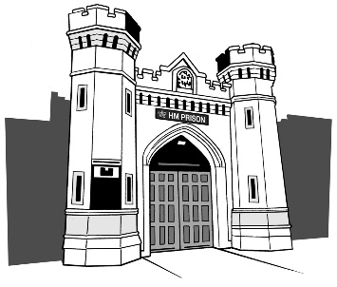
Arts Access Aotearoa also works with people who are in prison so they have access to good arts activities.

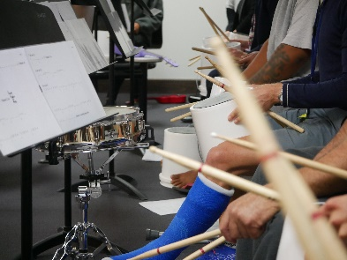
People do things like:
- music
- painting
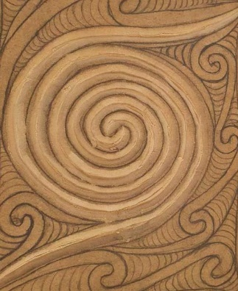
- weaving
- carving

- creative writing.
There are lots of good things people in prison learn when they do arts activities.
Where to find more information

You can find out more about Arts Access Aotearoa on our website at:
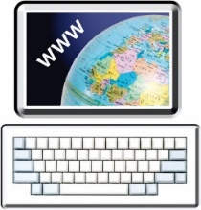
www.artsaccess.org.nz.

You can also contact us:
- by email to:
info@artsaccess.org.nz
- by phone to:
04 802 4349

- by post to:
PO Box 9828
Wellington 6141.
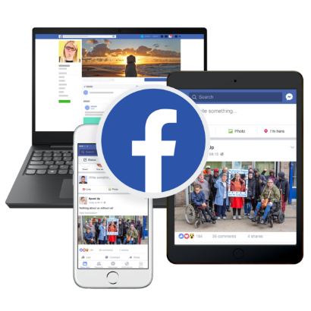
You can find out more about what we do on social media:

- Facebook
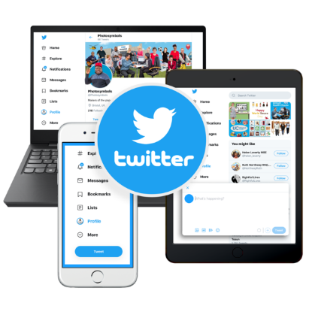
facebook.com/ArtsAccessAotearoa

- Twitter
twitter.com/ArtsAccessNZ
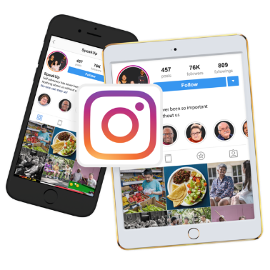
- Instagram
instagram.com/arts_access_aotearoa

This information has been written by Arts Access Aotearoa.
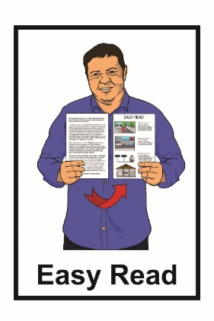
It has been translated into Easy Read with advice from the Make It Easy service of People First New Zealand Inc. Ngā Tāngata Tuatahi.

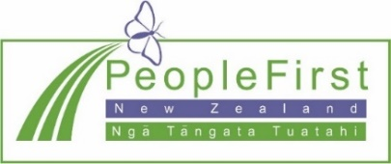
The ideas in this document are not the ideas of People First New Zealand Inc. Ngā Tāngata Tuatahi.

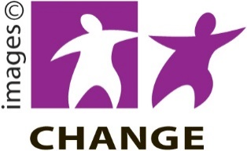
Make It Easy uses images from:

- Changepeople.org

- Photosymbols.com
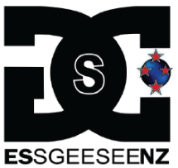
- SGC Image Works
- Huriana Kopeke-Te Aho.

All images used in this Easy Read document are subject to copyright rules and cannot be used without permission.

