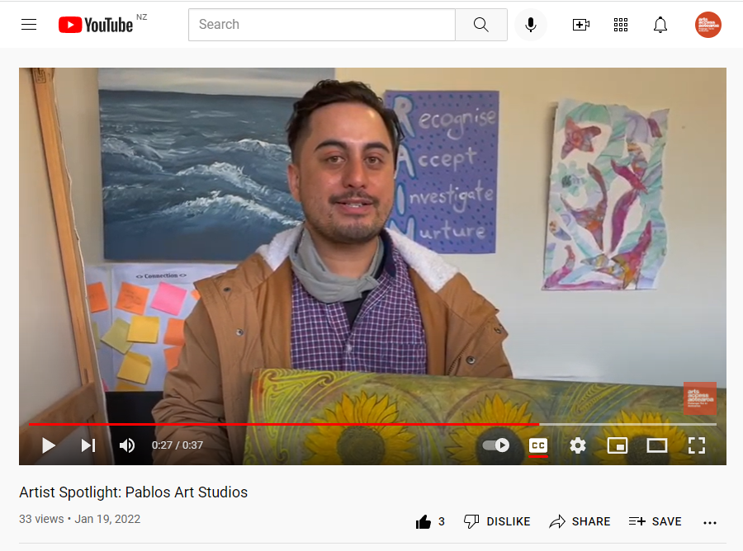
Guidelines for creating an Artist Spotlight Video

By Lachlan Giddens

This is a step-by-step guide to help you create your own short video. We suggest a video between 30 to 60 seconds that focuses on a single artist. This video will act as a testimony for the benefits of your creative space.

Note that this is just a guide providing an easy format for those who might be unfamiliar with video production and editing. Feel free to use a format that suits you.

Visit Arts Access Aotearoa’s YouTube channel for examples of Artist Spotlight videos.

Part 1 - Recording your video

1. Find the artist you would like to spotlight.

2. Select with the artist or performer the piece of work they will focus on.

3. Brainstorm a short script. We encourage the artists to include brief descriptions of their work and of themselves. This is especially helpful for blind or low vision people. Your script should answer these three questions.
- What would you like to share about this piece of work? For example: what it’s called, what you made it from, why you made it, how you felt when you made it. Include a brief description of what it looks like. For example: This artwork has three big yellow sunflowers with dark brown centres.
- How has the creative space supported or inspired you to create this work?
- Who are you? What do you want people to know about you? Did you wear something especially for the video? An example: “My name is Sam. I’m wearing a tee-shirt that says ‘The future is accessible’ and I’m leaning on my walking stick.”
It’s up to you which order the questions are answered in. For example, you may want to answer “Who are you?” first.

4. Once the artist has practised this a few times and feels comfortable with their script you are ready to record. Be careful not to over-rehearse as it needs to feel natural.

5. Filming on a phone means that you have easy access to equipment and good video quality. Landscape is always best.

6. Begin with the camera close up to the work and slowly move across and back to show more of the work as the artist describes it.

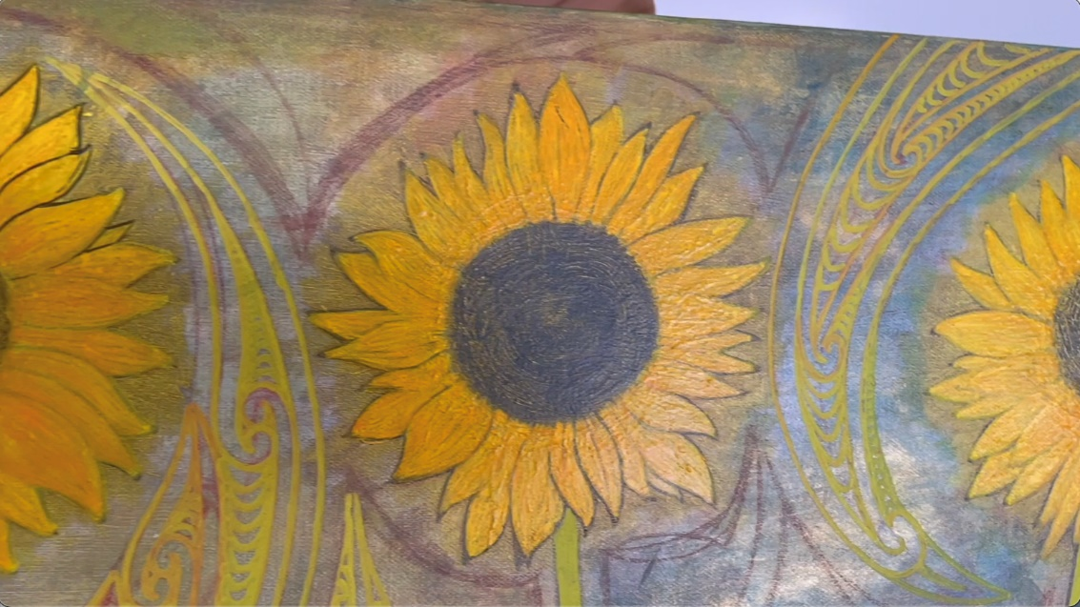
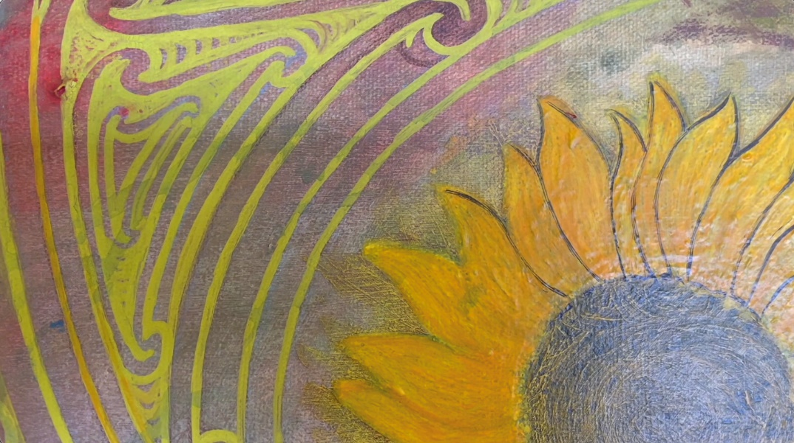

7. Step back and film both the artist and their work as they introduce themselves.

8. This may take a few tries but once you have a take you are happy with you should be ready to edit it together.

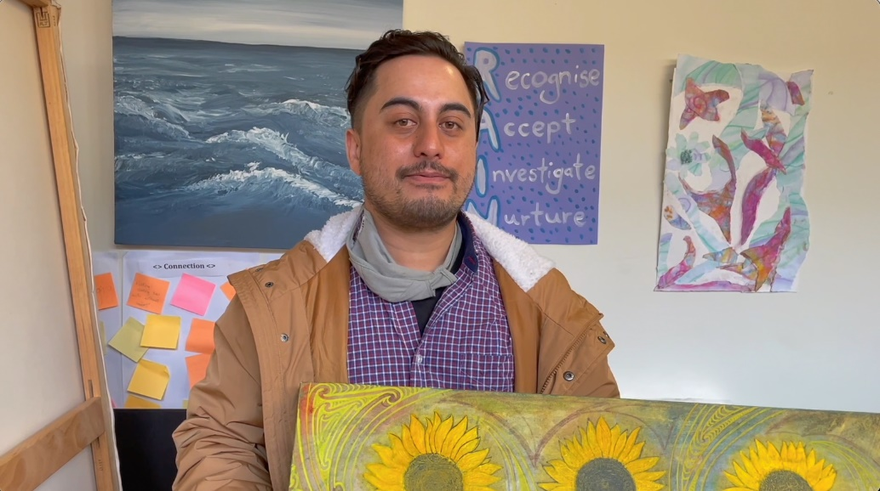
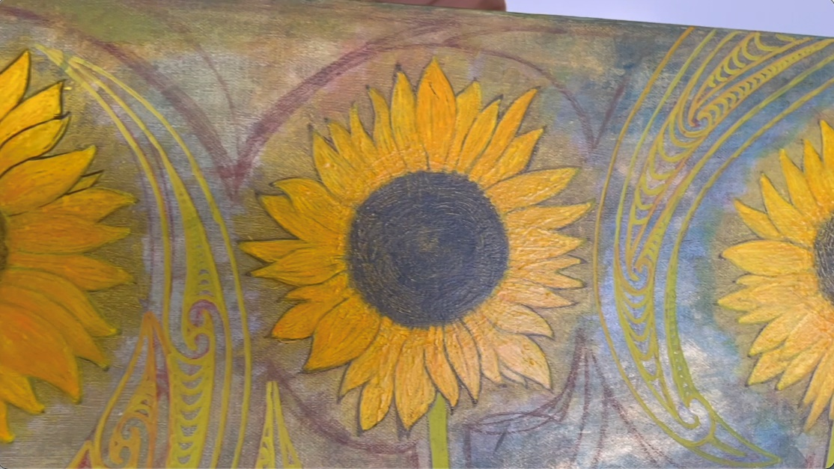

9. If the artist is performing, this will be a more complicated process and will require at least three clips.

10. We suggest you record a video of the artist performing and then a separate video of them speaking about their performance. Make sure these two clips are a similar length (40 seconds or so) to make editing easier.

11. Then record a separate clip of the artist introducing themselves to the camera.

12. Save the videos you have to your computer. This can be done by saving it to your computer directly through Airdrop, Dropbox (or similar) or email.
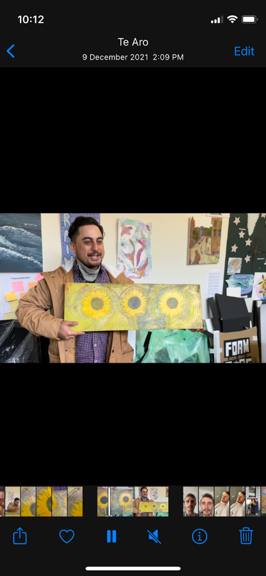
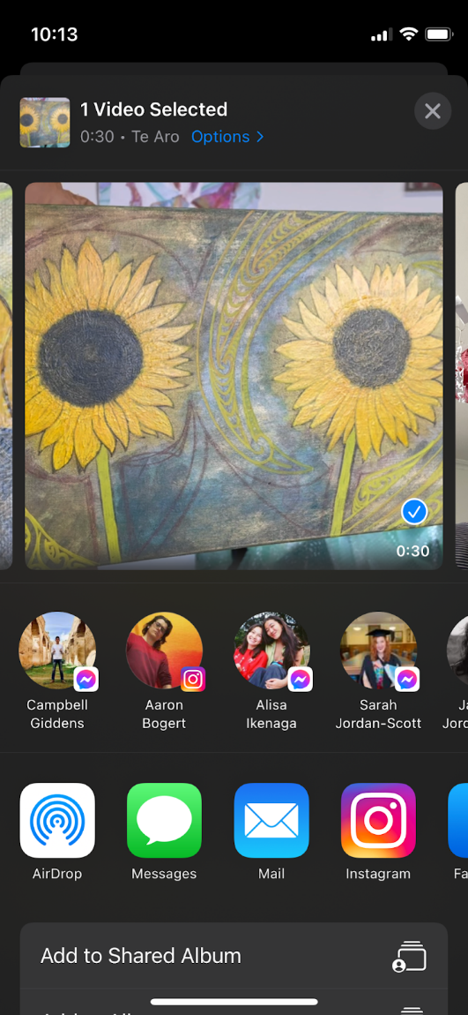
Part 2 - Editing Your Video

1. Video Editor is free editing software that is pre-installed on most Windows computers.

2. Once you have opened the software you will need to create a new project. Call it something relevant like Artist Spotlight Video.
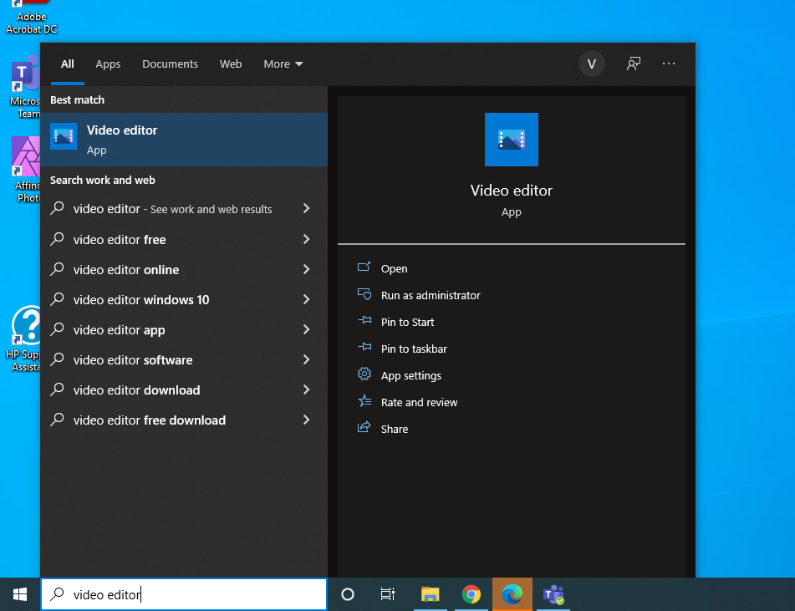
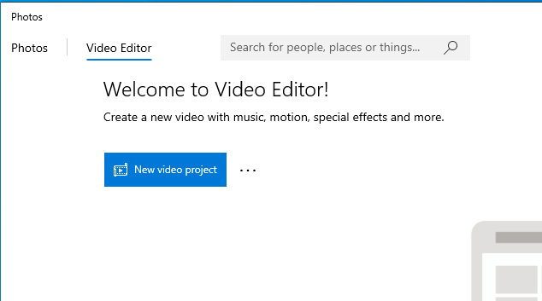

3. Next you will need to bring in your footage and the other elements (e.g. logo) of your video. Select ‘Add’ followed by ‘From this PC’. You will then be able to select your files.

4. Drag your footage and other files down into the main editing bar. If you have an additional clip of the artist/performer introducing themselves, place it after the clip of them performing.
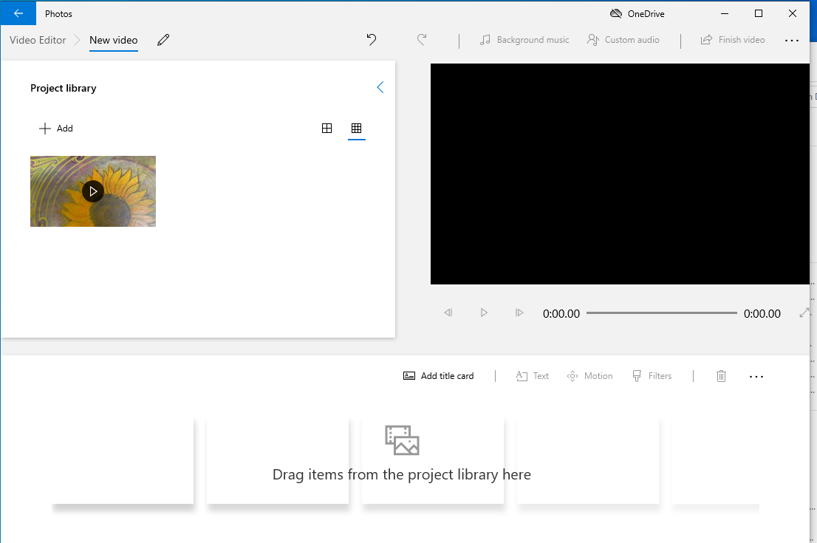
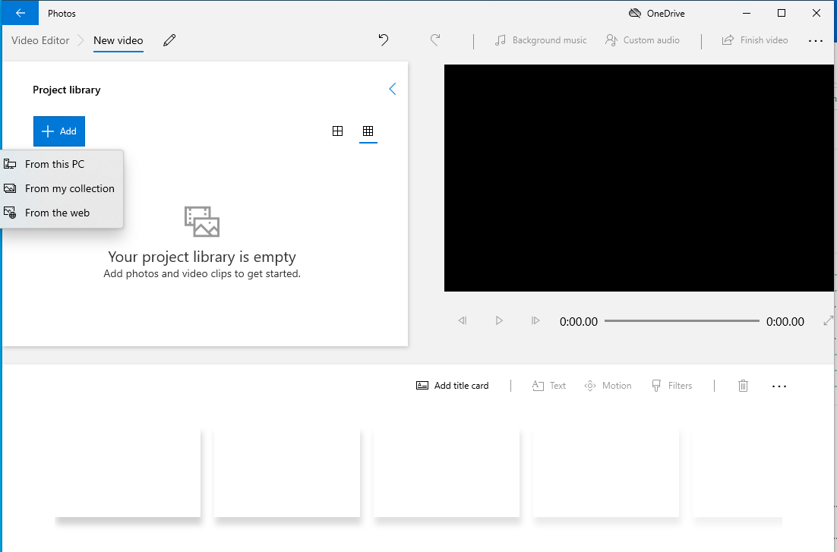

5. The next stage is to add music to the video. Select ‘Background music’.

6. Scroll through the available options until you find something you like. Once your selection is highlighted you will need to adjust the volume to ensure it does not overpower the video, then select done.
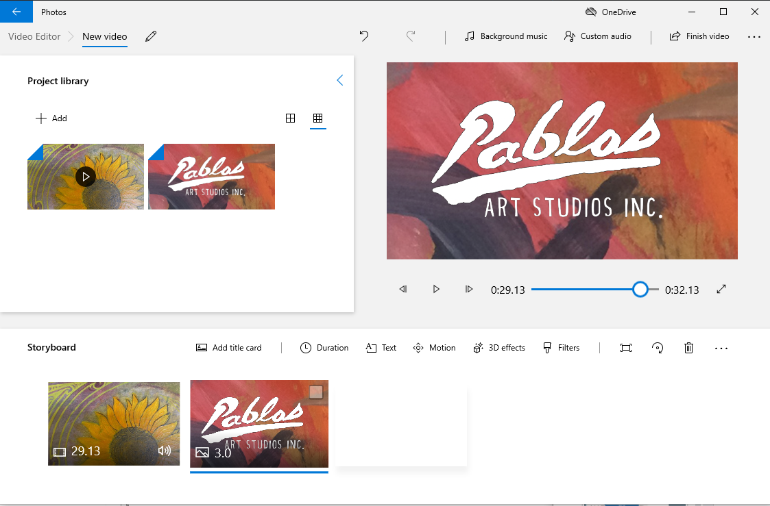
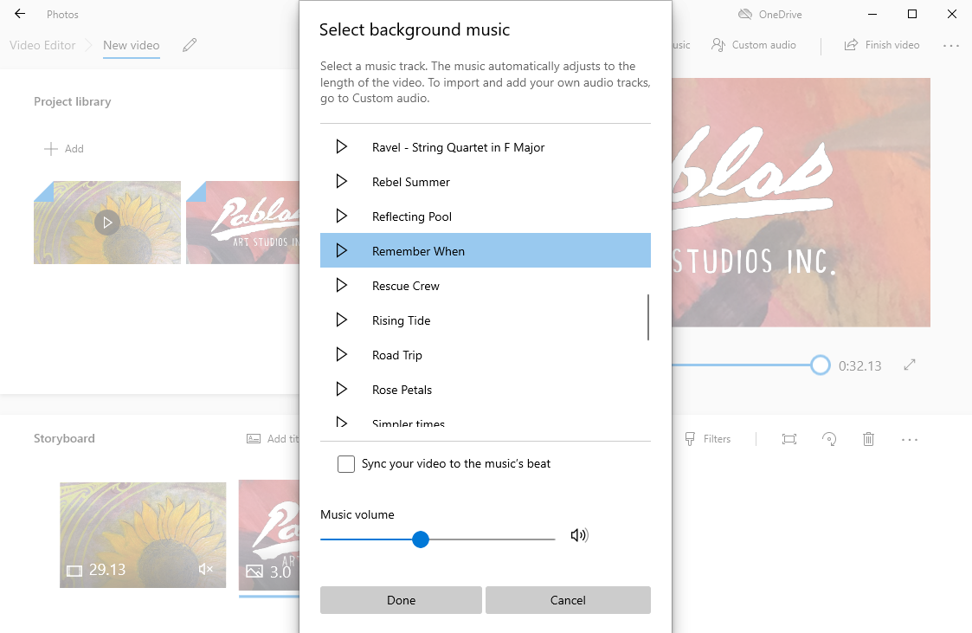

7. If you have recorded separate clips of the artist performing and speaking make sure the clip of the performance is in the main editing bar. You can then overlay the audio of the artist talking. Select ‘Custom audio’.

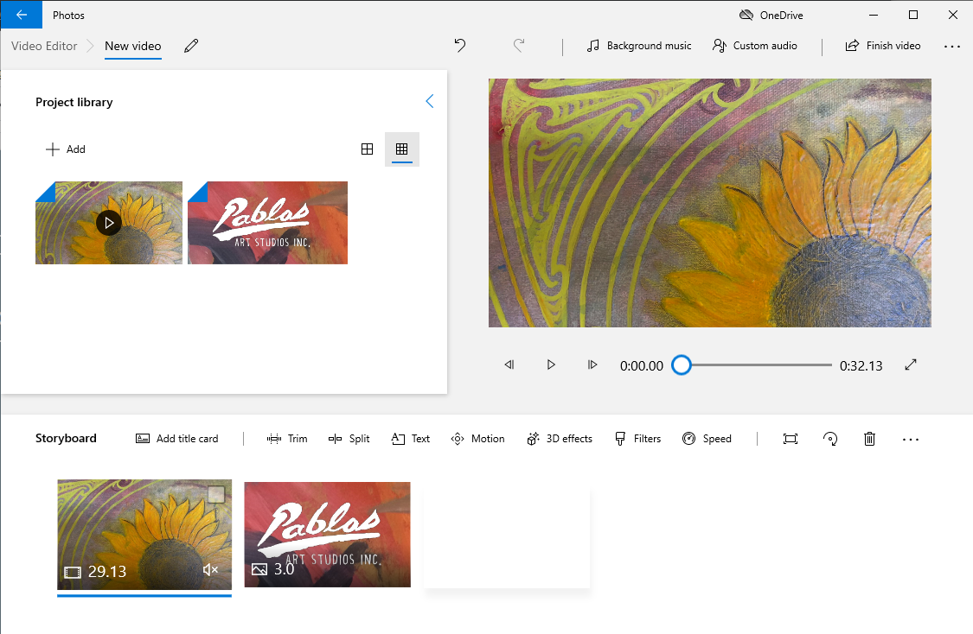
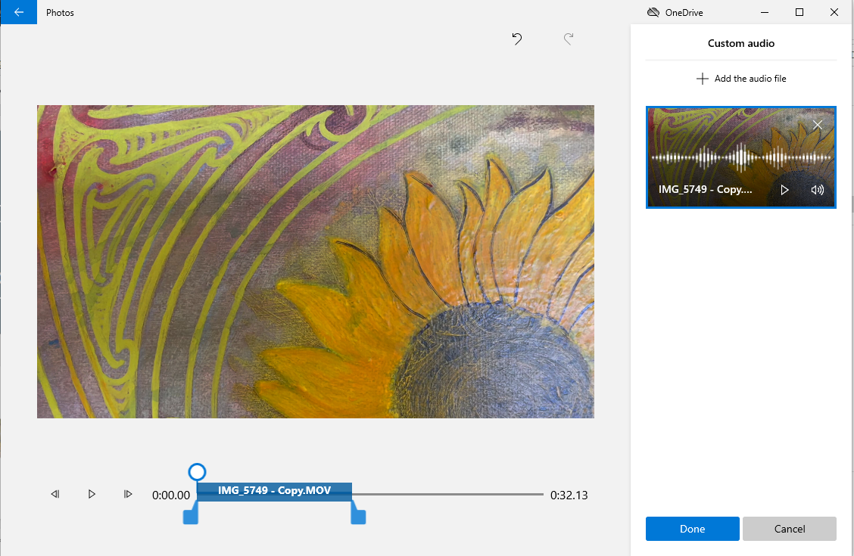
8. Select ‘Add the audio file’ and choose the clip of the artist speaking about the performance. The sound from the clip will then appear over the video and you can then adjust the timing as shown below. Following this, select ‘Done’.

.

10. To add text at the end select ‘Add title card’. Once it appears click and drag the card to the right side of the other clips.

11. If the tile is not black you may want to change the colour. Select the tile and click on ‘Background’ just below the preview window.
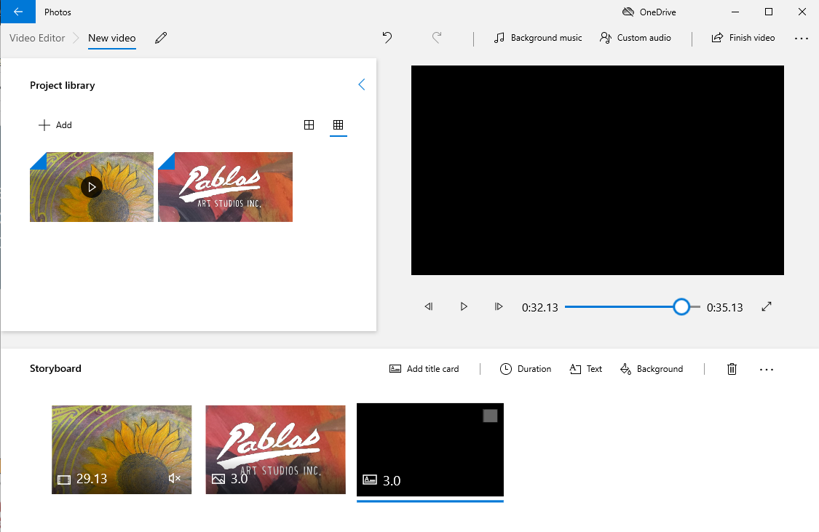
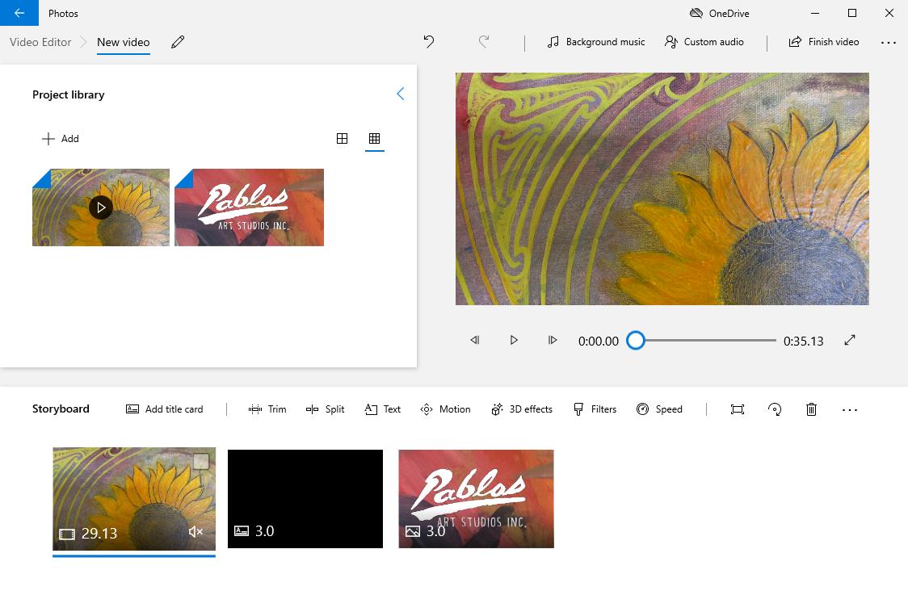
11. Scroll through the options and select the black square before pressing ‘Done’. Black is preferable but you can select any colour as long as there is strong colour contrast with the text.

12. To add the text you will need to once again select the blank tile and press the ‘Text’ button above it.
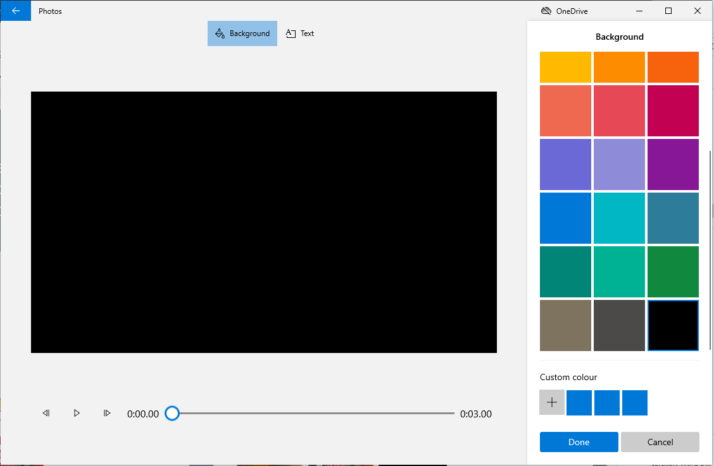

13. Add the text in the box and select an easy-to-read font. Select the standard layout and then press ‘Done’.

14. It is a good idea to get a colleague to help you double-check for errors. Ensure the artist is happy with the final video too. Then select ‘Finish Video’ and, finally, ‘Export’.

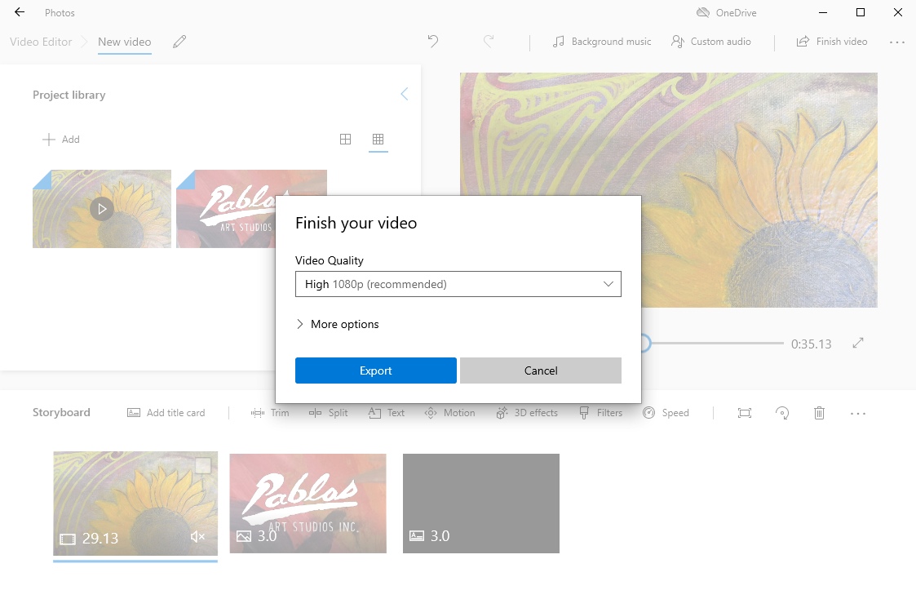
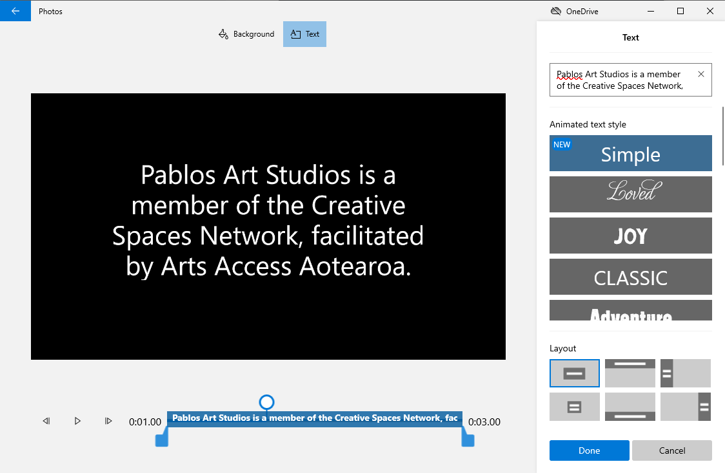
15. Once the file is exported you can upload it to your YouTube or Vimeo channel, or send it to Arts Access Aotearoa to post on its YouTube channel.

16. On YouTube select the camera icon and then upload your video.

17. Once the video is uploaded, title it Artist Spotlight: [your creative space]. You should also add a description for the video and some information about your creative space.

18. It is also important to subtitle/caption your video. You can do this through YouTube.
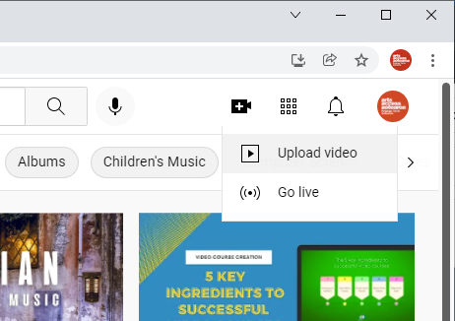
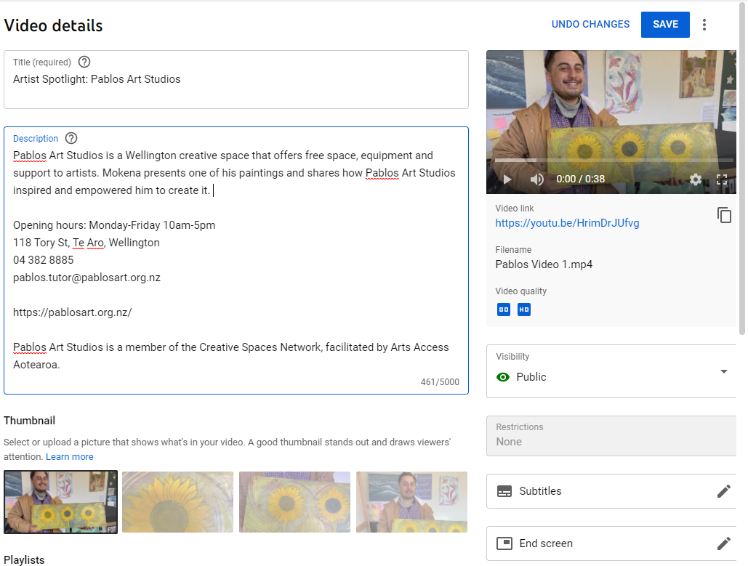
Now you need to promote your great new video. YouTube has a built-in Share button where you can post to your social media channels.

Encourage your colleagues to like and comment on your video.

In 2021, 87% of New Zealanders were active users of YouTube so make as many high-quality videos as you want. The more the better!
