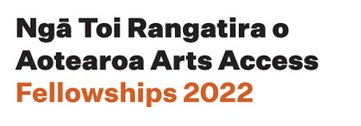
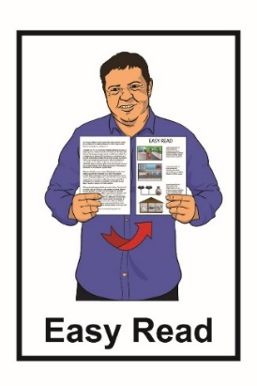

Ngā Toi Rangatira o Aotearoa
Arts Access Fellowships 2022
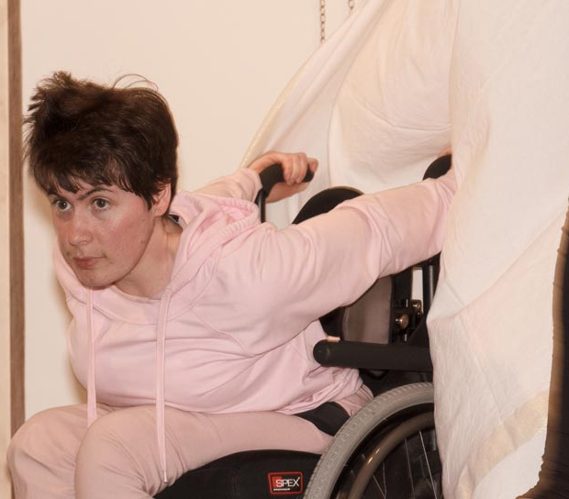
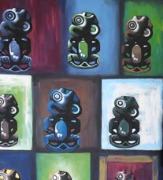

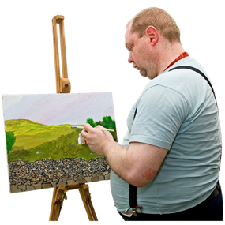

Information about all 4 fellowships
What you will find in here

Page number:

Ngā Toi Rangatira o Aotearoa Arts Access Fellowships 2022………2

The 4 fellowships 4
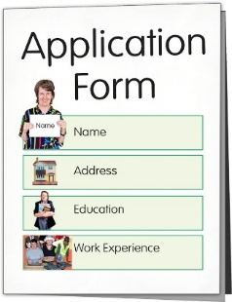

How to apply for a fellowship……….12

Getting support to do your application 14

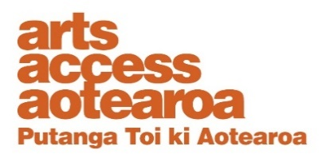
Where to find more information 16

Ngā Toi Rangatira o Aotearoa Arts Access Fellowships 2022

This year Arts Access Aotearoa is offering 4 different arts fellowships.

A fellowship is money that is given to someone so they can do their art.

Each of the 4 fellowships is 10 thousand dollars.

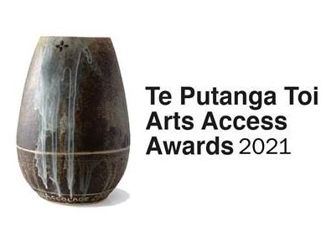
Arts Access Aotearoa is offering these 4 fellowships instead of the Te Putanga Toi Arts Access Awards.

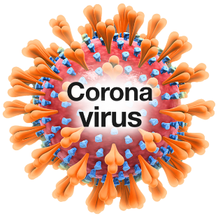
These fellowships aim to reduce the impact that COVID-19 has had on the arts community over the past 2 years.
Art can be things like:
          - dancing
          - music / singing
          - acting

          - painting

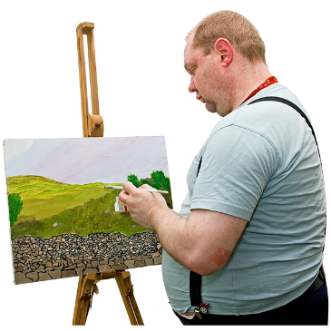
          - film making

          - writing:

  - poems
  - stories

  - novels / books
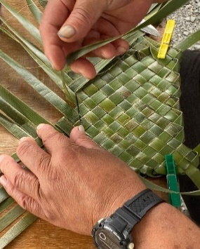
- Māori arts:

- whakairo – carving

- raranga – weaving.
The 4 fellowships

- Whakahoa Kaitoi Whanaketanga PAK’nSAVE Artist Fellowship
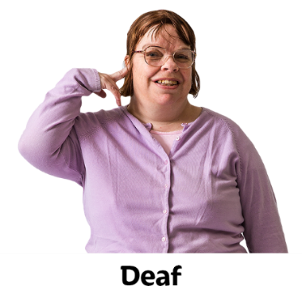

This fellowship is open to:

- Deaf artists
disabled artists
artists living with a mental health condition.

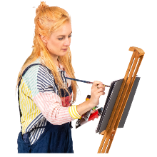
The PAK’nSAVE Artist Fellowship can be used to work on an arts project.

A project is when you use your art to make something.

You can find Easy Read information about the PAK’nSAVE Artist Fellowship on the Arts Access Aotearoa website:

www.artsaccess.org.nz/Arts-Access-Fellowships-2022

You can also phone or email Arts Access Aotearoa for more information about this fellowship.

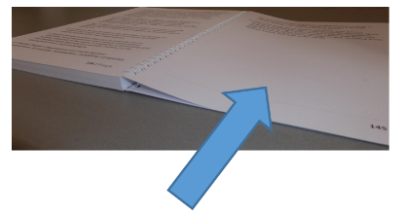
You can find the contact details for Arts Access Aotearoa on page 16 of this document.
- Whakahoa Kaitoi i Te Ara Poutama Arts in Corrections Artist Fellowship

This fellowship is to support an artist who is:

- living in the community

and

- is / has been in the criminal justice system.

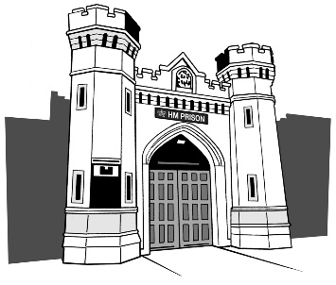
Criminal justice system means things like:

- being found guilty of a crime

- doing time in prison or community service.

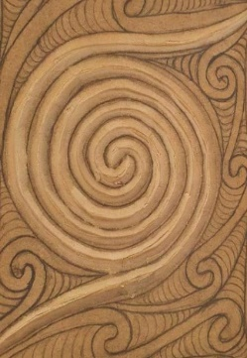
The Corrections Artist Fellowship is for an artist:

- to do more of their art

- to have a mentor who can help them with their art.

You can find more information about the Corrections Artist Fellowship on the Arts Access Aotearoa website:

www.artsaccess.org.nz/Arts-Access-Fellowships-2022

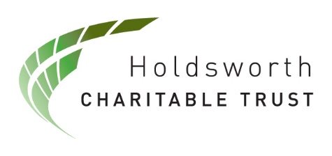
- Whakahoa Whakawatea Kaitoi Tangata Holdsworth Creative Spaces Fellowship

This fellowship is to support a facilitator / tutor-led project that brings artists to work together in a creative space.

A facilitator or tutor is like a teacher who knows a lot about doing art.

Accessibility will be built into the:

- creation / making of art

and / or

- presentation of new art or art work already done.
Accessibility means making it easy for people to take part in the arts.

You can find more information about the Holdsworth Creative Spaces Fellowship on the Arts Access Aotearoa website:

www.artsaccess.org.nz/Arts-Access-Fellowships-2022

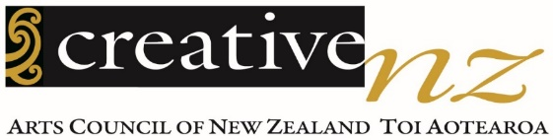
- Whakahoa Kaitoi Te Puna Toi Creative New Zealand Arts For All Fellowship

This fellowship is to support a person to research ways of making the arts more accessible to people.

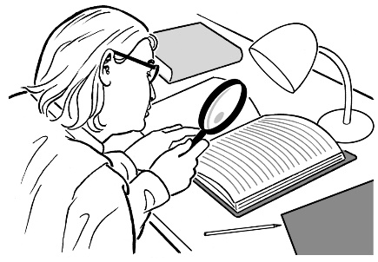
Research means to look into something closely for more information.

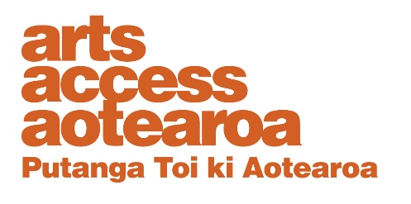
You must be working in or with an arts company or organisation that is a member of the Arts For All Network that is supported by Arts Access Aotearoa.

The Arts For All Network works
to improve access to the arts for Deaf and disabled people.

You can find more information about the Arts For All Network on this Arts Access Aotearoa website:

https://tinyurl.com/2s364ttk

You can find more information about the Creative New Zealand Arts For All Fellowship on the Arts Access Aotearoa website:

www.artsaccess.org.nz/Arts-Access-Fellowships-2022

How to apply for a fellowship
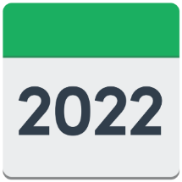
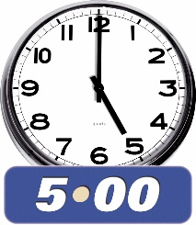

Arts Access Aotearoa must get your application by 5 pm on Monday 5 September 2022.

You can find the application form on the Arts Access Aotearoa website:

www.artsaccess.org.nz/Arts-Access-Fellowships-2022

You can also phone or email Arts Access Aotearoa to ask for the fellowship application form to be sent to you.

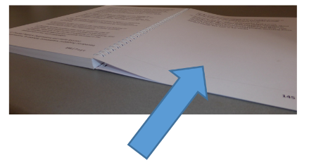
You can find the contact details for
Arts Access Aotearoa on page 16
of this document.

You can do your application as:

- a written application online or on paper

- a New Zealand Sign Language video
- an audio file.

Getting support to do your application

If you need some support to put together your application you can:

- ask someone you know
- talk to Arts Access Aotearoa.

You can email or phone Arts Access Aotearoa:

- Email:

fellowships@artsaccess.org.nz
- Phone: 04 802 4349

If you find it hard to use the phone the New Zealand Relay service is for people who:

- are deaf / hard of hearing
- are deafblind

- find it hard to talk.
You can find more about the New Zealand Relay service at this website:

https://www.nzrelay.co.nz/index

Where to find more information

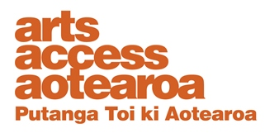
You can find out more about Arts Access Aotearoa on its website:

www.artsaccess.org.nz.

You can find out more about the fellowships on the Arts Access Aotearoa website at:

www.artsaccess.org.nz/Arts-Access-Fellowships-2022

You can also contact Arts Access Aotearoa about the fellowships by:

- Email:
fellowships@artsaccess.org.nz
- Phone: 04 802 4349
This information has been written by Arts Access Aotearoa.
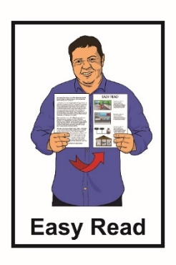
It has been translated into Easy Read with advice from the Make It Easy service of People First New Zealand Inc. Ngā Tāngata Tuatahi.

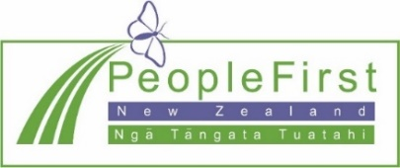
The ideas in this document are not the ideas of People First New Zealand Inc. Ngā Tāngata Tuatahi.

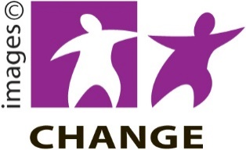
Make It Easy uses images from:

- Changepeople.org

- Photosymbols.com

- SGC Image Works.

Some images have been provided by Arts Access Aotearoa

All images used in this Easy Read document are subject to copyright rules and cannot be used without permission.

