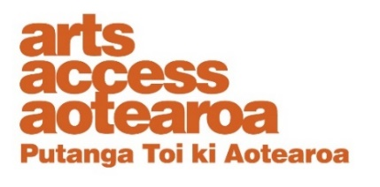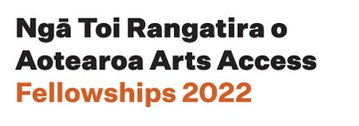

Fellowships 2022: frequently asked questions

It’s important to read this document and the one about the fellowship you wish to apply for before completing your application form.
Please get in touch if you want support to understand the information about the fellowship and to complete the application form. You can also ask a support person to assist you.
Contact Arts Access Aotearoa staff if you have any questions. You can phone us on 04 802 4349 or email us at fellowships@artsaccess.org.nz.
Budget questions

- Do I need evidence of quotes for costs?

No, you do not need to provide quotes but you must use figures that reflect an accurate market cost.

- What is a reasonable hourly rate for fees?

We recommend that you pay yourself and other collaborators no less than $25.50 an hour (more as appropriate, depending on levels of experience).

- Should I pay for community consultation?
Yes. It is essential to acknowledge the value of community participants by paying people for their time and knowledge. Remember to allow for this in your budget.

- Do I need to pay mentors?
Yes.

- Can I use part of my fellowship towards access-related costs?

Yes, for individual access needs. Get in touch with Arts Access Aotearoa if you have any questions.

- Can I include travel as part of my fellowship budget?

A small amount of travel may be included. However, you need to be able to show it’s essential for you to realise your goals for the fellowship.

Technical support material questions

- Can I send examples of my art by post or courier?

No. Please do not post or courier physical copies of support material or artwork. All support material needs to be sent as a digital file or link.
- What digital formats are acceptable for audio?

Please use mp3 files, if possible.

- What digital formats are acceptable for video?

Please use H264 or mp4 files, if possible.

- What size of files can be included in an email?
Please send files totalling no more than 5MB per email.

- How do I send larger files such as video/audio files?

Please send large files via WeTransfer or Dropbox. Do not send files larger than 100MB.

Ownership and promotional questions

1. Do I own the artwork I make as part of the fellowship?

Yes, artists (individuals or part of your organisation) keep ownership of their artwork but Arts Access Aotearoa would like to share images or video for publicity purposes.

2. Is there an obligation to share the findings, outcomes and art generated by these
Fellowships with Arts Access Aotearoa?

Yes. Arts Access Aotearoa would like to share the outcomes of the fellowships with the arts sector, sponsors and the wider community.

Payment questions

1. If successful, when will I receive my fellowship money?

This can be negotiated with you, based on your individual circumstances. However, our standard process is that recipients will receive half of the fellowship after you have signed the contract accepting the terms and conditions of the fellowship. After we have received your mid-project assessment report, the second instalment will be sent to you.

Accountability reporting questions

- Do I need to sign a contract?

Yes, you will need to sign a contract confirming your agreement of the terms of the fellowship.

- Is there a mid-project check-up required where I need to show my progress?

Yes. You will be required to complete a mid-point assessment that enables Arts Access Aotearoa to confirm you are on track with your project.

3. Is there a final report required for my project?

Yes. When you have finished your project, you will need to complete a fellowship evaluation and supply evidence of your final work.

4. What happens if things go wrong?

Please keep in touch with Arts Access Aotearoa staff because we’re here to help you achieve your goals. If there are any problems along the way, The important thing is to tell us as early as possible so that we can help you get things back on track.

Additional questions

1. Can I ask someone to help me complete my application?

Yes.

2. What happens if I miss answering a question and my application is not complete?

If your application has missed answering a question, Arts Access Aotearoa will prompt you to fill in any missing information. An incomplete application will be less competitive than a fully completed one.

