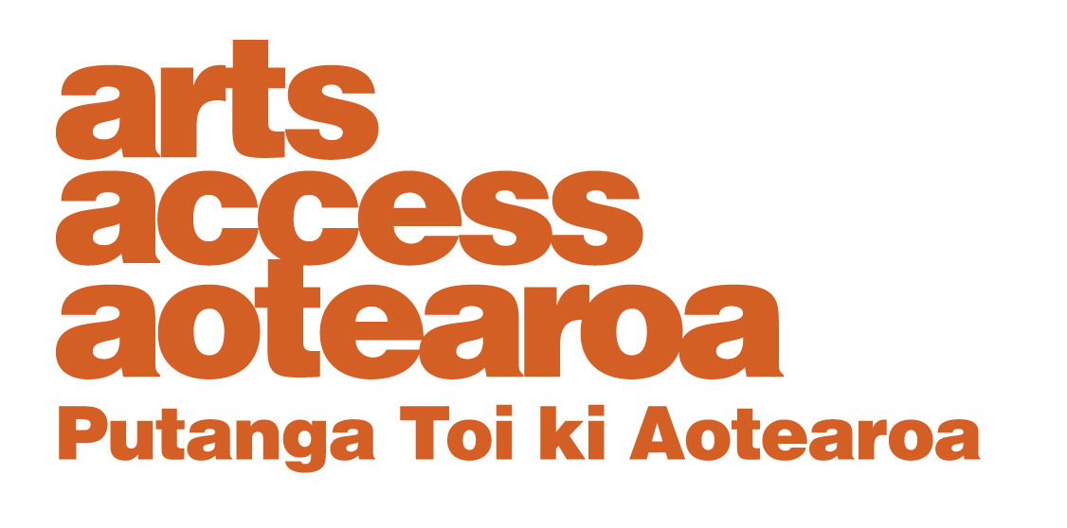
APPLICATION FORM:

Winton and Margaret Bear Charitable Trust grants 2021

Please ensure you meet the criteria, outlined in section 6.

You must complete all the questions in the application form. Incomplete applications cannot be considered.

1. Contact details

Name of individual or organisation to benefit from grant:

Date of birth (for individuals):

Address:

Telephone number/s:

Email address:

Contact details for the person making the grant application:

Name:

Telephone numbers:

Email address:

2. Required information

Please write your responses to points 1–4 in the following spaces. Alternatively, you may post us your hand-written responses, along with the application form.

1. Tell us about the young person or your organisation.
No more than 200 words

2. Tell us why you would like this grant and how you would use it. Please include a breakdown of costs.
No more than 200 words

3. How would the grant benefit the artistic development of the young person or people?
No more than 200 words

4. Please include the names and contact details of two referees whom we can contact.

REFEREE ONE:
Name:
Telephone number/s:
Email address:

REFEREE TWO:
Name:
Telephone number/s:
Email address:

5. Application deadlines

Please email your completed application form to: info@artsaccess.org.nz
by 12 noon Monday 24 May 2021.

If you have any questions, please contact Dawa Devereux, Arts Access Aotearoa (T: 04 802 4349 info@artsaccess.org.nz).

6. Eligibility Criteria

Arts Access Aotearoa is calling for grant applications to the Winton and Margaret Bear Charitable Trust from individuals and groups who meet the following criteria:

- The young people benefiting from the grant must demonstrate artistic potential across any artforms.

- The young people benefiting from the grant must live in the Greater Wellington region (i.e. Wellington City, Lower Hutt, Upper Hutt, Wairarapa, Porirua, Kapiti Coast).

- The young people benefiting from the grant must be aged 21 years or under on 30 June 2021.

- The young people benefiting from the grant require support in one or more areas stipulated by the Winton and Margaret Bear Trust objectives: confidence building, self-motivation, control of aggression, coping with the demands of society, and physical and mental wellbeing.

