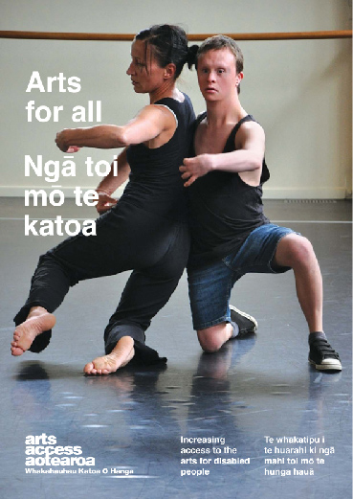
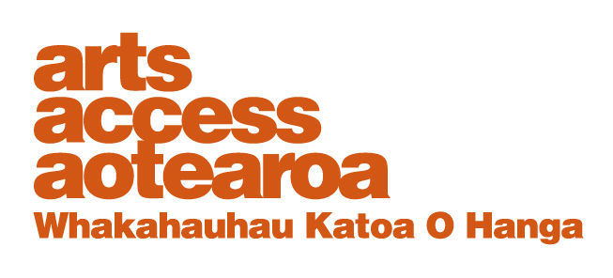
Q & A: ARTS FOR ALL
Audio Described Aotearoa
Putting blind people in the picture is what Auckland audio describer Nicola Owen does for a living. She talks to Arts Access Aotearoa about touch tours and audio description of arts and cultural events.
1. Background: about Audio Described Aotearoa

My own audio description training was via Auckland Live’s SIGNAL programme back in 2011. I set up Audio Described Aotearoa in 2014 with my partner, Paul Brown, who is blind. This was in response to the growing demand for audio description in New Zealand. We wanted to make it easier for organisations and venues to provide audio description for blind and vision impaired people.
We provide training for staff, advice on applying for funding, and how to market to the blind community about audio description and touch tours. We’re passionate about quality control and ensuring that blind and vision impaired people across New Zealand can access a variety of arts and cultural events.
You can watch Arts Access Aotearoa’s audio described video called Access For All, where Paul and I talk about the benefits of audio description.

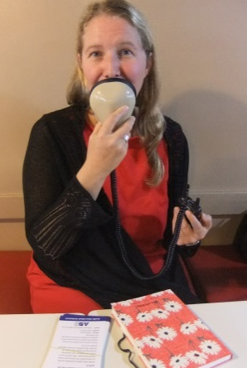
2. Tell us about the range of arts and cultural events you audio describe.
The range of arts and cultural events that are audio described is increasing rapidly as awareness of audio description grows. So far, we’ve used it in theatres, chamber music, award ceremonies, opera, contemporary dance, photography and art exhibitions, conference presentations, local festivals and events, children’s theatre, museums and galleries, sculpture and botanical gardens.

3. Does each artform bring its own set of challenges? If so, describe some of them.
Each artform is different, and we adapt our audio description accordingly to ensure high-quality delivery. However, the principles are the same. The most important thing is to describe what is seen in an objective way so that patrons can draw their own conclusions and opinions about the performance, exhibition or presentation.
For some events, such as tours, patrons can ask questions along the way and so audio description needs to allow time for this to happen.
For other events, audio description needs to be developed sensitively. For theatre productions, it’s important not to give away the plot: for example, when a character is “in disguise” and the disguise is removed later on during the show. This sensitivity to the essence of each production is crucial.
The audience listens to the description of a play through headsets and hears words that describe the action. The whole process of preparing audio description – from marking up the script and allowing silence where there’s dialogue or important gaps in the action on stage to finding the right words to describe what is seen – takes about 25 hours of preparation for each hour of the show.
Dance is the most recent artform we’ve worked with and it’s got particular challenges. Blind or vision impaired people may not have had previous access to dance and so dance vocabulary also needs to be made accessible.
This is where touch tours and workshops can be particularly useful: for example, an acrobat might allow a blind person to feel the position their body will be in during a contortion, or a blind person could be shown how to move their arm in a particular way so they can physically experience the meaning of dance terminology.
For dance, the combination of audio descriptions, workshops and touch tours can mediate people’s understanding.
In audio describing children’s theatre shows, an age-appropriate vocabulary needs to be used and the tone of voice needs to vary. It’s hugely important that blind and vision impaired children are able to access the arts, so they can experience creativity as fully as possible and also continue to expect to be able to participate in the arts.

4. What’s the point in audio describing music? Isn’t it about listening?
There’s a huge range of musical instruments involved in musical performances, and some of them are historic or from other cultures. Touch tours can illuminate the difference between, say, a cello and a rare baroque viol with seven strings.
Some music performances involve the performers interacting with the audience or each another in a variety of ways. For blind or vision impaired patrons, these connections and interplay are missed without audio description. If a violinist steps away from a music stand and plays without reading the music, showing their mastery of their instrument, the whole audience needs to experience that moment.

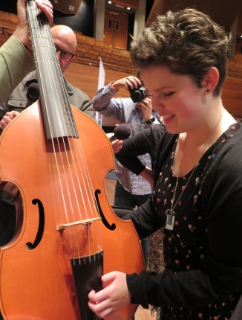
5. When do touch tours add value to an audio described event?
Touch tours add great value whenever there’s visual or sensory material included as part of the event. With opera productions, for example, touch tours are a particularly important part of the experience. These companies invest huge energy and resources into costumes, set design, props and so on. During touch tours, the set, props and costumes can be experienced using touch. Some opera productions have hugely elaborate costumes made of velvet or lace; others have masks and head-dresses made from cardboard and all kinds of materials.
Touch tours are also particularly effective when the actors or singers participate. If their voices can be heard in advance of the show, patrons can identify who is speaking or singing.
Touch tours also work well for art and sculpture exhibitions, garden tours and gallery visits. Really, anything that involves tactile objects or materials being part of the whole experience.

6. Is there a growing demand for audio described arts and cultural events?
Definitely. People are starting to ask for audio description and expect it to be available. More arts organisations than ever before are incorporating audio descriptions and touch tours into their programmes. This means greater accessibility and participation, as well as more diverse audiences at arts events.

7. Looking ahead, what do you see as key challenges in developing audio description and its audiences?
The biggest work we’ve still to do is in developing new audiences. We particularly need to reach out to older people who are losing their sight to let them know audio description is available so they can continue to enjoy the arts.
We’re continuing to reach out to children and their teachers, and engage with communities to find out what blind and partially sighted people want. Unfortunately, when we’ve found out what kinds of shows people would like to be audio described, organisations haven’t always been interested in offering it.
We’ve been doing a huge amount of training over the past two years, but there’s still much to be done. It’s important to continue training staff in accessible venues so that other organisations will see their confidence and consider the many benefits of increasing their own accessibility.

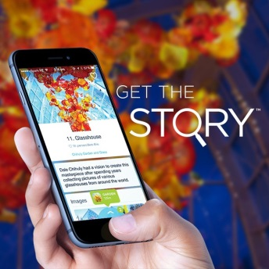
8. And finally, where do you want Audio Described Aotearoa to be in 2020?
It would be great to see a strong network of audio describers all around New Zealand, making it possible for blind and partially sighted people to go anywhere and at any time.
The STQRY app is a mobile storytelling platform that helps visitors engage with museums and galleries in their own time and at their own pace. We’d like to see audio description become this flexible.
Over time, audio descriptions will need to reflect the cultural diversity of the New Zealand population, and be available in a variety of languages.
We’d like there to be a “democratisation of description” so cultural event organisers can confidently produce high-quality audio descriptions for themselves.

For more information:
Nicola Owen
Audio Described Aotearoa
T: 09 636 0316 / 0210 358 513
E: nowen20@hotmail.com

