Making the most of acebook:
a guide for community arts organisations

How do I get started?
Why would I use Facebook?

What should I post?
How do I build my audience?

What should I do with negative comments on my page?
c

How long should the posts be?

Contents

1. Why use Facebook
Four good reasons to use
Facebook

2. How to get started

3. Write a strategy

4. What to post
Your cover photo
Ideas for content
Length of posts

5. When to post and how often

6. Voice/style of posts

7. Likes, comments and shares

8. Building your audience

9. Page insights

10. Negative comments – and what to
do
Code of conduct
Know your audience

11. Useful links

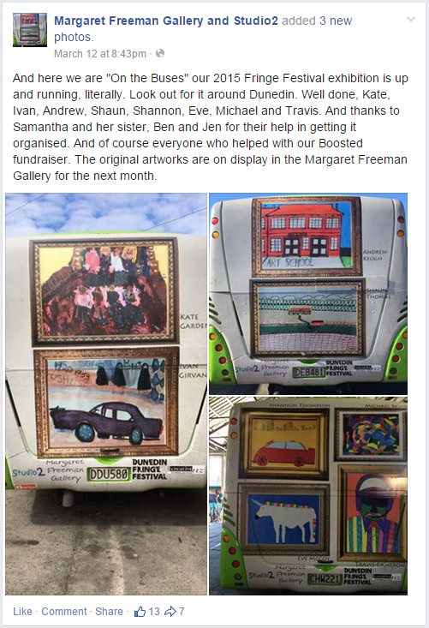

Acknowledgements:
Thanks to Carissa Paramita and Caitlin McNaughton, who wrote this guide in 2015.

Also thanks to Glen McDonald (Vincents Art Workshop) and Eryn Gribble (Alpha Art Studio) for their valuable feedback.

1. Why use Facebook

Imagine an audience of 2.4 million people. That’s the number of New Zealanders on Facebook (56% of the population).

Most of these users are aged between 18 to 24 and 25 to 34. However, the older demographic has increased significantly since 2012 with 22.4% of users aged between 45 to 64 in 2014.

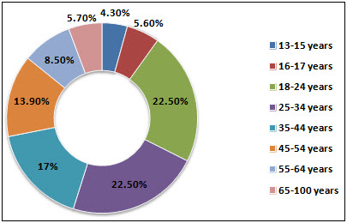
User age distribution, 2014 (socialbakers.com)

Perhaps you’ve noticed when you go online (e.g. online shopping, online games, booking airline tickets) that you’re often asked to login with your Facebook account.

This feature, called Facebook Login, was launched in 2008 to help app developers cross-reference users already linked on Facebook. In 2014, Facebook Login became the most popular social login for mobile apps, preferred by 44% of app users, ahead of Google IDs.

Facebook is here to stay and for non-profits, it’s still the best platform to build the character of your brand.

Four good reasons to use Facebook

- It’s a daily platform to share your news, promote what you’re doing and check what others are doing.
- You can have daily conversations with your community.
- You can monitor the feedback of your supporters.
- The newsfeed on Facebook provides access to relevant events and opportunities.
2. How to get started

For creative spaces, it’s best to create a “page” rather than a personal profile. Personal profiles represent individual people. You need to have a personal profile to be able to manage your organisation’s page.

Visit www.facebook.com/page and follow the step-by step instructions for creating a page. It’s best for an organisation to have only one page so you don’t confuse you audience. Focus on building a page with interesting content that engages people and builds your audience.

Anyone can read the content on your page, provide comment and “like” your page and posts. At the same time, you can “like” other pages and see updates on your newsfeed.

Commenting on posts in other pages is also a good way to drive audiences to your page.

3. Write a strategy

Writing a strategy about your Facebook page will clarify what you want to achieve and set some guidelines for the organisation to follow. It doesn’t have to be complicated and might just be a one-pager. Things to include:

- Overall aim
- Key goals
- What’s your story
- Who is your audience
- Responsibilities: who will post and how often

4. What to post

Once you’ve decided you’re going to use Facebook as a voice for your organisation, think carefully about the tone of voice you will use. Will it be formal, friendly, pushy or proud? Consider the following:

- What are your organisation’s cultures and values? How do you want to appear to your audience? What makes you stand out? What is your personality?
- Decide some key things such as who will manage your page; how often you will use it; and the overall tone of your social media presence.
- Try and involve everyone who will be active on your Facebook page in making decisions.
- Don't make it all about you. Celebrate your supporters more than you congratulate yourself.
- If people post something great on your Facebook page, re-post it, respond personally and thank them by name. If you want people to engage with your page, you need to engage with theirs.

Before you post content, ask yourself:
Would you read it? Would you be intrigued enough to click on the given link?
If you wouldn’t, most likely others won’t either.
Your cover photo
First and foremost, your Facebook page needs an eye-catching cover photo that represents your brand and the message you want to convey. Take, for example, the following cover photo. It shows a busy workshop with real people engaged in art and persuades people to scroll down and check what other interesting content the page has to offer.

Example of an interesting cover photo

A collage of images showing the range of activities and people in your creative space is also effective. An easy way to make photo collages is using the online tool PicMonkey (www.picmonkey.com/collage).

Ideas for content
As for content, you can rotate between compelling quotes, links to relevant stories, questions and calls to action: e.g. asking your supporters to like, comment or share.

If you want to get more people linking to your website, try to incorporate links to your website in every post.

Another way to relate to your audience is to post on relevant awareness days, campaign dates, key events relevant to your cause, and national or international days – with links and photos, wherever possible.

Here are more ideas about content:
- Post exclusive content that followers cannot see anywhere else: e.g. behind-the-scenes photos or videos of staff/volunteers.
- Try and include images or videos with posts, as they draw more attention in the newsfeed and are much more likely to get likes, comments and shares.
- Bright, colourful images depicting human interaction are most successful.

When you’re short of ideas for content, make your supporters the star of the page by hosting the occasional small competition. It’s a great way to start a conversation and also get content from them to share on your social media platforms.

The size of the prize won’t matter when it comes to a competition. It could simply be a guided tour of your creative space. A competition can also be an efficient way to drive traffic to your website.

Length of posts
There is no rule of thumb but you should keep posts brief. This makes the posts easier to read and makes followers more likely to respond or click on the link to your website at the end of the post. Try not to post so much that your audience has to click on “see more.”

A study by BlitzLocal looked at nearly 120 billion Facebook impressions and found that performance tailed off as posts grew longer.

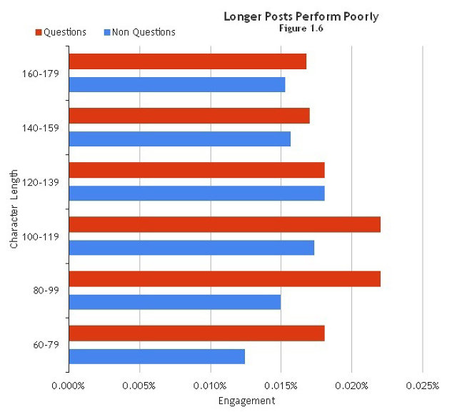

BlitzLocal: Longer posts perform poorly
5. When to post and how often

It’s always better to post when your audience is most active. Sharing is mostly done on a Saturday, and Facebook users in New Zealand are known to be active around noon or after 7pm.

Clearly, you don’t want to be posting at 7pm. You can schedule your posts to appear at a specific time and date. Create your post with any links and images. Then instead of clicking on the “Post” button, click on the downward arrow beside it and click on “Schedule”. Here, you can select a time and date to publish your post.

As for the frequency of posts per day, you will find your best pattern once you get to know more about your audience, and when and how to reach them. Posting twice a day seems like a good balance.

6. Voice/style of posts

- Speak in the first person in your posts.
- Write content as if you were talking to someone one-on-one.
- Be genuine, conversational and personable.
- Let your enthusiasm show in your posts and comments.
- Find your own words to retell trending stories within your sectors in a way that is most relevant and accessible to your audience.

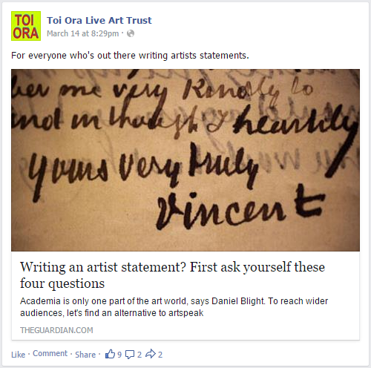
7. Likes, comments and shares
A post with 9 likes, 2 comments and 2 shares
So you have a Facebook page with some interesting and varied content. But you need people to see it. The more likes, comments and shares a post gets the more people will see it. And the more people will come to your page and “like” it.

Respond to comments on your posts. This lets your followers know you are interested in what they have to say and keeps the post in the newsfeed of your followers.

8. Building your audience

Let’s imagine the Facebook page of a creative space. It has 1500 people who have liked its page and it posts content twice a day. Unfortunately, this doesn’t mean that all 1500 people will see the posts in their newsfeeds.

On average, around 20% of your followers will get to see any one post. But every post is different: it might reach 80 people, 120, 210, 300 – or more. This depends on things like the time of day, the image or video clip you use, and the interest in the content. Sometimes, it’s hard to figure out why one post does really well and another only reaches 50 people.

Boosting your post
Let’s say you have something important to post – maybe about a job coming up at your creative space with a link to your website for more information and the job description. You want to reach as many people as possible.

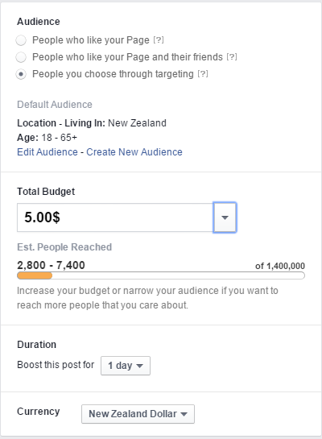
For as little as US$5, you can boost the post so it appears higher in the newsfeed. This means more people who have liked your page will see your post. It also means their friends with similar interests are more likely to see the post.
The options once you click "Boost Post"

Boosting posts leads to an increase of your “organic” (or natural) reach and, most likely, an increase in the number of “likes” on your page.

It’s a good idea to wait until your post is reaching its audience. Once people are engaging with it, you can then boost it by clicking on the Boost Post icon.

You have the option to choose either pushing the post to “People who like your page and their friends” or “People you choose through targeting.” You’ll also be able to set your budget. If your goal is to drive some targeted traffic to your website, then choose the third audience option: “People you choose through targeting”.

Your organisation may wish to allocate a budget so you can boost, for example, two posts a month. That’s US$120 per year.

9. Page insights

It is important to measure your page weekly (once a month at the very least) to ensure everything you’re posting to your community has value, relevance and significance. Use Facebook insights to collect weekly or monthly analytics. This way, you can assess the performance of your page, learn which content resonates with your audience, and optimise how and when you publish to your audience.

Create a spreadsheet to track these statistics. It’s interesting – and satisfying – to see the number of likes or your reach increasing. If you don’t notice much increase – or in fact, a decrease – you need to think about what you could do differently.
Here are some things you could track:
- Likes: track the growth of your page and where page likes have come from
- Reach: track how many people saw your posts, and how many likes, comments and shares they got
- Posts: track when your followers are online, what type of posts get the most likes, clicks, comments and shares
- People: track who your fans/followers are (gender, nationality).

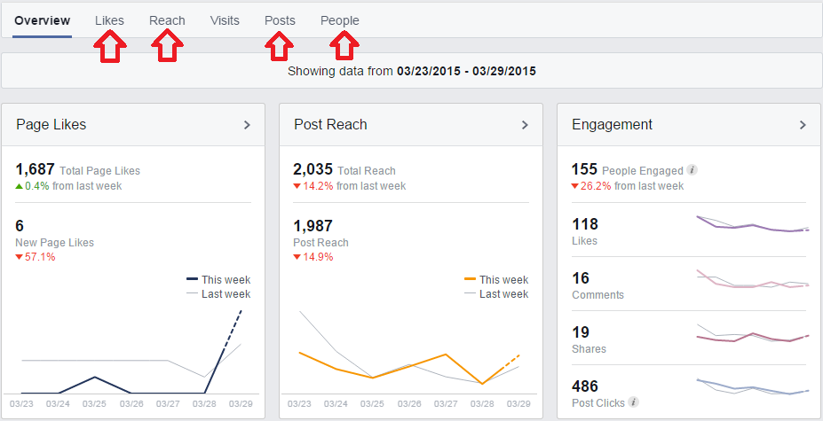

To learn more about page insights you can download this guide.

10. Negative comments – and what to do

As the number of likes on your page grows, you’re bound to get more comments. Unfortunately, that may also include the occasional offensive or negative comment.

Think about how you would manage an offensive or negative comment or comments. It’s a good idea not to react immediately to a negative comment. If you know you have supportive followers, hopefully they will jump in on your behalf.

But what if it’s not the case? Removing a negative comment can be a tricky business and needs to be handled carefully.

Code of conduct
It’s a pretty easy decision to remove a comment if it goes against the code of conduct you’ve established for your social media presence. It’s a good idea to spell this out in the “about” section of your page.

Here’s an example of a code of conduct/policy you might like to adapt:

[Insert name of organisation] loves social media as a way of connecting with people, and sharing news and ideas. We welcome your comments and feedback but reserve the right to delete comments, images or links that contain:
- offensive language
- personal attacks of any kind
- improper comments that are likely to offend or that target any ethnic, racial or religious group
- spam or include certain links to other sites
- any infringement on copyrights or trademarks
- excessive self-promotion.

Continual breaches of this policy will result in blocking.

Know your audience
Whenever you’re dealing with a negative comment online, the first question should be “who is this person?” You may not know them but others in your organisation or sectors may have dealt with them.

Before you proceed, you want to know things like how well-known they are in the industry; whether they’re known for causing trouble; and whether they’re the type of person who is never going to be made happy.

11. Useful links

Building your presence with Facebook Pages: A guide for causes and nonprofits

The Complete Facebook Guide for Small Non-Profits

http://www.firstdigital.co.nz/blog/2014/09/10/facebook-demographics-new-zealand-age-distribution-gender/
http://janrain.com/blog/social-login-trends-q2-2014/
https://www.facebook.com/help/364458366957655/
http://www.socialmediaexaminer.com/facebook-boost-posts-promoted-posts/
https://www.facebook-studio.com/fbassets/resource/37/PageInsightsProductGuide.pdf
http://www.icip.iastate.edu/sites/default/files/uploads/IRI/Pages_Guide_2013.pdf
http://johnhaydon.com/wp-content/uploads/2010/06/The-Complete-Facebook-Guide-For-Small-Non-Profits-6-17-2010.pdf

