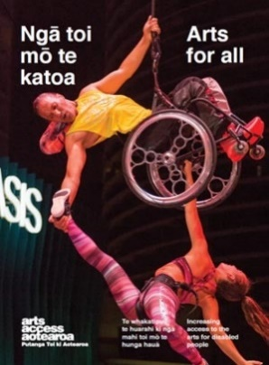
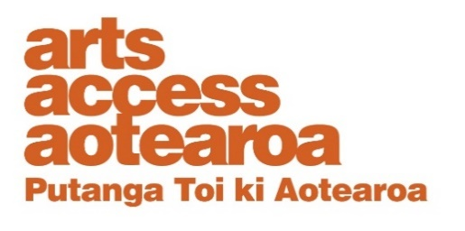
Q & A INSIGHT: ARTS FOR ALL
Tim Bray Theatre Company’s sensory relaxed performances
What are relaxed/sensory relaxed performances and what are the benefits to a theatre company in providing them? Tim Bray, Artistic Director, and Katie Querin, Company Stage Manager, of Auckland’s Tim Bray Theatre Company talk to Arts Access Aotearoa about the challenges and opportunities to connect with young audiences.
1. Background: about us
Tim Bray Theatre Company has been making children’s theatre since 1991. Our focus on accessibility began in 2004, when we started including NZSL interpreted performances in each production. Audio described performances followed in 2015 and sensory relaxed performances in 2019.

In 2021, we introduced drama classes called Extraordinarily Creative in to our Youth Theatre programme for children and teenagers with autism and other neurodiversities. The classes are led by Jeanita Cush-Hunter of ACE (Autism Consultancy and Education). Jeanita also trains the assistant tutors and provides training sessions for all our Youth Theatre tutors.

Our Gift a Seat™ programme started informally in 2005 when we began offering free tickets to low-decile schools, and later to families under the care of Make-A-Wish (NZ). The programme was formalised in 2016, by which time we were encouraging audience donations and seeking funding for Gift a Seat™.

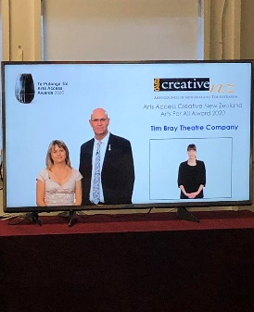
Every year, more than 20,000 children attend our shows and participate in our Youth Theatre workshops and classes.

We celebrated our thirtieth birthday in 2021, and appreciate the community support that keeps us focused on our purpose of inspiring children and young people of all backgrounds and abilities to be confident and creative through New Zealand theatre.

In 2020, we were proud to be awarded the Arts Access Creative New Zealand
Arts For All Award 2020 for more than 15 years of commitment to accessible theatre. We’re also a member of the Arts For All Auckland Network.

2. What are sensory relaxed performances?
Our sensory relaxed performances create a supportive, less formal atmosphere in the theatre. The show softens some technical elements and offers free support materials on our website to enable neurodiverse children and their families with sensory, movement, communication or learning needs to enjoy a comfortable and inclusive theatre experience.
Support materials include a “story summary” with details and photos of the performance, plus a “visual story” and “welcome video” for learning what the theatre visit will be like. Autistic children may find these performances especially beneficial and we’ve been guided by specialists at Autism NZ to create these shows.
The goal of sensory relaxed theatre is to create a safe, welcoming space where children and their families can relax and be themselves. We reduce theatre capacity and offer beanbags, open floor space and a chill zone for taking a break during the show.
Before the performance, the actors, set, lighting, sound, and any “surprises" are introduced to the audience. This includes any costume and character changes an actor may take during the show. The overall lighting is reduced so that the effect is softer on eyes.
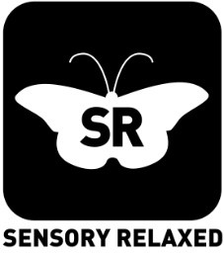
For many children, this will be their first experience of live theatre. The sensory elements and theatre etiquette are relaxed, but the integrity of the show is left intact to offer the same magical theatre experience.
Tim Bray Theatre Company created the moth logo to represent their sensory relaxed performances. We’re happy for other groups to use this. Contact us if you’d like the artwork.
3. How did sensory relaxed performances at Tim Bray Theatre Company start?
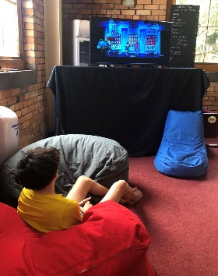
Accessibility has been a cornerstone of our shows since 2004. We were first made aware of sensory relaxed performances during a discussion at the Imaginate Festival in Edinburgh. After watching a young boy struggling with the volume of the music during one show, we decided to make sensory relaxed performances a part of our accessible offerings.
After almost a year of development, we debuted our first sensory relaxed performance of The Santa Claus Show 2019. Sensory relaxed performances are now a regular offering during our school holiday and school term performances, and we currently offer the sessions at two venues as part of our Auckland regional tours.
We’ve been inundated with feedback from parents who have struggled with the stress of being judged when their neurodiverse child is behaving differently in public.
The sensory relaxed performance creates a unique place where it’s acceptable to move around, call out and be yourself, and no one worries about their child being criticised or misunderstood.
After each sensory relaxed performance we send out a survey to the audience. This allows us to learn what worked for the audience and what didn’t, and how we can improve our delivery of the performances for next time.
Inspired by our sensory relaxed performances, we launched our Extraordinarily Creative programme in early 2021, an after-school drama programme for children and teenagers who are differently wired to find their own voice and place. We offer four age groups, with small and limited numbers and two dedicated tutors for these classes.
There is a clear need in Auckland to create experiences for neurodiverse children, and our audience numbers at the sensory relaxed performances and the enrolments for Extraordinarily Creative have been growing ever since. We are now looking for a second location for Extraordinarily Creative.
4. What are some key challenges in providing relaxed theatre performances?
Maintaining the show’s integrity: We have the show assessed by a consultant from Autism NZ, who brings a neurodiverse young person to provide feedback. This feedback helps us decide what modifications we can make without compromising on integrity or altering the story. It’s challenging to know whether to soften, remove or explain sensory elements, as each audience will have difference needs and preferences. Our biggest learning has been to focus wherever possible on preparing the audience for the sensory element rather than removing it completely.
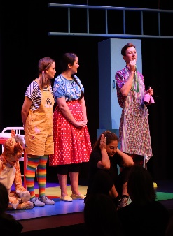
Educating our audiences: We use the term “sensory relaxed” for our shows rather than “relaxed” because “sensory relaxed” completely describes the elements we are focused on altering. We don’t relax the actors’ performances or the pace of the show unless the feedback is such that a particular moment needs to be softened or slowed down. Instead we relax the sensory elements and traditional theatre etiquette. Relaxed and sensory-friendly events (e.g. the sensory hour at the supermarket) are becoming more common in Aotearoa and we continue to promote knowledge of the terminology in the community. We introduced our own logo for our sensory relaxed performances – that of a moth - to portray the idea that these performances “land softly”.
Streamlining the process: Our goal is to offer accessible shows that are easily integrated into our busy show seasons. Resources are created, modifications made, and the change in stage and auditorium set-up all happen with very tight turn-arounds. We strive to fit the offering smoothly into every show season without requiring an unachievable amount of hours or resources. This allows us to integrate them into our seasons over the long term.

5. What are some key benefits of relaxed performances?
- A lifetime love: Creating an experience that means neurodiverse children will enjoy themselves rather than having to leave because of the bright lights, noise and sudden actions on the stage could start a child on a lifetime of loving the arts.
- Welcoming environment: Some parents (who had been attending our shows with their neurodiverse child) attended a sensory relaxed performance and told us that, for the first time, they themselves could relax and enjoy the show. They felt the environment was welcoming and accepting, and they didn’t need to stress about their child rocking or making noise.
- Expanding audiences: Increasing accessibility is not a token goal. Increased access creates a more equal, active world, leading to more ideas, more productivity and more growth for everyone in all fields. Everyone has a right to arts experiences, and accessible theatre can help deliver those experiences and increase theatre patronage.
- Relaxing shows: Many events, including rock concerts, can be relaxed. Relaxing a show encourages us to focus on the most important aspects, which can lead to a rewardingly fresh and innovative performance that challenges our team to be creative.
6. How do you evaluate the impact of relaxed performances?
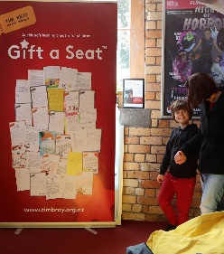
We’ve had incredible positive feedback from parents and kids. The audiences are kept small so we can speak with them after the performances, we get thank you emails from many, and we send out a short survey to get detailed feedback on what the audiences liked and what we could improve.
We’ve learned that parents drive across Auckland and even from out of town to attend our sensory relaxed shows. Our most common praise is that the parents could relax and not worry about their child being disruptive because their behaviours are welcome and understood during the show.
7. Five key tips for anyone wanting to present a relaxed theatre performance.
- Connect with you community: We built our performances with direct feedback from parents, professionals and youth from the neurodiverse community. Get the right voices (the people for whom you’re creating the performance) in the room. Their expertise is invaluable.
- Contact your local organisations: For example, Autism NZ, for advice. Reach out to other theatres who put on relaxed shows and share ideas with each other. Many organisations are eager to help others create these shows by sharing experience. Come along to the Arts For All Network meetings – a great place to raise questions and connect.
- Focus on acceptance: Material resources don’t matter as much as a focus on creating the accepting, welcoming spirit. Be honest about what you can provide and prioritise a positive, inclusive atmosphere.
- Learn over time: What show elements you modify, how you attract an audience and how you set up resources will all evolve over time. There’s no way you can get everything “right” in one go – and that’s fine! Learn from your experience and keep building. We are still learning.
- Be committed: Put in the time and effort to create a show that’s the same calibre as your other offerings, and which demonstrates your commitment to high standards of accessibility. Put the show in a decent timeslot and give it as much attention as you give to all performances.
For more information
Tim Bray, QSM
Artistic Director, Tim Bray Theatre Company
T: 09 486 2261 E: tim@timbray.org.nz

Katie Querin
Company Stage Manager, Tim Bray Theatre Company
T: 09 486 2261 E: katie@timbray.org.nz

Arts For All is an Arts Access Aotearoa/Creative New Zealand partnership programme. It aims to encourage arts organisations, venues and producers to improve access to Deaf and disabled audiences. Download the guide at artsaccess.org.nz or call
04 802 4349 for more information.
