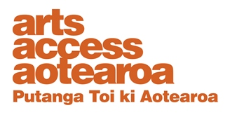  ARTS FOR ALL: INFORMATION SHEET  Making arts events accessible to Deaf  and hard of hearing people  Aucklanders Lorraine McQuigg, Rachel Coppage and Debra Bathgate provide the following tips to make your arts events accessible to Deaf and hard of hearing people.  Always ask people what they require  - Small signs are available from The National Foundation for the Deaf to put on reception or box office desks, encouraging hard of hearing people to let staff know if they have a hearing impairment. This will make communication easier.  - Encourage the involvement of Deaf artists, and have Deaf people and sign language represented in the arts.  - Engageme with people in the Deaf community to help attract Deaf people to come to venues together in groups.  - Organise a meeting with three or four people from the particular community you are targeting. Do this well in advance of when you start to market your event. Deaf Aotearoa and the Disability Information Service can help you with this. If possible, set up an advisory group. See this as the start of a long-term partnership and offer free tickets to opening night, special deals, regular newsletters etc.  - Make sure to book an NZSL interpreter for each meeting if you know one will be required. Do this at least one week in advance.  - Provide audio loops and any assistive technology. They will not assist everyone and Deaf people should always be consulted about technology such as audio loops and captioning devices. The National Foundation for the Deaf can provide advice about fitting loop devices because they may not work if they’re not fitted properly. It’s also useful to seek feedback from people who use these.  - Keep up with technological advances. Deaf organisations or clubs will be able to advise on these. Consultation about the introduction of new technology is essential to make sure things will work in practice.  - Consider using real-time captioning: a person types what is being said by the speaker, which is then shown on a large screen. Surtitles are also useful: e.g. for museums and galleries that show film clips.  - Consider pre-recorded NZSL interpretation on a screen.  - For hearing impaired people, elimination of background noise (such as background music when there are speakers) will help make dialogue easier to understand.  - Offer to provide scripts in advance at the time of booking (or advice on where they can be obtained).  - Box office:  - Ask the customer if they have accessibility requirements.  - In your promotions, provide a phone number for customers who have accessibility requirements or questions relating to access of the event.  - For a NZSL interpreted event, reserve seating close to the interpreter for people who are Deaf or hearing impaired. You can indicate in your ticketing details that these seats will be released if they’re not purchased by a certain date.  - Consider visibility for hearing impaired people trying to lip read by providing seats close to the stage.  - Make it common practice to advertise your accessible event in all marketing and promotion. For example, state the date and time of an NZSL interpreted performance with the international sign symbol on your website, social media, posters and flyers etc.  - Advertise early to your targeted groups: ideally six weeks in advance. Ask organisations such as Deaf Aotearoa, Disability Information Service and National Foundation for the Deaf to help spread the word.  - Contact Arts Access Aotearoa if you have any questions. Download the Arts For All guide and read its many resources and checklists on the Arts Access Aotearoa website.  - Remember: “Nothing about us without us” – Disabled Peoples Assembly  Contact Arts Access Aotearoa  T: 04 802 4349  E: info@artsaccess.org.nz  W: www.artsaccess.org.nz |  | 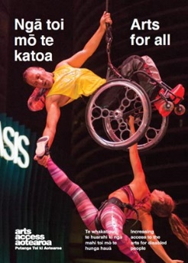  Arts For All is an Arts Access Aotearoa-Creative New Zealand partnership programme. The aim of this programme is to encourage arts organisations, venues and producers to improve their access to Deaf and disabled audiences. Download the guide at artsaccess.org.nz or call 04 802 4349 for more information.

