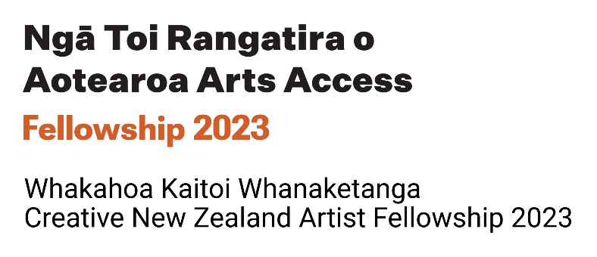
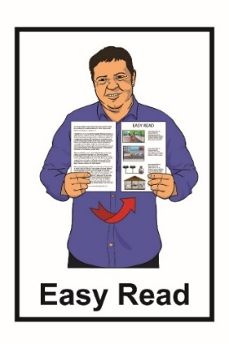

Ngā Toi Rangatira o Aotearoa Arts Access Fellowships 2023
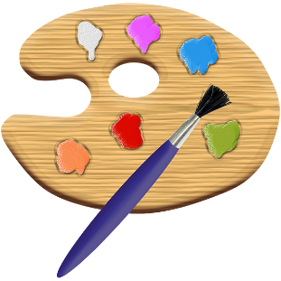
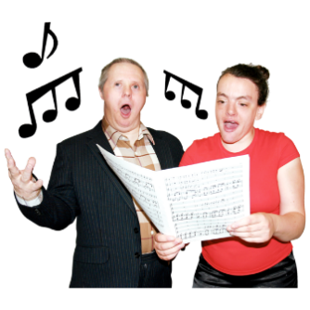

Whakahoa Kaitoi Whanaketanga
Creative New Zealand Artist Fellowship 2023

Before you start

This is a long document.

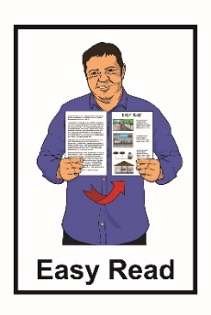
While it is written in Easy Read it can be hard for some people to read a document this long.

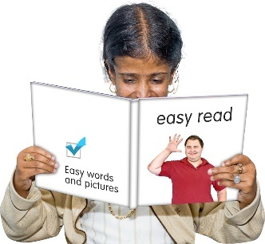
Some things you can do to make it easier are:

- read a few pages at a time
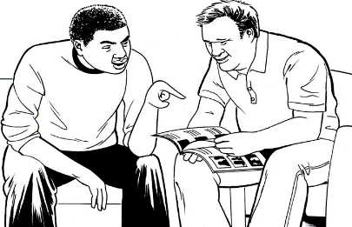
- have someone to support you understand it.

What you will find in here

Page number:

Ngā Toi Rangatira o Aotearoa Arts Access Fellowships 2023…… 4

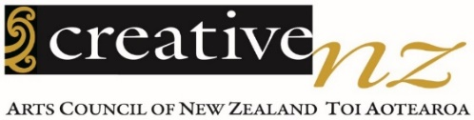
About the Creative New Zealand
Artist Fellowship 6
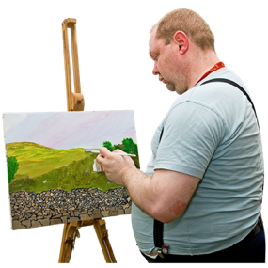

Who can apply for the fellowship?...9

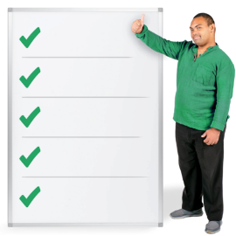
How the fellowship money can be used…………………………………...11

Who will decide who gets the fellowship? 13

Page number:

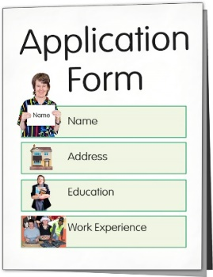
How to apply for the fellowship 15

Getting support to do your application 22
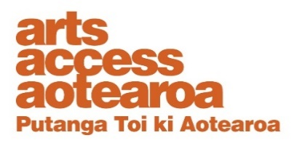

Where to find more information 24

Ngā Toi Rangatira o Aotearoa
Arts Access Fellowships 2023

This year Arts Access Aotearoa is offering 4 different arts fellowships.

A fellowship is money that is given to someone so they can do their art.

Each of the 4 fellowships is 10 thousand dollars.

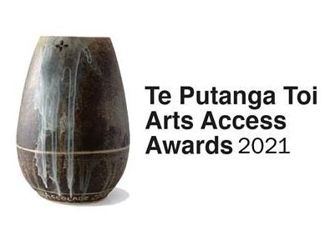
Arts Access Aotearoa is offering these 4 fellowships instead of the Te Putanga Toi Arts Access Awards.

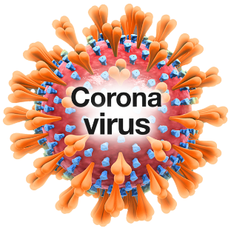
These fellowships aim to reduce the impact that COVID-19 has had on the arts community over the past few years.
The 4 fellowships are called:
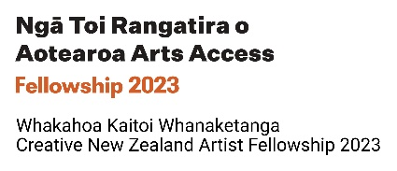
- Whakahoa Kaitoi Whanaketanga Creative New Zealand Artist Fellowship
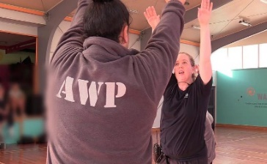
- Whakahoa Kaitoi i Te Ara Poutama Arts in Corrections Artist Fellowship
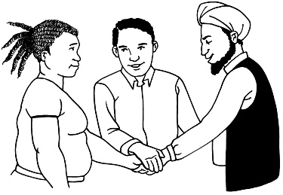
- Whakahoa Whakawatea Kaitoi Tangata Holdsworth Creative Spaces Fellowship

- Whakahoa Kaitoi Te Puna Toi Arts For All Fellowship
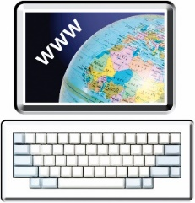
You can find more information about all 4 fellowships on the Arts Access Aotearoa website:

www.artsaccess.org.nz/Arts-Access-Fellowships-2023
About the Creative New Zealand
Artist Fellowship

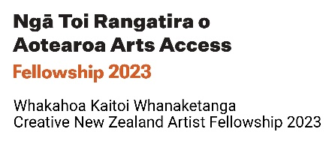
This Easy Read document is about the Creative New Zealand Artist Fellowship.

The money for this fellowship has been given by Creative New Zealand.

Your project should not take you more than 200 hours. That is about 1 or 2 months.

You have 6 month to finish your project. You do not have to take 6 month to finish it.

In this document we will call the Creative New Zealand Artist Fellowship the fellowship.
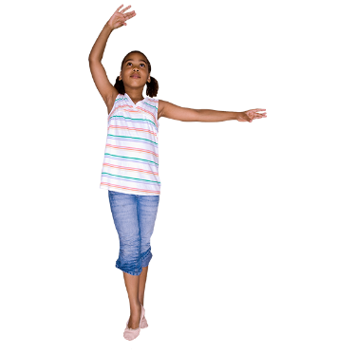
Art can be things like:
          - dancing
          - music / singing
          - acting

          - painting

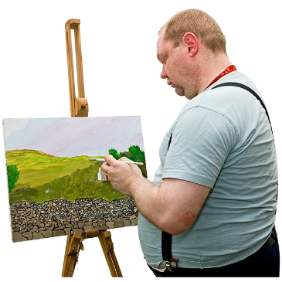
          - film making

          - writing:

  - poems
  - stories

  - novels / books
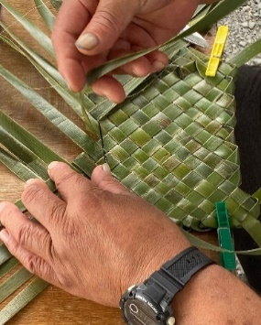
- Māori arts:

- whakairo – carving

- raranga – weaving.
To apply for the fellowship you need to have an art project you want to do.

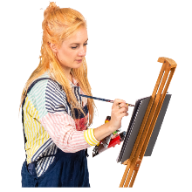
A project is when you use your art to make something.

The project must be:

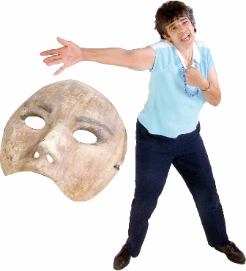
- to make some new art

or

- to work on art you have already started.

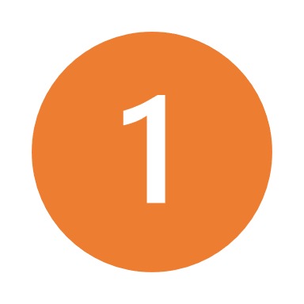
The fellowship is for 1 artist.

The artist will get 10 thousand dollars to do their project.

Who can apply for the fellowship?

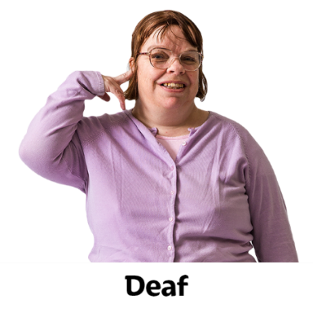
To be able to apply you must be:

- a Deaf artist
and / or
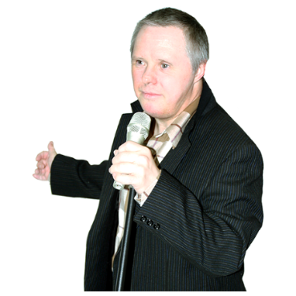
- a disabled artist
and / or
- an artist with a disability or
an impairment

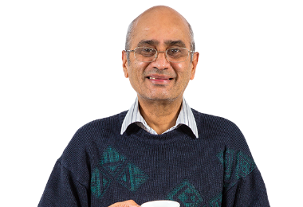
and / or

- an artist living with a mental health condition.

You must also be:
18

- 18 years or older
- a New Zealand citizen or permanent resident.

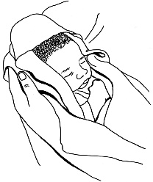
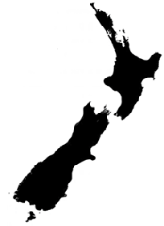
A New Zealand citizen is someone who was born in New Zealand

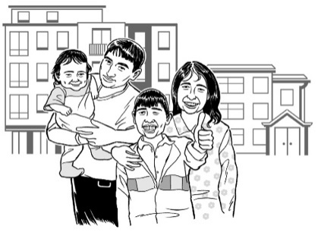
A permanent resident is someone who was not born in New Zealand but has been told by the government they can live in New Zealand all the time.

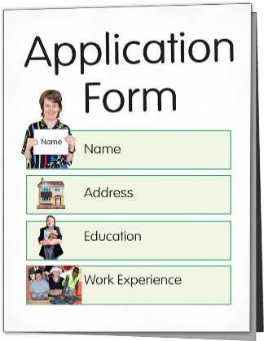
You will need to make an application for the fellowship.

You can find the application form on the Arts Access Aotearoa website:

www.artsaccess.org.nz/Arts-Access-Fellowships-2023
How the fellowship money can be used

You can use the fellowship money to pay:

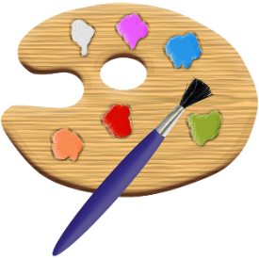
- yourself and others for working on the project

- for things you need for the project like:

  - paint brushes

  - music

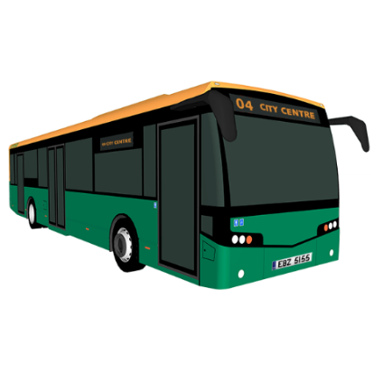
  - paper

- for travel costs needed for the project

- costs for the project like:

  - an New Zealand Sign Language interpreter

  - having information in braille.
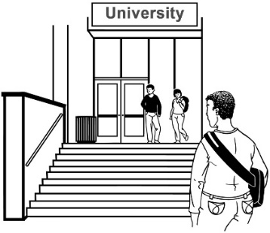
You cannot use the fellowship money to pay for:

- study costs
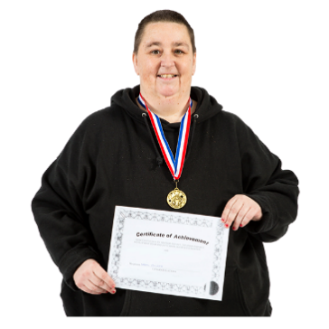
- a competition
- fundraising
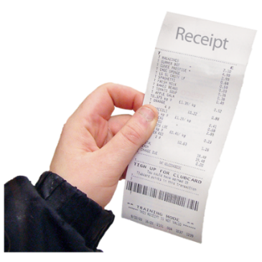
- costs that are not for the project.

Who will decide who gets the fellowship?

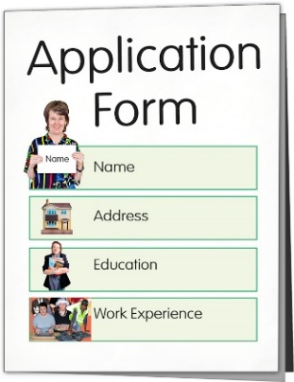
A small group of people will:

- read all the applications

- talk about the applications.

The group of people will be called the selection panel.

The selection panel will work together to decide who will get the fellowship.
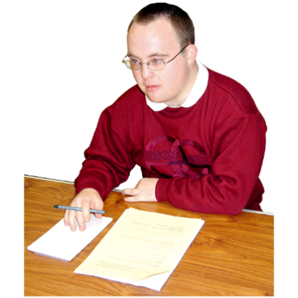

At least 1 Deaf person or disabled person will be part of the selection panel.

Arts Access Aotearoa will not make any decisions about who gets the fellowship.

The selection panel will look at your application to get information about:
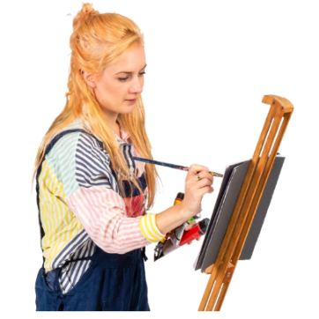
            - your project idea

            - how you will be able to finish your project
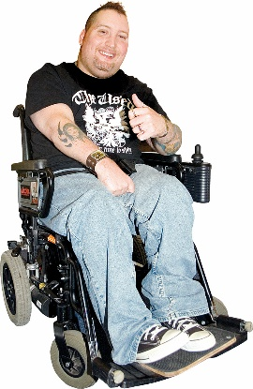
            - you as an artist

            - what your project will do / achieve.

The selection panel needs you to complete all parts of the application.

How to apply for the fellowship

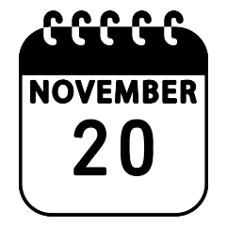
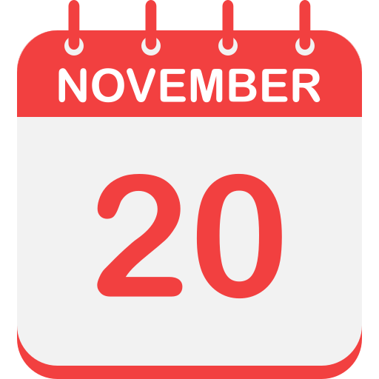
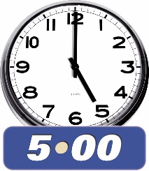
Step 1: Check the dates.

Applications for the fellowship close at 5pm on Monday 20 November 2023.

Arts Access Aotearoa will let you know the outcome of your application by 5pm by Monday 4 December 2023.

If you get the fellowship you need to start your project within 2 months of saying yes to the fellowship

You will have 6 months to finish your project.

Step 2: Think about what you need in your application.

Before you start your application read the:

- questions in the application form

- Frequently Asked Questions.

Frequently Asked Questions has answers to questions about the fellowship.

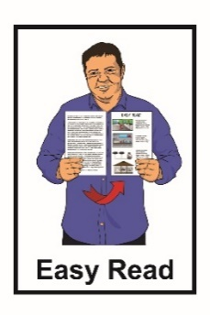
Frequently Asked Questions are sometimes called FAQs.

The application form and FAQs are not in Easy Read.

You can ask someone for support with reading the application form and FAQs.
Step 3: Decide how you want to do your application.

You can do your application as:
- a written application

- a New Zealand Sign Language video

- a video file
- an audio file.

Step 4: What you need to have in your application.

- A budget showing how you will spend the 10 thousand dollars.

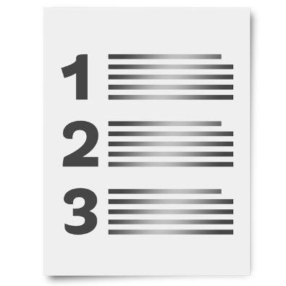
A budget is a list that shows:

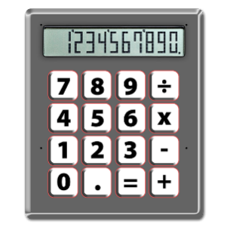
- how you will spend the fellowship money

- how much each thing will cost.

- A list showing the:

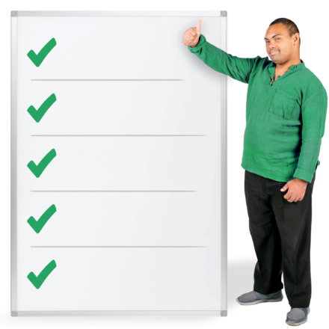
- things you need to do for your project

- date you want to do them by

- what you will do to make sure you finish the project.
In your application you also need to:

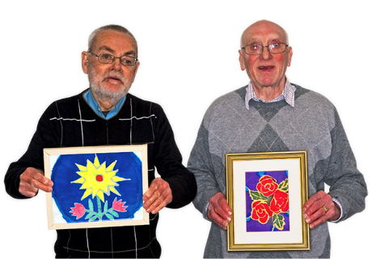
- Show some examples of your art.

This might be:

                - photos

                - a video

                - a link to a story on the internet.

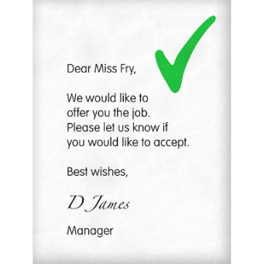
- Have no more than 2 letters of support from people who know:

- about your project

- what you do as an artist.

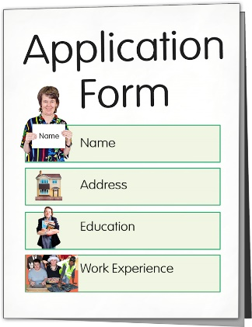
Step 5: Send Arts Access Aotearoa:

- your application form

- any other information.

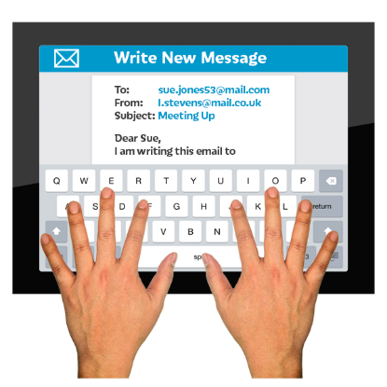
If you are sending in a written application you can:

- email your application to:

fellowships@artsaccess.org.nz

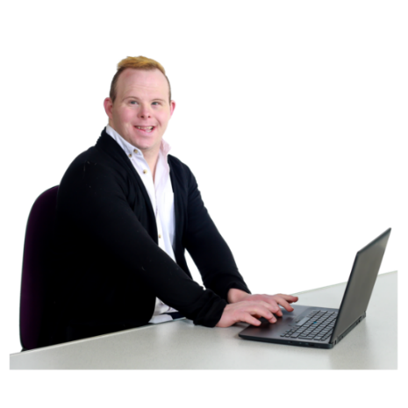
If you are sending a video or audio files as part of your application you need to upload them to:

- WeTransfer

or

- Dropbox.
WeTransfer and Dropbox are tools on the internet that make it easy to send big files like video and audio files.
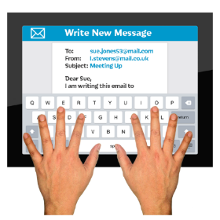
Please do not email your video or audio files to Arts Access Aotearoa.
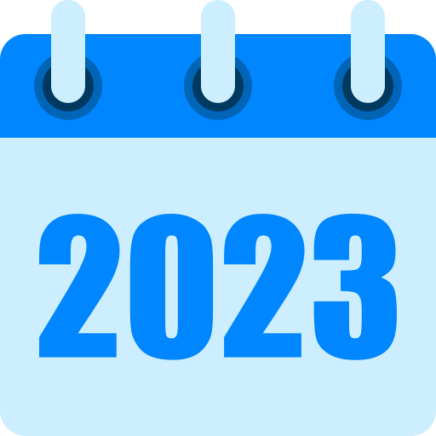

Arts Access Aotearoa must get your application by 5 pm on Monday 20 November 2023.

Getting support to do your application

If you need some support to put together your application you can:

- ask someone you know
- talk to Arts Access Aotearoa.

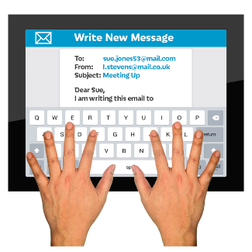
You can email or phone Arts Access Aotearoa:

- Email:

fellowships@artsaccess.org.nz
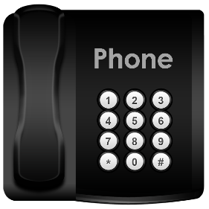

- Phone: 04 802 4191

If you find it hard to use the phone the New Zealand Relay service is for people who:

- are deaf / hard of hearing
- are deafblind

- find it hard to talk.
You can find more about the New Zealand Relay service at this website:

https://www.nzrelay.co.nz/index

Where to find more information

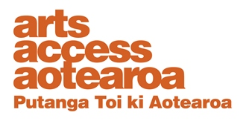
You can find out more about Arts Access Aotearoa on their website:

www.artsaccess.org.nz

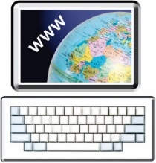
You can find out more about the fellowships on the Arts Access Aotearoa website at:

www.artsaccess.org.nz/Arts-Access-Fellowships-2023

You can also contact Arts Access Aotearoa about the fellowships by:

- Email:
fellowships@artsaccess.org.nz
- Phone: 04 802 4191
This information has been written by Arts Access Aotearoa.
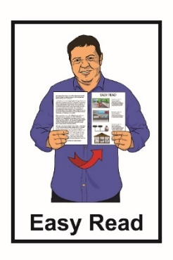
It has been translated into Easy Read with advice from the Make It Easy service of People First New Zealand Inc. Ngā Tāngata Tuatahi.

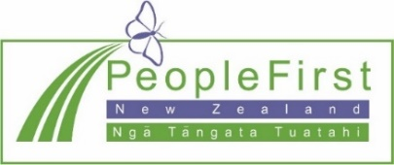
The ideas in this document are not the ideas of People First New Zealand Inc. Ngā Tāngata Tuatahi.

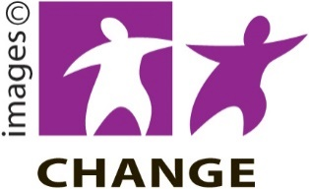
Make It Easy uses images from:

- Changepeople.org

- Photosymbols.com

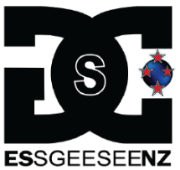
- SGC Image Works.

Some images have been provided by Arts Access Aotearoa

All images used in this Easy Read document are subject to copyright rules and cannot be used without permission.

