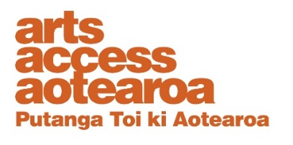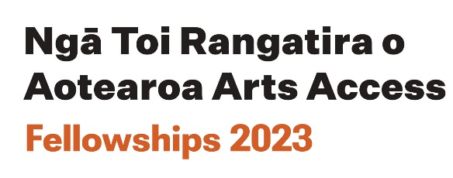

APPLICATION FORM:
Whakahoa Kaitoi i Te Ara Poutama Arts in Corrections

Artist Fellowship 2023

This is an application form for the Whakahoa Kaitoi i Te Ara Poutama Arts in Corrections Artist Fellowship.

Before you begin filling in this form please read the information about the Arts in Corrections Fellowship (AICF) and the Fellowship FAQs which will tell you what is required.

Eligibility requirements

Please confirm you are:

☐ 18 years or older
☐ A New Zealand citizen or permanent resident
☐ An artist living in the community who is/has been in the criminal justice system.

COMPLETE THE APPLICATION FORM BELOW

1. Contact details

Name:
Pronouns:
Email address:
Contact phone number:
Preferred method of communication:

2. Other project contact details
If you have already chosen a mentor, please provide their name, email and phone number.

Name:
Email address:
Contact phone number:

3. Project proposal details
Please provide no more than a total of 1000 words or a video/audio of 15 minutes. We encourage bullet points, where feasible.
Below are some prompts to help guide you as you prepare your answers. Where appropriate you may want to provide details in a separate document.
1. Tell us about your project idea.

2. Why do you want to do this project?

3. How will this project be achieved? Describe the process.

4. Provide a timeline of the project.

5. Provide a detailed budget for the project.

6. How will you document and/or evaluate your project?
7. Briefly tell us about yourself and your experience relevant to realising this project.
8. Will anyone else be involved? What is their role and relevant experience for the project? (Mentor / Collaborator).

4. Support material checklist

☐ A competed application form
☐ CV of 1-2 pages including any Corrections art programme you have participated in.
☐ Examples of your previous work (no more than 3 examples)
☐ A budget showing how you will use the $10,000.
☐ A timeline.
☐ A letter of support. (e.g., from an art tutor)
☐ A letter of commitment from your mentor if already selected.
Letters need to be recent, specific to the application and include the writer’s contact details.

5. Signature declaration

Please sign below and confirm that the content in your application is accurate by uploading a digital file of your signature.

Signature:

Date:

