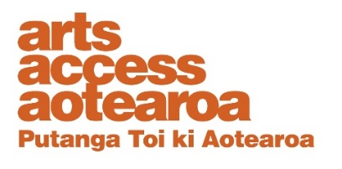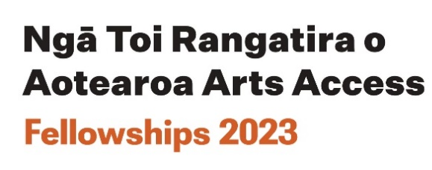

APPLICATION FORM:
Whakahoa Kaitoi Te Puna Toi Arts for All Fellowship 2023

This is an application form for the Whakahoa Kaitoi Te Puna Toi Arts For All Fellowship.

Before you begin filling in this form make sure it is for the fellowship you are interested in and most suited to your project. Read the information about the Arts For All Fellowship (AFAF) and the Fellowship FAQs which will tell you what is required.

Eligibility requirements

Please confirm you are:

☐ 18 years or older
☐ A New Zealand citizen or permanent resident
☐ Employed by an Arts For All member organisation
or
☐ partnering with an Arts For All member organisation

COMPLETE THE APPLICATION FORM BELOW

1. Contact details

Name:
Pronouns:
Your role in the organisation:
Email address:
Contact phone number:
Preferred method of communication:

2. Other project contact details
Arts For All member organisation you are employed by or working for:

Arts For All organisation:
Region:

3. Project proposal details
Please provide no more than a total of 1000 words or a video/audio of 15 minutes.
We encourage bullet points, where feasible.
Below are some prompts to help guide you as you prepare your answers. Where appropriate you may want to provide details in a separate document.
1. Tell us about your project idea.

2. Why do you want to do this project?

3. Describe the barriers/gaps to accessibility that this project will help address.

4. How will this project be achieved? Describe the process.

5. Provide a timeline of the project.

6. Provide a detailed budget for the project.

7. How will you document and/or evaluate your project?
8. Briefly tell us about yourself and your experience relevant to realising this project.
9. Tell us about your role in your organisation.
10. Who else is involved? What is their role and relevant experience for the project?

4. Support material checklist

☐A competed application form
☐ CV of 1-2 pages describing your skills and experience.
☐ Examples of your previous accessibility work or research (no more than 3 examples.)
☐ A budget showing how you will use the $10,000.
☐ A timeline.
☐ Up to two letters of support from a Deaf or disabled person. These need to be recent, specific to the application and include the writer’s contact details.
☐ A letter of commitment from an Arts For All Network member organisation.

5. Signature declaration

Please sign below and confirm that the content in your application is accurate by uploading a digital file of your signature.

Signature:

Date:

